-------- Release Notes from v0.3.0 to v0.2.0 -------------
7e5a8e231b56de717d3418a2385c86042d7ffca4 to 382b17907c5731636718b971580f0960295ca713

---a/TR-0077-oneM2M_and_MEC_integration_scenario_and_mechanisms.md
+++b/TR-0077-oneM2M_and_MEC_integration_scenario_and_mechanisms.md
@@ -1,59 +1,12 @@
1 -
2 - ![~~CAPTION~~](media/logo.png)
3 -
4 -
5 - +----------------------------------------------------------------+
6 - |**oneM2M** \ |
7 - |**Technical** **Report** |
8 - +:================+:=============================================+
9 - |Document Number |oneM2M-TR-0077-V-0.2.0 |
10 - +-----------------+----------------------------------------------+
11 - |Document Name: |oneM2M and MEC integartion scenario and |
12 - | |mechanisms |
13 - +-----------------+----------------------------------------------+
14 - |Date: |&lt;2025-09-29> |
15 - +-----------------+----------------------------------------------+
16 - |Abstract: |&lt; An abstract of the document and |
17 - | |information that may be used in subsequent |
18 - | |electronic searches> |
19 - +-----------------+----------------------------------------------+
20 - |Template Version: January 2020 (Do not modify) |
21 - +----------------------------------------------------------------+
22 -
23 -
24 -
25 - The present document is provided for future development work within oneM2M only. The Partners accept no liability for any use of this report.
26 -
27 - The present document has not been subject to any approval process by the oneM2M Partners Type 1. Published oneM2M specifications and reports for implementation should be obtained via the oneM2M Partners' Publications Offices.
28 -
29 -
30 -
31 - About oneM2M
32 -
33 - The purpose and goal of oneM2M is to develop technical specifications which address the need for a common M2M Service Layer that can be readily embedded within various hardware and software, and relied upon to connect the myriad of devices in the field with M2M application servers worldwide.
34 -
35 - More information about oneM2M may be found at: http//www.oneM2M.org
36 -
37 -
38 -
39 - Copyright Notification
40 -
41 - (c) 2025, oneM2M Partners Type 1.
42 -
43 - All rights reserved.
44 -
45 - The copyright and the foregoing restriction extend to reproduction in all media.
46 -
47 -
48 -
49 - Notice of Disclaimer & Limitation of Liability
50 -
51 - The information provided in this document is directed solely to professionals who have the appropriate degree of experience to understand and interpret its contents in accordance with generally accepted engineering or other professional standards and applicable regulations. No recommendation as to products or vendors is made or should be implied.
52 -
53 - NO REPRESENTATION OR WARRANTY IS MADE THAT THE INFORMATION IS TECHNICALLY ACCURATE OR SUFFICIENT OR CONFORMS TO ANY STATUTE, GOVERNMENTAL RULE OR REGULATION, AND FURTHER, NO REPRESENTATION OR WARRANTY IS MADE OF MERCHANTABILITY OR FITNESS FOR ANY PARTICULAR PURPOSE OR AGAINST INFRINGEMENT OF INTELLECTUAL PROPERTY RIGHTS. NO oneM2M PARTNER TYPE 1 SHALL BE LIABLE, BEYOND THE AMOUNT OF ANY SUM RECEIVED IN PAYMENT BY THAT PARTNER FOR THIS DOCUMENT, WITH RESPECT TO ANY CLAIM, AND IN NO EVENT SHALL oneM2M BE LIABLE FOR LOST PROFITS OR OTHER INCIDENTAL OR CONSEQUENTIAL DAMAGES. oneM2M EXPRESSLY ADVISES ANY AND ALL USE OF OR RELIANCE UPON THIS INFORMATION PROVIDED IN THIS DOCUMENT IS AT THE RISK OF THE USER.
54 -
55 -
56 - # Contents
1 + ---
2 + Title: oneM2M and MEC integration scenario and mechanisms
3 + Spec Number: TR-0077
4 + Version: v0.3.0
5 + Date: 2026-03-26
6 + Abstract: TBD An abstract of the document and information that may be used in subsequent electronic searches
7 + Copyright Year: 2026
8 + Copyright: oneM2M Partners Type 1. All rights reserved. The copyright extends to reproduction in all media.
9 + ---
57 10
58 11 # 1 Scope
59 12 The present document ...
@@ -438,7 +391,6 @@
438 391 ![Fig 6.5.2](media/federated_learning_option_2_updated.png)
439 392
440 393 **Fig 6.5.2 Federated Learning Orchestration - Option 2**
441 -
442 394
443 395
444 396 The orchestration mechanism should be able to perform the following steps:
@@ -470,13 +422,538 @@
470 422 ### 7.1.7 Solution 4: Registering MN-CSE as MEC application
471 423 ### 7.1.8 Solution 5: Integrating oneM2M as a MEC service
472 424
473 - ## 7.2 Transfer registration from oneM2M host on a first MEC platform to another second MEC Platform
474 - ### 7.2.1 Description
475 - <mark> show a couple images from use cases showing some sort of neighbour search and handover process</mark>
425 + ## 7.2 Handover of IoT devices to oneM2M/MEC platforms
426 + ### 7.2.1 Introduction
427 + This clause describes handover mechanisms for IoT devices operating across oneM2M CSEs hosted on ETSI MEC platforms, with a focus on service-layer continuity during mobility, topology changes, or platform re-selection events.
428 +
429 + In the target operational model, an IoT device is initially registered with a source MN-CSE hosted on a MEC platform. Upon a mobility or orchestration-triggered event, the device’s service context is transitioned to a target MN-CSE hosted on a different MEC platform. This transition includes the migration or re-establishment of relevant oneM2M resources—such as AE registrations, subscriptions, and associated data—so that application services remain uninterrupted.
430 +
431 + ![Fig 7.2.1-1](media/handover_7_2_1.png)
432 +
433 + **Fig 7.2.1-1 oneM2M-MEC Service-Layer Handover with IN-CSE Coordination**
434 +
435 + Within oneM2M–MEC integrated environments, handover extends beyond radio or access mobility to encompass dynamic relocation of service-layer entities and contexts, including AEs and MN-CSE registrations, across MEC platforms, access networks, and cloud domains. This enables adaptive resource placement and consistent service behavior across heterogeneous access technologies (e.g., cellular, Wi-Fi, BLE, DECT-NR+).
436 +
437 + The primary objectives of handover in such environments include:
438 +
439 + - **Service Continuity:** Preserving active service interactions and data flows during mobility or platform transitions.
440 + - **Context Preservation:** Maintaining oneM2M resource state (e.g., registrations, containers, subscriptions) across MN-CSE boundaries.
441 + - **Performance Optimization:** Selecting target MEC nodes or MN-CSEs to minimize latency and optimize application performance.
442 + - **Load and Resource Optimization:** Dynamically redistributing devices or AEs across CSEs or MEC hosts.
443 + - **Policy and Energy Awareness:** Supporting QoS, energy, and policy constraints via CMDH and orchestration frameworks.
444 + - **Autonomous and Assisted Operation:** Enabling both device-initiated and network-assisted handover workflows.
445 +
446 + The following definitions are used in this clause:
447 + - **Registration Handover:** The process of transferring an AE’s registration from a source MN-CSE to a target MN-CSE, including the migration or re-establishment of associated resources (containers, subscriptions, etc.) to maintain service continuity.
448 + - **Context Transfer:** The migration of application state, session information, and resource data associated with an AE during handover to ensure seamless service operation post-transition; e.g. continuity of subscriptions/queued downlink/state across the change.
449 + - **Endpoint Steering:** The redirection of application traffic flows to the new MN-CSE or MEC host post-handover, ensuring that data paths are updated to reflect the device’s new point of attachment.
450 + - **Application Relocation:** The process of moving an application instance and its associated user context from one MEC host to another to maintain service continuity during UE mobility.
451 +
452 + _“This clause focuses on Registration/Context Handover for oneM2M AEs; MEC 021 relocation is optional and orthogonal.”_
453 +
454 + By combining MEC service exposure APIs (e.g., location, radio network information, orchestration) with oneM2M service-layer capabilities (e.g., AE, remoteCSE, CMDH), multiple complementary handover strategies can be supported. These range from fully network-assisted approaches to device-driven mechanisms, as summarized in the following clauses.
455 +
456 + ### 7.2.1.1 Core Network Initiated Application Relocation (MEC-assisted)
457 +
458 + ETSI GS MEC 021 specifies the Application Mobility Service (AMS), which supports relocation of MEC application instances and associated user context across MEC hosts to preserve service continuity during UE mobility.
459 +
460 + In the MEC-assisted mode (focus of this clause), the MEC system is responsible for detecting mobility conditions and initiating relocation. The decision is typically driven by event notifications and telemetry correlated to UE identifiers, including:
461 +
462 + 1. UE mobility / cell change / handover events
463 + 2. UE departure from a serving area associated with the current MEC host
464 + 3. predicted or observed QoS degradation (e.g., latency/throughput thresholds) relative to application requirements.
465 +
466 + To detect such conditions, AMS commonly integrates with the Radio Network Information Service (RNIS, ETSI GS MEC 012) through queries and/or subscriptions for UE-specific and radio-node events. Optionally, the Location Service (ETSI GS MEC 013) may provide supplementary location data to refine decisions for geo-sensitive applications. Application-specific mobility preferences and constraints may be expressed during registration (e.g., via AppMobilityServiceLevel and/or information derived from the application descriptor), allowing AMS to map detected events to the affected application instance(s).
467 +
468 + When conditions are met, AMS notifies the application instance via subscription-based MobilityProcedureNotification messages (e.g., INTERHOST_MOVEOUT_TRIGGERED and INTERHOST_MOVEOUT_COMPLETED) and provides the target endpoint information needed to proceed. AMS supports structured sub-procedures (enablement, initiation, preparation, execution, traffic path update, completion). While AMS defines the coordination and notification mechanisms, the exact application context/state content and its transfer format remain application-specific.
469 +
470 + ![Fig 7.2.1.1-1](media/handover_7_2_1_1.png)
471 +
472 + **Fig 7.2.1.1-1 MEC System-Initiated Application Relocation (MEC-assisted)**
473 +
474 + **Key oneM2M/MEC Components:**
475 +
476 + - MEC Application Mobility API (MEC 021)
477 + - MEC RNIS API (MEC 012)
478 + - MEC Location API (MEC 013)
479 + - MEC Use case and Requirements (MEC 002)
480 + - MEC Framework and Reference Architecture (MEC 003)
481 + - oneM2M `trigger`, `remoteCSE` and `AE` re-registration procedure
482 +
483 +
484 +
485 + ### 7.2.1.2 Signal-Quality-Triggered Handover (Edge-Assisted)
486 +
487 +
488 + A MEC application or edge AE may monitor radio conditions such as RSRP or SINR using the MEC Radio Network Information Service (ETSI GS MEC 012) or vendor-specific telemetry. When degradation is detected, application-specific logic may notify a oneM2M orchestrator AE or IN-CSE. Based on local policies, the orchestrator may decide to redirect the application or re-register the AE with another MN-CSE. Such behavior is implementation-specific and does not provide standardized application context transfer or session continuity.
489 +
490 + ![Fig 7.2.1.2-1](media/handover_7_2_1_2.png)
491 +
492 + **Fig 7.2.1.2-1 Signal-Quality-Triggered Handover (Edge-Assisted)**
493 +
494 +
495 +
496 + **Key oneM2M/MEC Components:**
497 +
498 + - MEC RNIS API (MEC 012)
499 + - oneM2M `flexContainer` or `mgmtObj` schema to represent and cache MEC platform utilization metrics as a oneM2M resource, enabling policy evaluation against CMDH thresholds.
500 + - oneM2M `AE` re-registration triggered by policy
501 +
502 +
503 +
504 + ### 7.2.1.3 Load-Balancing-Based Handover (Orchestrator-Driven)
505 +
506 + The **MEC Orchestrator (MEO)** collects utilization data from multiple MEC platforms (CPU, memory, radio load). Using **MEC 010-02 Orchestration API**, it informs the **oneM2M IN-CSE Orchestration AE**. The AE decides to migrate certain devices or AEs to other MN-CSEs to balance processing or connectivity load. The migration involves updating the **remoteCSE** and `AE` resources.
507 +
508 +
509 + ![Fig 7.2.1.3-1](media/handover_7_2_1_3.png)
510 +
511 + **Fig 7.2.1.3-1 Load-Balancing-Based Handover (Orchestrator-Driven)**
512 +
513 +
514 + **Key oneM2M/MEC Components:**
515 +
516 + - MEC Application lifecycle, rules and requirements management (MEC 010-02)
517 + - MEC RNIS API (MEC 012)
518 + - oneM2M Orchestration AE managing `remoteCSE` mappings
519 +
520 +
521 +
522 + ### 7.2.1.4 Device-Initiated Handover (Autonomous Device)
523 +
524 + A **oneM2M AE running on the UE** monitors signal strength, latency, or application performance using **MEC Radio Network Information Service (RNIS, MEC 012)**. Based on predefined policies or ML inference, it selects a new access point and re-registers with another MN-CSE directly, reporting the change to the IN-CSE.
525 +
526 + ![Fig 7.2.1.4-1](media/handover_7_2_1_4.png)
527 +
528 + **Fig 7.2.1.4-1 Device-Initiated Handover (Autonomous Device)**
529 +
530 + **Key oneM2M/MEC Components:**
531 +
532 + - MEC RNIS API (MEC 012)
533 + - oneM2M AE with embedded policy or ML model
534 + - Local `mgmtCmd` or `flexContainer` for decision logic
535 +
536 +
537 +
538 + ### 7.2.1.5 Policy-Driven Handover (CMDH Integration)
539 +
540 + The oneM2M **Common Device Management and Handling (CMDH)** capability defines policy rules (`mgmtObj`, `policySet`) for QoS, power, and network selection. The MEC Orchestrator evaluates policies across platforms and triggers device migration accordingly.
541 +
542 +
543 + ![Fig 7.2.1.5-1](media/handover_7_2_1_5.png)
544 +
545 + **Fig 7.2.1.5-1 Policy-Driven Handover (CMDH Integration)**
546 +
547 +
548 + **Key oneM2M/MEC Components:**
549 +
550 + - oneM2M CMDH `mgmtObj` for network policy
551 + - MEC Application lifecycle, rules and requirements management (MEC 010-02)
552 + - Policy synchronization via IN-CSE
553 +
554 +
555 +
476 556
477 557 ### 7.2.2 Feature Gap Analysis
558 + #### 7.2.2.0 Introduction
559 + oneM2M systems are increasingly deployed in distributed environments where Application Entities (AEs) interact with multiple MN-CSEs across edge and core domains. In such environments, changes in execution context may occur due to user or device mobility, service relocation, operational policy, or infrastructure dynamics. Mobility events—such as a device moving between coverage areas—may result in a transition of the serving MN-CSE for an AE while the application itself remains logically active within the same oneM2M system.
560 +
561 + From a mobility perspective, context handover reflects a change in the serving edge environment rather than a change in application intent or identity. While external systems, such as MEC platforms, may detect and signal mobility-related context changes (e.g., changes in location, serving zone, or execution host), current oneM2M specifications primarily model registration, lifecycle, and resource management as static relationships bound to a single serving CSE. The specifications do not explicitly address how mobility-driven changes in serving context should be represented within the oneM2M system.
562 +
563 + As a result, mobility-induced context handover introduces ambiguity in how oneM2M systems are expected to manage AE identity continuity, resource state, request routing, and service interactions across MN-CSE boundaries. Without standardized semantics linking mobility events to oneM2M lifecycle behavior, implementations rely on external orchestration or application-specific logic to respond to context changes, leading to inconsistent behavior across deployments.
564 +
565 + This lack of explicit mobility-aware context handover support limits the ability of oneM2M systems to align with edge computing environments where mobility, proximity, and dynamic service placement are fundamental. A clear articulation of the problem is therefore required to understand how mobility-related context changes should relate to oneM2M lifecycle concepts, resource relationships, and system behavior, independent of specific MEC APIs or orchestration mechanisms. These considerations are explored in the following subsections.
566 +
567 +
568 + #### 7.2.2.1 Absence of Mobility-Aware AE Registration Semantics
569 +
570 + Gap boundary: This subclause focuses on AE identity and lifecycle continuity semantics during MN-CSE change; detailed state/context preservation is covered in 7.2.2.2.
571 +
572 + In a core-network-initiated, MEC-assisted handover scenario, the network detects UE mobility events and redirects service anchoring to a different MN-CSE within the MEC domain.
573 +
574 + When mobility occurs, current implementations rely on:
575 + - Mobility notification of UE located in MEC managed zone
576 + - Deregistration of the `AE` from the source MN-CSE
577 + - Registration of a new `AE` instance at the target MN-CSE
578 +
579 + ![Fig 7.2.2.1-1](media/handover_7_2_2_1.png)
580 +
581 + **Fig 7.2.2.1-1 Mobility-Aware AE Registration Semantics**
582 +
583 +
584 + The oneM2M specifications do not define registration semantics that account for UE mobility across MN-CSE instances. There is no standardized distinction between:
585 +
586 + - Permanent termination of an `AE`, and
587 + - A change in the `AE` serving the MN-CSE due to mobility.
588 +
589 + Consequently, an `AE` cannot be treated as a logically continuous entity when its point of attachment changes within the oneM2M system. As a result:
590 +
591 + - Resource states associated with the `AE` is not preserved across mobility events.
592 + - Identity continuity of the `AE` across MN-CSE boundaries is not explicitly supported.
593 + - Application behavior during mobility is dependent on implementation-specific handling rather than standardized semantics.
594 +
595 + This gap complicates the development of mobility-aware devices and services that rely on consistent `AE` identity and state across MN-CSE instances. A potential goal is to preserve the `AE-ID`.
596 +
597 +
598 + **Possible Extensions to Related oneM2M Elements**
599 +
600 + - `AE` registration and deregistration procedures have 'CAE' and 'SAE'
601 + - `remoteCSE` federation mechanisms to select the target CSE, including the decendant list of the CSEs
602 + - `triggerRequest` is currently device-targeted (e.g., enable, wakeup, SOTA/FOTA, reboot), while mobility handover also needs AE-targeted commands (e.g., re-registration, update). This gap could be addressed by extending `triggerRequest` (or SDT _action_) with explicit AE-targeting semantics, or by defining a new `AETriggerRequest` resource.
603 +
604 + These mechanisms do not address mobility-related changes in serving MN-CSE context.
605 +
606 + #### 7.2.2.2 Lack of Defined Context Continuity During Context Handover
607 +
608 + Gap boundary: This subclause focuses on continuity of data/state/associations across the handover interval; serving-MN-CSE resolution for downlink is covered in 7.2.2.4.
609 +
610 + In distributed oneM2M systems, an Application Entity (AE) may transition between MN-CSEs as part of a registration handover, without implying termination of the application itself.
611 +
612 + Current oneM2M specifications define registration as a local relationship between an AE and a specific serving CSE. Registration-related information—such as resource identifiers, subscriptions, and access control context—is maintained independently at each MN-CSE and is removed when the AE is deregistered.
613 +
614 + ![Fig 7.2.2.2-1](media/handover_7_2_2_2.png)
615 +
616 + **Fig 7.2.2.2-1 Context Continuity During Context Handover**
617 +
618 + The specifications do not describe how state context is handled when an AE changes its serving MN-CSE. There is no normative definition of how identity, state, or associations established at one MN-CSE relate to subsequent registration at another MN-CSE within the same system.
619 +
620 + As a consequence, data produced or exchanged during the handover interval may be lost or become unobservable due to the absence of a defined serving MN-CSE and associated registration context. This limits the ability of oneM2M systems to provide seamless service continuity and state persistence across MN-CSE boundaries during mobility events.
621 +
622 + **Possible Extensions to Related oneM2M Elements**
623 +
624 + - AE
625 + - container and contentInstance (and other data sharing resources)
626 + - subscription
627 + - accessControlPolicy
628 + - group
629 + - CMDH
630 +
631 + #### 7.2.2.3 Resource Announcement Does Not Address Context Handover Semantics
632 +
633 + Gap boundary: This subclause focuses on announcement behavior under handover and does not redefine AE registration semantics.
634 +
635 + Resource announcement enables visibility or replication of resources across CSEs. However, announcement is defined independently of context handover scenarios.
636 +
637 + The oneM2M specifications do not describe how announced resources should behave when the originating AE undergoes a handover between MN-CSEs. Announced resources remain dependent on the lifecycle of the original resources and do not convey continuity of ownership or execution context. For example, if a resource on the original MN-CSE is deleted during handover, the announced resource may also become invalid.
638 +
639 + ![Fig 7.2.2.3-1](media/handover_7_2_2_3.png)
640 +
641 + **Fig 7.2.2.3-1 Resource Announcement and Context Handover**
642 +
643 + As a result, announcement mechanisms cannot be used to represent application continuity or state persistence across MN-CSE boundaries during handover. The desired solution is that when an `AE` moves from one MN-CSE to another, the announced resources should continue to reflect the state and identity of the `AE` at the new MN-CSE as well as the IN-CSE (the announced resource should be linked to the new MN-CSE).
644 +
645 + This limits the applicability of announcement in mobility-aware or context-adaptive deployments.
646 +
647 + **Possible Extensions to Related oneM2M Elements**
648 +
649 + - Announced AE
650 + - Announced container and contentInstance
651 + - Announced subscription
652 + remoteCSE
653 +
654 + #### 7.2.2.4 No Defined Resolution of Serving MN-CSE for Downlink Interactions
655 +
656 + Gap boundary: This subclause focuses on authoritative serving-MN-CSE resolution and downlink targeting; candidate discovery/ranking is addressed in 7.2.2.6 and 7.2.2.7.
657 +
658 + During context handover, interactions initiated toward an AE—such as commands, configuration updates, or control requests—must be delivered to the currently serving MN-CSE.
659 +
660 + The oneM2M specifications do not define a mechanism for determining which MN-CSE is currently serving a given AE when its point of attachment changes. There is no standardized approach for redirecting or resolving downlink interactions during or after handover.
661 +
662 + ![Fig 7.2.2.4-1](media/handover_7_2_2_4.png)
663 +
664 + **Fig 7.2.2.4-1 Resolution of Serving MN-CSE for Downlink Interactions**
665 +
666 + This creates ambiguity in request routing and may result in downlink interactions being sent to an MN-CSE that no longer serves the AE.
667 +
668 + **Possible Extensions to Related oneM2M Elements**
669 +
670 + - AE
671 + - request routing via CSEBase
672 + - subscription
673 + - remoteCSE
674 + - group
675 +
676 + #### 7.2.2.5 Lack of Normative Enforcement of Single-CSE AE Registration
677 +
678 + Gap boundary: This subclause focuses on prevention/detection/reconciliation of concurrent registrations and complements 7.2.2.1 and 7.2.2.4.
679 +
680 + oneM2M specifications describe a constraint that an Application Entity (AE) is registered to a single serving Common Services Entity (CSE) at a given time. This constraint is fundamental to maintaining unambiguous service relationships, consistent lifecycle behavior, and predictable request routing within the oneM2M system.
681 +
682 + However, the specifications do not define a normative mechanism to enforce this constraint across distributed deployments involving multiple CSEs. Registration procedures are defined locally at each CSE, and there is no standardized method by which a CSE can determine whether an AE is already registered with another CSE at the time a new registration request is processed.
683 +
684 + ![Fig 7.2.2.5-1](media/handover_7_2_2_5.png)
685 +
686 + **Fig 7.2.2.5-1 Lack of Normative Enforcement of Single-CSE AE Registration**
687 +
688 + As a result, concurrent registration of the same AE at multiple MN-CSEs may occur, either intentionally or due to timing and race conditions during context handover. In such situations, multiple CSEs may independently assume they are the serving CSE for the same AE, despite the conceptual constraint that only a single serving relationship should exist.
689 +
690 + The specifications do not define how such conditions are to be detected, prevented, or resolved. There is no normative guidance on arbitration, rejection, or reconciliation of concurrent registrations, nor is there a defined authority responsible for maintaining global awareness of an AE’s serving CSE.
691 +
692 + This absence of enforcement semantics introduces ambiguity in AE lifecycle management, request routing, subscription handling, and access control evaluation. It further complicates mobility and context handover scenarios by allowing transient or persistent system states that violate stated assumptions of single-CSE AE registration.
693 +
694 + **Possible Extensions to Related oneM2M Elements**
695 + - AE registration and deregistration procedures
696 + - CSEBase request handling
697 + - remoteCSE relationships
698 + - subscription
699 + - accessControlPolicy
700 + - group
701 +
702 + #### 7.2.2.6 Lack of Service Registry and Discovery Mechanism for Mobility-Aware Handover
703 +
704 + Gap boundary: This subclause focuses on discovery coverage and metadata comparability across candidate targets; deterministic multi-candidate selection behavior is covered in 7.2.2.7.
705 +
706 + Current specifications do not define a unified service registry and discovery model that covers all valid MN-CSE handover targets.
707 +
708 + For mobility-aware handover, the target MN-CSE may belong to any of the following classes:
709 +
710 + 1. MEC-hosted MN-CSE that is already instantiated and registered to the IN-CSE.
711 + 2. MEC-hosted MN-CSE that is provisioned but not yet instantiated.
712 + 3. MEC-hosted MN-CSE that is not yet provisioned and requires onboarding/instantiation via operator workflows (e.g. OSS/CFS).
713 + 4. Non-MEC-hosted MN-CSE in the same oneM2M domain (e.g. enterprise, private edge, or regional node).
714 + 5. Federated MN-CSE in another administrative domain, subject to inter-domain trust and policy constraints.
715 + 6. MN-CSE (host on MEC or not) that is not connected to the IN-CSE.
716 +
717 + The current gap is that MEC-native discovery only provides visibility of MEC-managed targets, while oneM2M service continuity may require selecting a target outside the MEC-managed set. There is no normative method to:
718 +
719 + - build one consistent candidate list across MEC and non-MEC domains,
720 + - expose comparable target metadata (location, reachability, load, policy, trust, and capabilities),
721 + - rank and select the best target using common criteria, and
722 + - trigger instantiation/onboarding when a preferred target is not yet active.
723 +
724 + As a result, target selection logic is implementation-specific and may produce inconsistent handover behavior across deployments.
725 +
726 + **Possible Extensions to Related oneM2M/MEC Elements**
727 +
728 + - oneM2M `remoteCSE`/`CSEBase` extensions to expose handover-target metadata (e.g. location/coverage, reachability, capacity/load, policy tags, trust domain, and administrative scope).
729 + - oneM2M discovery extensions to support unified candidate-list retrieval across MEC-hosted and non-MEC-hosted MN-CSEs, including federated domains.
730 + - oneM2M policy model extension to define common ranking criteria and target-selection constraints for handover (latency, cost, trust, sovereignty, and service capability).
731 + - oneM2M orchestration extensions to trigger target activation workflows (instantiate, onboard, or pre-warm) when the preferred MN-CSE is provisioned but not active.
732 + - MEC inventory/discovery extensions to expose MN-CSE hosting state (instantiated, provisioned-not-instantiated, not-provisioned) in a form consumable by oneM2M selection logic.
733 + - MEC-to-oneM2M interworking for on-demand activation, including alignment between MEO lifecycle operations and oneM2M handover intent.
734 + - Cross-domain federation extensions (oneM2M and/or MEC) to advertise and validate inter-domain trust, policy compatibility, and roaming constraints for candidate MN-CSE targets.
735 +
736 +
737 + #### 7.2.2.7 Lack of Multiple Results for Discovery Mechanism for Mobility-Aware Handover
738 +
739 + Gap boundary: This subclause focuses on multi-candidate response behavior, ranking repeatability, and fallback determinism after discovery.
740 +
741 + In mobility-aware handover, target selection should be performed from a ranked set of candidate MEC platforms/MN-CSEs rather than from a single discovered endpoint. If discovery returns only one candidate, the handover decision becomes single-path and cannot optimize across latency, radio conditions, load, policy, and resilience constraints.
742 +
743 + Current specifications do not normatively define minimum multi-candidate discovery behavior (e.g. required number of candidates when available), candidate comparability rules, or deterministic ranking and fallback behavior when the preferred target fails admission/activation.
744 +
745 + Therefore, the MEO/oneM2M decision function should be able to discover multiple candidates and select the best target using explicit, comparable, and repeatable criteria.
746 +
747 + <mark>[ISG MEC]: This topics raised a lot of discussion during the ISG MEC meetings. The following is point were highlighted:
748 +
749 + 1. The MEO determine the best candidate, not the closest one.
750 + 2. ETSI MEC is mainly an edge at network. Even if the criteria to select the best candidate are not clearly specified, these criteria are focused on radio based metrics.
751 + BTW, the **MEC relocation is agnostic these criteria are more implementation dependent.** Further discussion is needed to clarify the requirements and the possible solution for this topic.
752 +
753 + </mark>
754 +
755 + Open issue OI-7.2-01 (from ISG MEC discussions):
756 +
757 + - Decision needed: whether specifications should require single-best output, N-best output, or policy-defined candidate set size.
758 + - Observed concern: candidate ranking is often implementation-specific and may be strongly radio-metric-driven in MEC environments.
759 + - Unresolved point: minimum standardized ranking/fallback behavior needed for repeatable inter-implementation outcomes.
760 +
761 + **Possible Extensions to Related oneM2M/MEC Elements**
762 +
763 + - oneM2M discovery query/profile extension to request N-best candidate MN-CSE targets (not only one result), with deterministic ordering semantics.
764 + - oneM2M target-selection policy extension to define normative scoring and tie-break rules (e.g. latency, radio quality, load, trust, and cost).
765 + - oneM2M metadata normalization for candidate comparability across domains (common units, freshness indicators, confidence, and validity window).
766 + - oneM2M filtering constraints to exclude ineligible candidates (policy conflict, trust-domain mismatch, unsupported capability, or insufficient resources).
767 + - MEC discovery/ranking extension to expose multiple candidate MEC hosts with explicit ranking attributes and reason codes for candidate ordering.
768 + - MEC-to-oneM2M interworking extension to provide the complete candidate set (including alternates) to the oneM2M handover decision function.
769 + - Handover fallback semantics (oneM2M and/or MEC) so alternate candidates are tried deterministically when the preferred target fails admission, activation, or registration.
770 +
771 + #### 7.2.2.8 Lack of Deployment Control for Mobility-Aware Handover
772 +
773 + Gap boundary: This subclause focuses on target readiness control (onboarding/instantiation/activation) before serving switch; it complements candidate selection gaps in 7.2.2.6 and 7.2.2.7.
774 +
775 + In mobility-aware handover, the selected target MN-CSE may need to be instantiated, activated, or onboarded on a MEC platform before the serving-CSE switch can complete. Current specifications do not provide a normative control model that aligns oneM2M handover intent with MEC lifecycle responsibilities.
776 +
777 + As a result, oneM2M functions (e.g. IN-CSE or orchestration AE) cannot consistently request, authorize, and verify deployment readiness of target MN-CSEs across MEC domains. The specifications also do not define clear constraints for when a target platform outside direct IN-CSE administrative control can be used (for example, remote provisioning capability, trust agreement, and policy compatibility).
778 +
779 + This gap can delay or block handover completion, create inconsistent activation workflows, and prevent deterministic fallback when the preferred target cannot be prepared in time.
780 +
781 + <mark>[ISG MEC]:
782 + It was highlighted that the MEO is not responsible for triggering onboarding and instantiation of a MEC application. This is the responsibility of the administrator (OSS or CFS portal). The MEO executes the instantiation and termination of the MEC application on the MEC platform.
783 + Further discussion is required.
784 + </mark>
785 +
786 + Open issue OI-7.2-02 (from ISG MEC discussions):
787 +
788 + - Decision needed: explicit responsibility split between administrative onboarding trigger and MEO execution responsibilities.
789 + - Observed concern: current role split can delay readiness confirmation during handover.
790 + - Unresolved point: common readiness-state model and timeout/fallback expectations across domains.
791 +
792 + **Possible Extensions to Related oneM2M/MEC Elements**
793 +
794 + - oneM2M handover-intent extension to express target deployment requirements (e.g. target class, readiness deadline, and required capabilities).
795 + - oneM2M policy/trust extension to encode deployment authority constraints (same-domain only, delegated domain, or federated domain with explicit trust).
796 + - oneM2M orchestration status model for target preparation states and failures (requested, admitted, onboarding pending, instantiated, activation failed, timeout).
797 + - oneM2M to MEC interworking profile that maps handover intent to MEC lifecycle and OSS/CFS onboarding workflows, including asynchronous status callbacks.
798 + - MEC lifecycle API/profile extension to expose preconditions and reason codes for onboarding, instantiation, and termination decisions relevant to handover.
799 + - MEC inventory extension to advertise MN-CSE hosting readiness and administrative ownership in a form consumable by oneM2M target selection.
800 + - Deterministic fallback semantics (oneM2M and/or MEC) to switch to the next ranked target when deployment preparation of the preferred target fails or exceeds policy time bounds.
801 +
802 + #### 7.2.2.9 Lack of MEC Platform Metrics for Utilization-Based Handover Decisions
803 +
804 + Gap boundary: This subclause focuses on standardized utilization observability and its relation to handover decisions, distinct from policy authority questions in 7.2.2.11.
805 +
806 + Handover decisions based on resource utilization require that the oneM2M decision function (e.g. IN-CSE orchestration AE or MEO) can observe real-time and aggregate platform metrics—such as CPU load, memory utilization, network throughput, and latency—for candidate MEC hosts. Current MEC specifications do not define a standardized, queryable service that exposes these metrics in a form consumable by oneM2M handover logic.
807 +
808 + As a result, utilization-triggered handover decisions rely on implementation-specific data sources or proprietary APIs, making consistent load-balancing and resource-aware handover across deployments impossible. The same limitation applies beyond mobility to other oneM2M workloads, including Federated Learning client selection and Swarm Computing node assignment, where MEC platform utilization is also a meaningful selection criterion.
809 +
810 + An additional constraint arises from the placement dependency between a oneM2M AE and the data stored on its serving MN-CSE: migrating an AE to a less-loaded MEC host is only meaningful if the associated data can also be moved or remains accessible. Platform metrics alone are insufficient without a corresponding data-placement and reachability model.
811 +
812 + <mark>[ISG MEC]:
813 + The possibility of a new MEC Service providing global metrics of a MEC platform was considered without objection.
814 + On the other hand, it seems that the handover managed by device application as mentioned in MEC 021 Clause 5.6.2 is out of scope:
815 +
816 + 5.6.2 Application self-controlled user context transfer
817 + The application self-controlled user context transfer assumes the application (server side, client side, centralized cloud component) to be able to detect the need for the user context transfer by its own means. Furthermore, it assumes the application is able to execute the context transfer without assistance from the MEC system.
818 + </mark>
819 +
820 + Open issue OI-7.2-03 (from ISG MEC discussions):
821 +
822 + - Decision needed: minimum common MEC platform metric set and exposure model relevant to handover.
823 + - Observed concern: utilization-only decisions are insufficient without data-placement/reachability coupling.
824 + - Unresolved point: scope boundary between MEC-assisted and application-self-controlled transfer behavior.
825 +
826 +
827 +
828 + **Possible Extensions to Related oneM2M/MEC Elements**
829 +
830 + - MEC platform metrics service (new or extended) to expose normalized utilization indicators (CPU, memory, radio load, throughput, latency) queryable and subscribable by oneM2M orchestration functions.
831 + - MEC metrics subscription extension so that oneM2M AEs or IN-CSE orchestration AEs can register for threshold-crossing notifications relevant to handover triggers.
832 + - oneM2M `flexContainer` or `mgmtObj` schema to represent and cache MEC platform utilization metrics as a oneM2M resource, enabling policy evaluation against CMDH thresholds.
833 + - oneM2M handover policy extension to define normative utilization-based trigger conditions for initiating, deferring, or blocking a handover decision.
834 + - oneM2M data-placement awareness model to correlate AE migration feasibility with MN-CSE data reachability and MEC host co-location constraints.
835 + - MEC-to-oneM2M interworking extension to propagate platform utilization state as a candidate-ranking attribute during handover target selection (complement to 7.2.2.7).
836 + - Scope extension to cover non-handover use cases (e.g. Federated Learning client selection and Swarm Computing task assignment) driven by the same MEC platform utilization metrics.
837 +
838 + #### 7.2.2.10 Lack of MEC Platform APPs Provisioning, Orchestration and Discovery
839 + Gap boundary: This subclause focuses on discovery/provisioning visibility for MEC applications relevant to oneM2M handover decisions; policy authority alignment is addressed in 7.2.2.11.
840 +
841 + Current specifications do not define a clear model for oneM2M discovery of MEC applications (including non-service-producing applications) and their handover-relevant capabilities. This creates ambiguity for scenarios such as swarm and federated learning clients where application capabilities can influence handover decisions.
842 +
843 + Current specifications also do not clearly define how oneM2M orchestration functions (e.g., IN-CSE orchestration logic) request or verify provisioning/orchestration alignment when oneM2M AEs are hosted as MEC applications.
844 + <mark>[ISG MEC]:
845 + A lot of questions regarding the exact requirements and some detailed use cases were raised here.
846 + Due to the limited time during the MEC meeting, Dario proposed to organize a meeting all together to discuss these topics.
847 + </mark>
848 +
849 + Open issue OI-7.2-04 (from ISG MEC discussions):
850 +
851 + - Decision needed: minimum discovery and provisioning semantics required for handover-relevant MEC application visibility to oneM2M.
852 + - Observed concern: use-case granularity is currently insufficient for converged behavior.
853 + - Unresolved point: required integration depth between oneM2M orchestration intent and MEC application lifecycle operations.
854 +
855 +
856 + #### 7.2.2.11 Lack of policy control and coordindation for MEC platforms
857 + Gap boundary: This subclause focuses on policy authority, policy visibility, and conflict handling between oneM2M CMDH and MEC policy domains.
858 +
859 + Current specifications do not define a normative coordination model that explains how oneM2M CMDH policy intent and MEC policy authority interact for handover decisions. This creates ambiguity when both systems constrain target selection or relocation behavior.
860 +
861 + Current specifications also do not define a conflict-handling model for policy mismatches (e.g., CMDH intent versus MEC platform policy constraints), which can lead to inconsistent enforcement outcomes across deployments.
862 +
863 + <mark>[ISG MEC]:
864 + This topics also raised a lot of discussion during the ISG MEC meetings. But the discussion was oriented on what are exactly the policies that are relevant to oneM2M.
865 + The global view is that the policies are part of MEO. The MEO cannot be influenced by 3rd-party policies.
866 + </mark>
867 +
868 + Open issue OI-7.2-05 (from ISG MEC discussions):
869 +
870 + - Decision needed: which policy classes are exchangeable across oneM2M and MEC and which remain strictly domain-local.
871 + - Observed concern: MEO policy authority may not accept direct third-party policy control.
872 + - Unresolved point: minimum interoperability expectation for policy visibility, conflict reporting, and traceable enforcement outcomes.
873 +
874 + #### 7.2.2.12 Deficiencies in AE S-Registrations
875 +
876 + Gap boundary: This subclause focuses on TS-0001 S-registration migration semantics and complements 7.2.2.1, 7.2.2.2, and 7.2.2.5.
877 +
878 + For mobility-aware handover, TS-0001 AE S-registration procedures provide a baseline but still leave behavior open to interpretation across implementations.
879 + This gap refines the broader concerns in 7.2.2.1, 7.2.2.2, and 7.2.2.5 by focusing specifically on unresolved normative S-registration migration semantics across registration-point changes.
880 +
881 + Evidence basis used in this analysis: TS-0001 AE registration and registration-point change handling were reviewed, including clause 10.2.2.2 (Create <AE>) and clause 10.2.16 (Procedure for Managing Change in AE Registration Point). Refer to oneM2M SDS-2026-0028.
882 +
883 + Main deficiencies are:
884 +
885 + - Ambiguity of `<AEAnnc>` role for AE S-registration tracking at the IN-CSE versus normal announcement semantics.
886 + - Unclear behavior when the initial Registrar CSE is already an IN-CSE and the AE later changes registration point.
887 + - Insufficiently constrained migration semantics in re-registration to a new Registrar CSE (e.g., transfer scope of child resources and reference rewrite rules in the Step 007e flow).
888 + - Incomplete lifecycle rules for old registration-point state (`ACTIVE` to `INACTIVE`, cleanup timing, and possible reactivation).
889 + - Unclear continuity requirements for Originator and access-control policy semantics after registration-point migration.
890 + - Inability to register AE S-registrations on an IN-CSE.
891 + - Overlapping functionality and ambiguity between AE S-registrations and AE C-registrations.
892 +
893 + Impact on handover:
894 +
895 + - Different CSE implementations may make incompatible choices for registration tracking and reference updates.
896 + - Context continuity can be degraded due to inconsistent transfer of registration-associated resources.
897 + - Access-control and notification behavior can diverge after migration.
898 + - Some scenarios (e.g., IN-CSE as initial Registrar) may not be supported at all due to above ambiguities.
899 +
900 + Therefore, oneM2M handover support needs explicit, mobility-focused S-registration semantics that normatively define registration-point tracking, migration transaction behavior, reference update scope, and post-migration lifecycle handling.
901 +
902 +
903 + #### 7.2.2.13 Lack of Device-Scoped Bundled Handover Semantics for Multi-AE Devices
904 +
905 + Gap boundary: This subclause focuses on device-scoped, all-AE-together handover behavior for deployments that do not allow selective AE movement.
906 +
907 + In practical deployments, a single device may host multiple AEs. For some mobility scenarios, all AEs associated with the same device are expected to move together to the same target MN-CSE in one coordinated handover transaction.
908 +
909 + Current specifications primarily model handover-relevant registration behavior at AE granularity and do not define a normative bundled-handover semantic for a multi-AE device context. In particular, there is no clear normative model for:
910 +
911 + - discovering the complete AE set bound to the same moving device context,
912 + - performing all-or-nothing admission/registration checks for that full AE set at the target MN-CSE,
913 + - committing serving-MN-CSE switch atomically for all associated AEs, and
914 + - avoiding partial migration where only a subset of AEs move while others remain on the source.
915 + - set priorities of the AEs and the dependency between the AEs (e.g. specifying the order to AE registration during a mobility event).
916 +
917 + As a result, multi-AE devices may experience split-serving states during handover, where request routing, policy evaluation, and context continuity diverge between AEs that should remain operationally coupled.
918 +
919 + Impact on handover:
920 +
921 + - Device-level consistency can be broken when only part of the AE set moves.
922 + - Downlink and control behavior can become non-deterministic across AEs on the same device.
923 + - Rollback behavior can diverge across AEs, complicating recovery and observability.
924 +
925 + **Possible Extensions to Related oneM2M Elements**
926 +
927 + - device-scoped handover context that binds all AEs associated with a moving device to one handover transaction,
928 + - transactional handover state model with explicit all-or-nothing commit/rollback behavior for AE bundles,
929 + - bundled admission checks at target MN-CSE for the complete AE set before serving switch,
930 + - serving-MN-CSE resolution semantics that prevent partial serving split for coupled AE bundles,
931 + - deterministic timeout/failure handling when any AE in the bundle fails validation or registration.
932 +
933 +
934 + #### 7.2.2.14 Synthesis
935 +
936 + The analysis in 7.2.2 shows that oneM2M and MEC provide relevant baseline capabilities, but still leave interoperability-critical ambiguities for mobility-aware handover in identity continuity, context continuity, serving-MN-CSE resolution, and deterministic candidate/deployment handling.
937 +
938 + The highest impact ambiguities are concentrated in 7.2.2.1, 7.2.2.2, 7.2.2.4, 7.2.2.5, 7.2.2.12, and 7.2.2.13, where inconsistent interpretation can produce incompatible behavior across implementations during mobility-driven transitions.
939 +
940 + Additional variability is introduced by discovery/ranking/deployment/policy integration gaps (7.2.2.6 through 7.2.2.11), including unresolved cross-domain and cross-authority coordination points captured as OI-7.2-01 through OI-7.2-05.
941 +
942 + As a result, implementation-specific choices are likely to diverge without a clearer common interpretation of handover-relevant semantics before solution definition and requirement formalization.
943 +
944 +
945 +
946 +
478 947 ### 7.2.3 Key Issues and requirements
479 - ### 7.2.4 Solution #n
948 + #### 7.2.3.1 Introduction
949 + To address the identified gaps in mobility-aware context handover within oneM2M systems, a set of key issues and requirements has been established. These requirements aim to define normative semantics, procedures, and constraints that enable consistent handling of AE mobility, context continuity, and serving CSE resolution across MN-CSE boundaries. The following subsections outline the primary requirements derived from the gap analysis.
950 +
951 + ### 7.2.4 Solutions Considered
952 + #### 7.2.4.1: Introduction
953 + Description of various solutions considered for handover between oneM2M and MEC platforms.
954 + #### 7.2.4.2: Network initiated handover
955 + #### 7.2.4.3: CSE initiated handover
956 + #### 7.2.4.4: MEC initiated handover
480 957
481 958 ## 7.3 Coordinate Federated Learning
482 959 ### 7.3.1 Description
@@ -570,6 +1047,7 @@
570 1047 | | | SDS-2025-0155-ESTIMED_tr-0077_orchestration \ |
571 1048 | | | SDS-2025-0156-ESTIMED_tr-0077_deployments |
572 1049 +-------+----------------+------------------------------------------------------------+
573 -
574 -
575 -
1050 + |V0.3.0 |2026-03-26 | SDS-2026-0007R03-ESTIMED-7_2_handover |
1051 + +-------+----------------+------------------------------------------------------------+
1052 +
1053 +

---a/handover_archive_notes.md
+++b/handover_archive_notes.md
@@ -0,0 +1,61 @@
1 +
2 +
3 +
4 +
5 + <mark> show a couple images from use cases showing some sort of neighbour search and handover process</mark>
6 +
7 + ![Fig 7.2.1-1](media/7_2_MEC_based_Handover.png)
8 +
9 +
10 + <mark> Provide details of the geo-fenceing and neighbour discovery process. </mark>
11 +
12 + - There are different services that are offered by MEC. For geo-fencing the MEC 012 (RNIS Radio Network Information Service) and MEC 013 (MEC Location API) can used. In particular RNIS can tell when UE changes zone or move accross different cell boundries via RNIS cell-change notification. MEC 021 (Application Mobility Service AMS) does not offer geo fencing but it can use MEC 012 (see 5.4.2.1 of MEC 021 v3.1.1) to subscribe to cell change notification and determine weather UE has out of MEC coverage zone or not.
13 +
14 +
15 + <mark> UE detects handover, describe what that means </mark>
16 + - UE recieves a notification from AMS when it changes zones. Notification is only recieved if UE has subscribed to it.
17 +
18 + <mark> AMS triggers MobilityProcedureNotification </mark>
19 +
20 + - The data model for AMS mobility subscription is known as MobilityProcedureNotification. It is issued whenever mobility procedure is initiated, completed or failed. It is given in Table 7.4.2‑1 (MEC 021 v3.1.1). One of variable in that model is "mobilityStatus" which has three possible values:
21 + - INTERHOST_MOVEOUT_TRIGGERED
22 + - INTERHOST_MOVEOUT_COMPLETED
23 + - INTERHOST_MOVEOUT_FAILED
24 +
25 + <mark> AMS queries adjacentAppInstances to find target MEC platform. How are adjacentAppInstances discovered? </mark>
26 +
27 + The AMS API provides a REST query for adjacent instances. A consumer issues an HTTP GET to the /queries/adjacent_app_instances endpoint (e.g. GET {apiRoot}/amsi/v1/queries/adjacent_app_instances). According to clause 8.8.3 of MEC 021 v3.1.1, this returns HTTP 200 with a JSON array of AdjacentAppInstanceInfo objects.
28 +
29 + <mark> ACTOR (TBD) sends &lt;TriggerRequest> to AE through MN-CSE1 **analyze for update to &lt;TriggerRequest> resource** </mark>
30 +
31 + <mark> MN-CSE initiates re-registration with target MN-CSE. The re-registration process uses the oneM2M &lt;trigger> resource</mark>
32 +
33 + <mark> MN-CSE migrates subscriptions and data to target MN-CSE. **New oneM2M feature** </mark>
34 +
35 + <mark> When handover is in progress the data generated by the device needs to be buffered to avoid data loss. **Updated CMDH feature** </mark>
36 +
37 + **Suggestion:** My Suggestion is that it would be better if Device first connects with new MN-cse then disconnect with previous MN-CSE this way we can avoid data loss plus we might not need to store data on device as well.
38 +
39 +
40 + <mark> Is the process dependent on UE performing the handover or can the **network** initiate the handover or **CSE** or **MEC**? This could be 4 possible solutions. </mark>
41 +
42 +
43 +
44 + ### **Table – Handover Methods using oneM2M and ETSI MEC**
45 +
46 + | **#** | **Method** | **Trigger / Decision Point** | **MEC Services Used** | **oneM2M Features Used** | **Typical Use Case** |
47 + | ----- | ------------------------------------------------------- | ------------------------------------------------------------ | ------------------------------------------------------------ | ------------------------------------------------------------ | --------------------------------------------------------- |
48 + | **1** | **Core-Network-Initiated Handover (Network-Assisted)** | Triggered by 3GPP core (AMF/SMF) mobility event; MEC notified of context change. | MEC 011 (Location Service), MEC 021/024 (Mobility APIs) | `remoteCSE` migration, AE re-registration | Seamless transition between cells under operator control. |
49 + | **2** | **Signal-Quality-Triggered Handover (Edge-Assisted)** | Detected link degradation (RSSI, SINR, latency). | MEC 012 (Performance Measurement), vendor telemetry | `MgmtObj` or `flexContainer` for link metrics, AE re-registration | Edge-based mobility for IoT sensors or moving vehicles. |
50 + | **3** | **Load-Balancing-Based Handover (Orchestrator-Driven)** | MEC Orchestrator detects resource imbalance. | MEC 010-2 (Orchestration API), MEC 012 (Performance metrics) | Orchestration AE, `remoteCSE` mapping, AE migration | Distribute workload across MEC hosts or MN-CSEs. |
51 + | **4** | **Device-Initiated Handover (Autonomous Device)** | Device policy or ML model detects poor link or high latency. | MEC 012 (RNIS, QoS info) | Embedded AE with policy/ML logic, `MgmtCmd` trigger | Smart UE or gateway with local intelligence. |
52 + | **5** | **Policy-Driven Handover (CMDH Integration)** | Network policy or QoS rule triggers migration. | MEC 010-2 (Orchestration APIs) | CMDH `MgmtObj` / `PolicySet` | Rule-based switching based on SLA or QoS targets. |
53 + | **6** | **Collaborative Multi-Access Handover (Cross-Radio)** | One radio link degrades; session moved to another interface (BLE/Wi-Fi/DECT-NR+). | Multi-Access MEC APIs (custom IPE) | Multi-access IPE AE, persistent AE session | IoT gateways with heterogeneous radio access |
54 +
55 + **Fig 7.2.1-1 Handover of IoT devices**
56 +
57 + ![Fig 7.2.1-2](media/Handover_snsdemo.png)
58 +
59 + **Fig 7.2.1-2 Figure for demo we are plaining for sns**
60 +
61 + <mark> Need to add numbers to the figure and describe the steps</mark>

---/dev/null
+++b/media/7_2_MEC_based_Handover.png
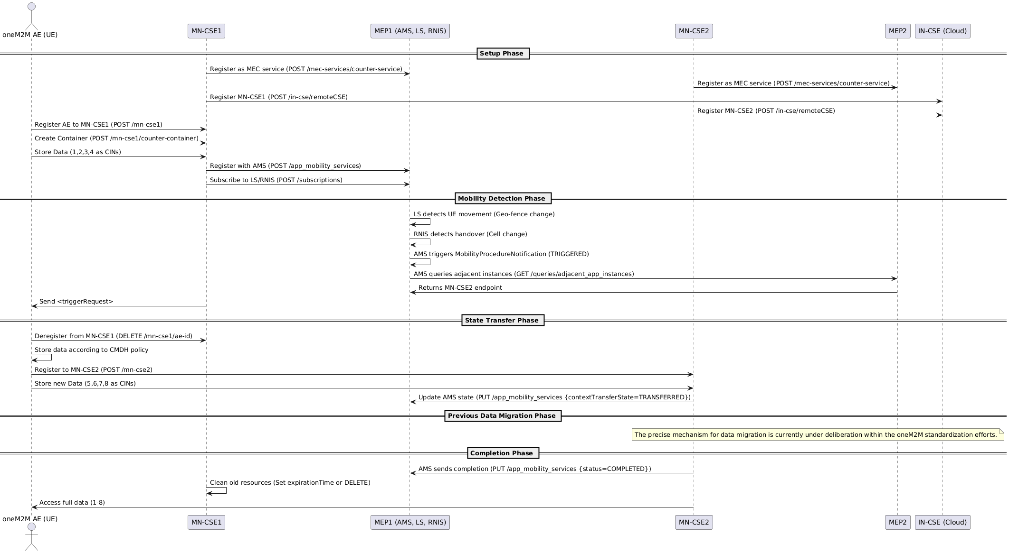

---/dev/null
+++b/media/Handover_snsdemo.png
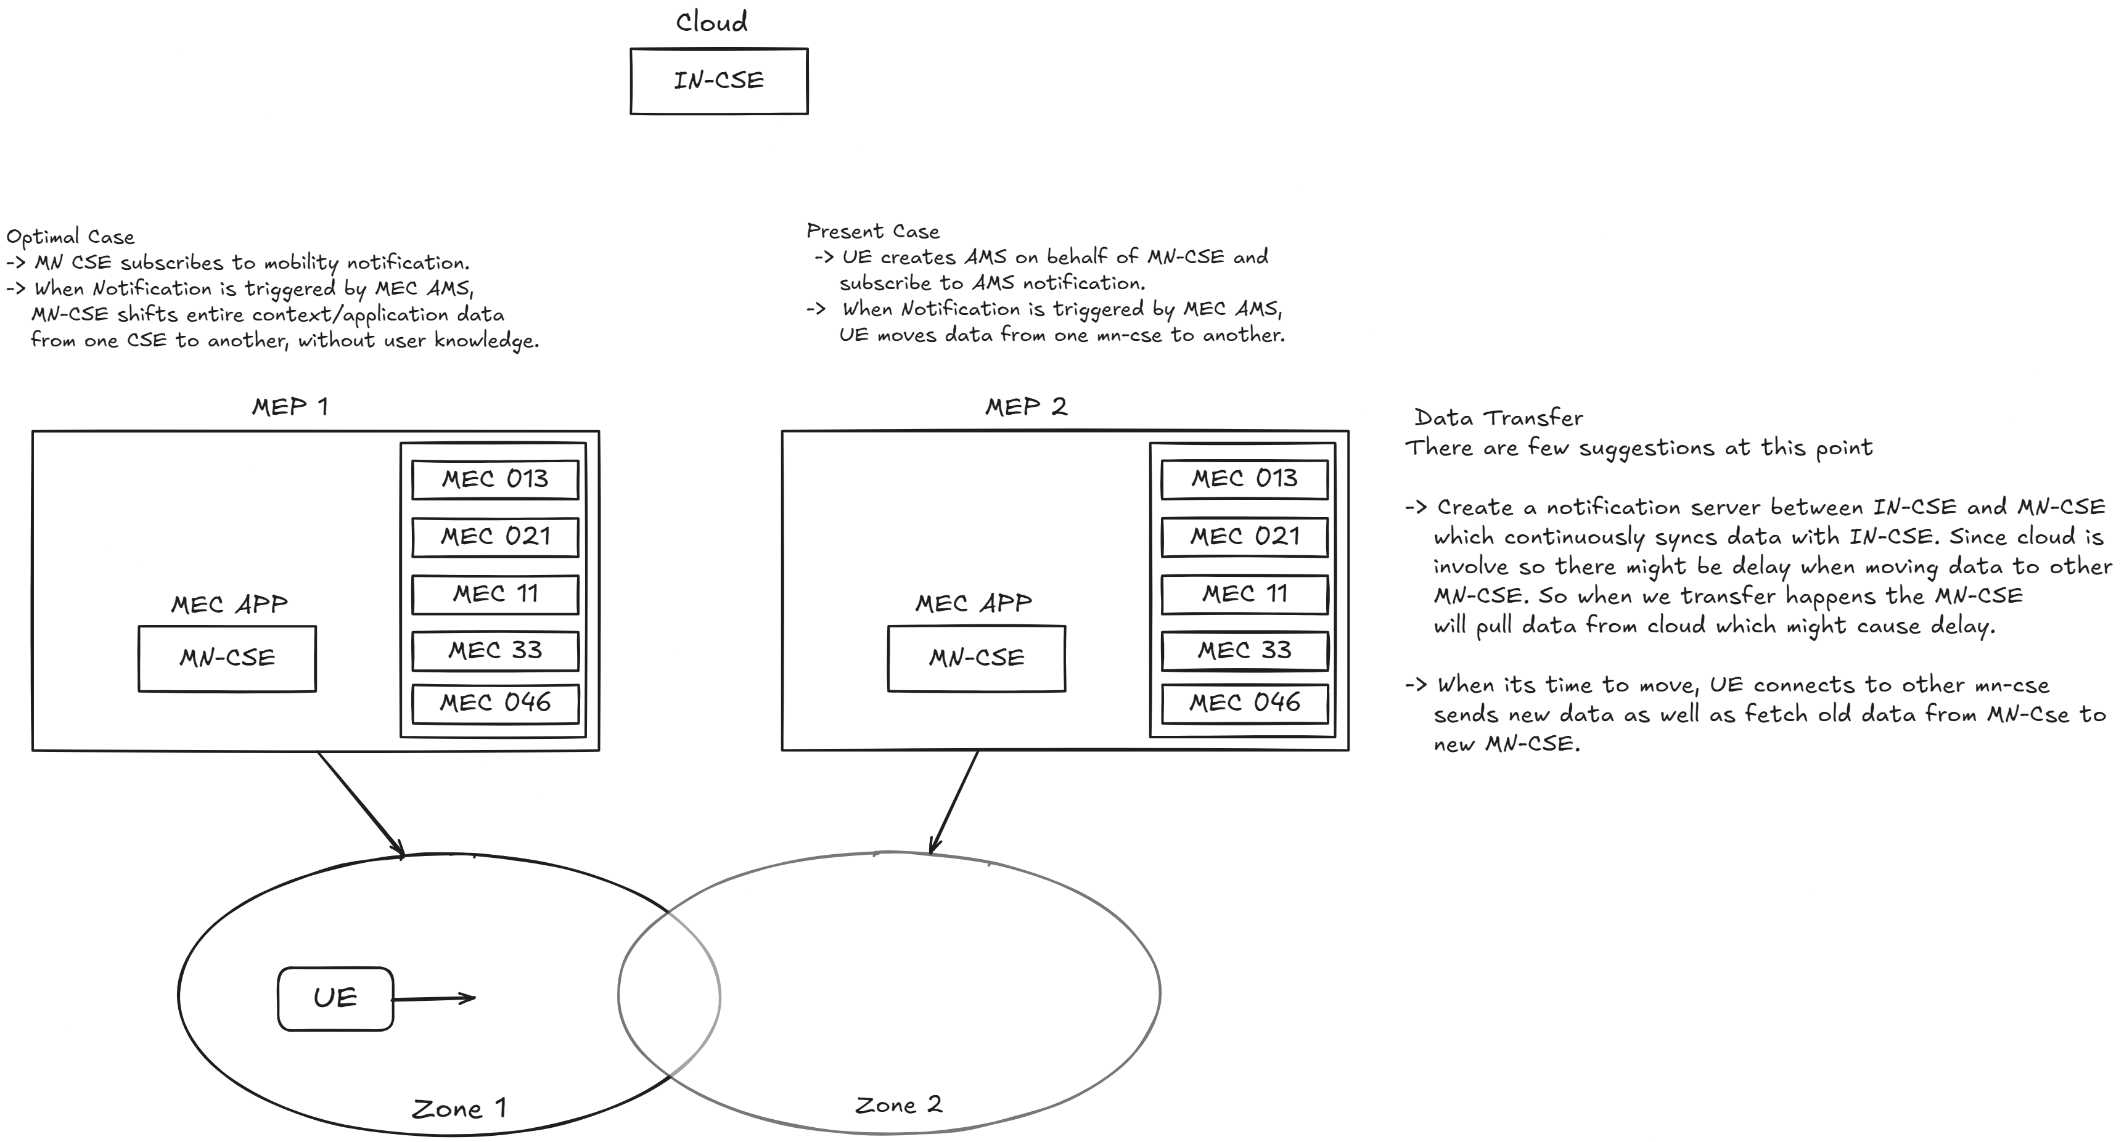

---/dev/null
+++b/media/VM_architecture.png
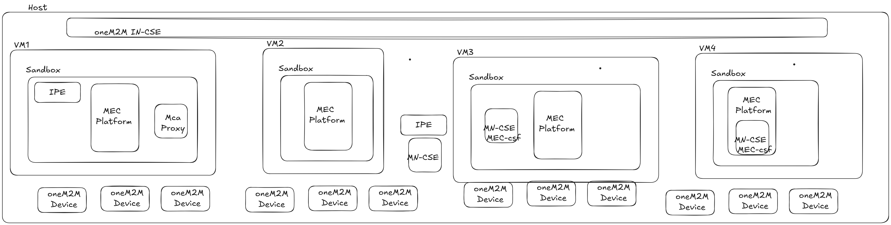

---/dev/null
+++b/media/handover_7_2_1.png
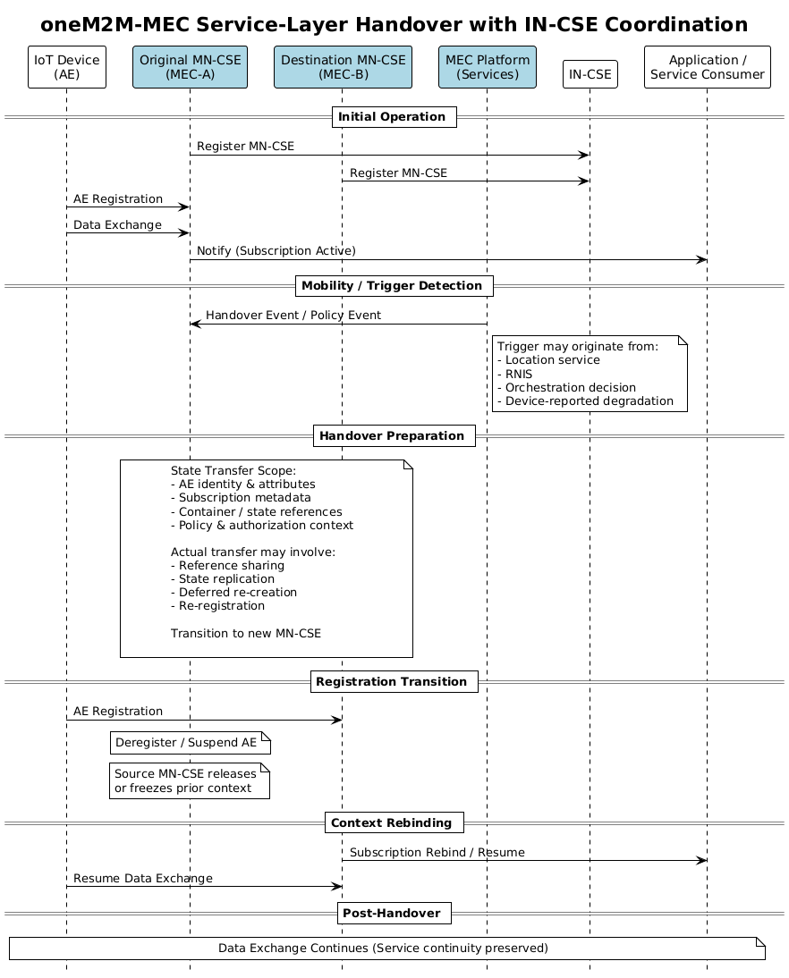

---/dev/null
+++b/media/handover_7_2_1_1.png
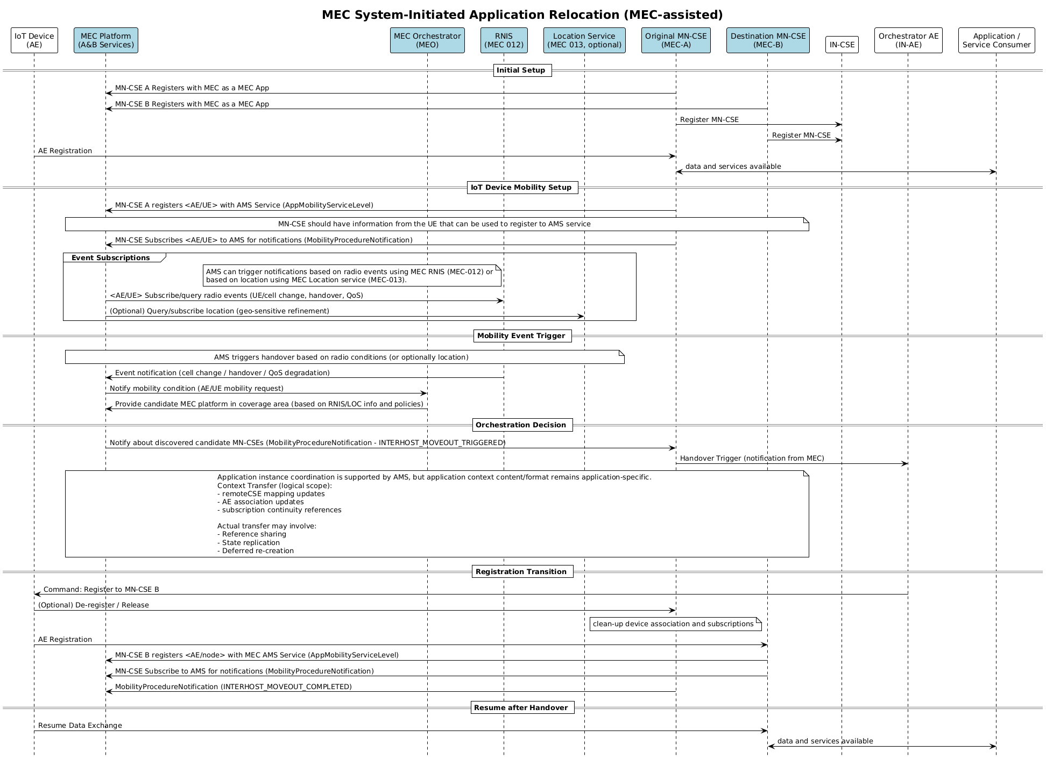

---/dev/null
+++b/media/handover_7_2_1_2.png
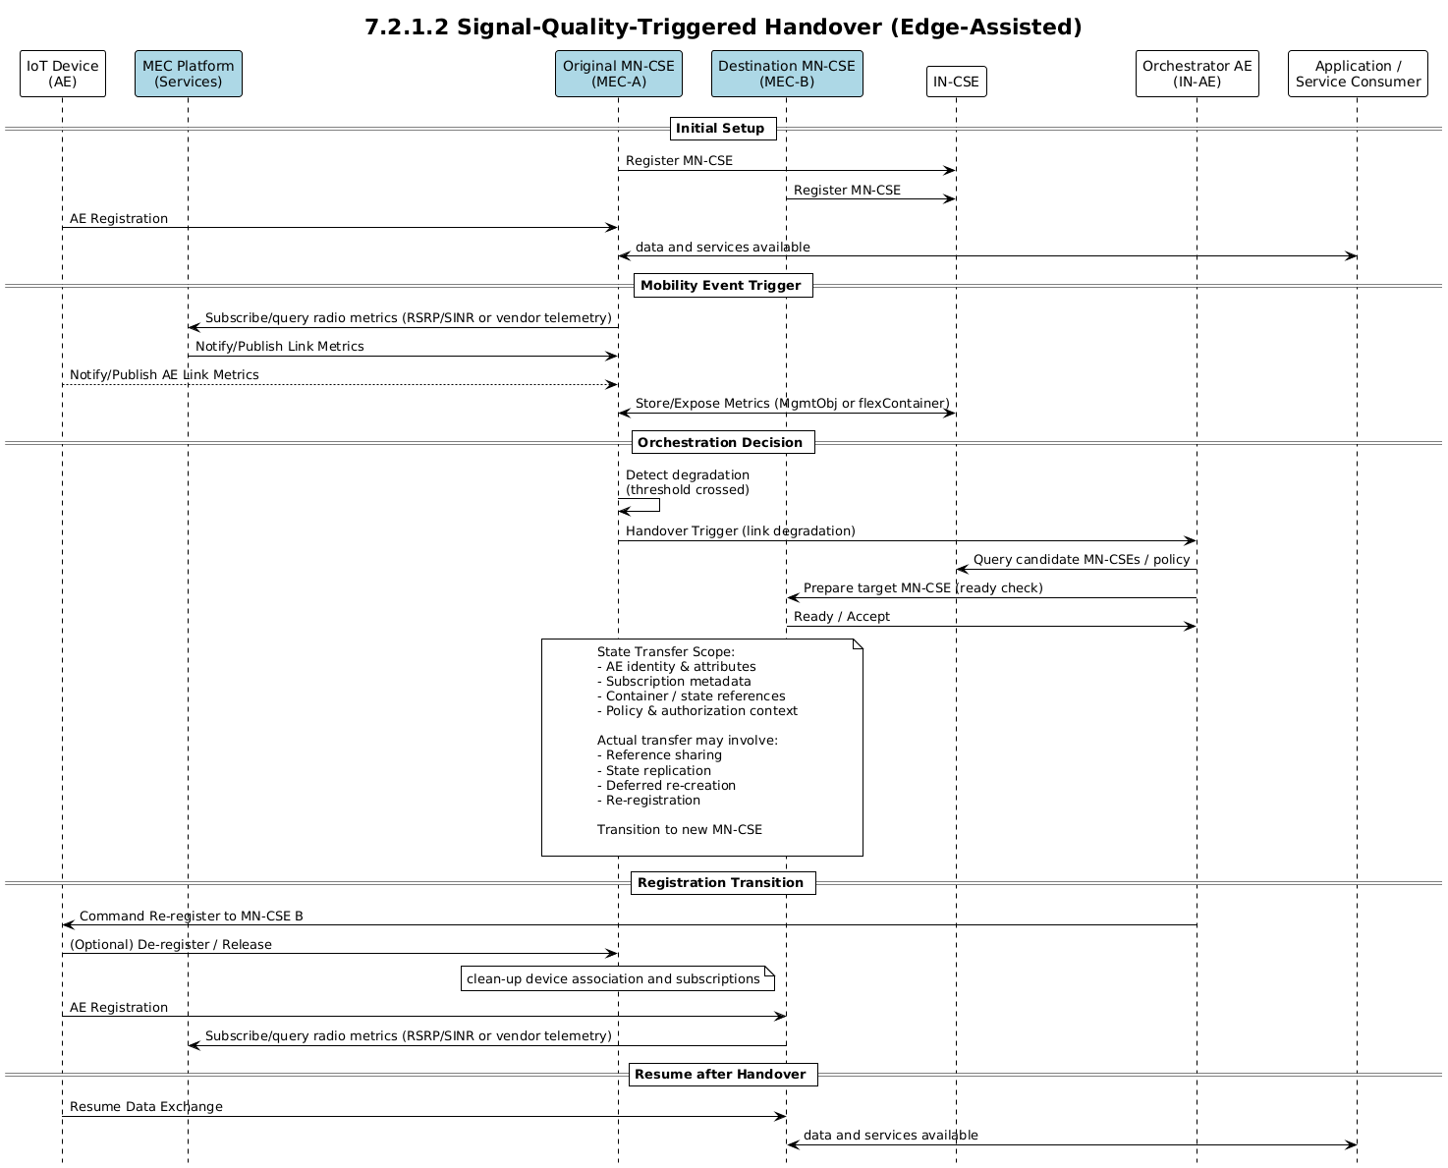

---/dev/null
+++b/media/handover_7_2_1_3.png
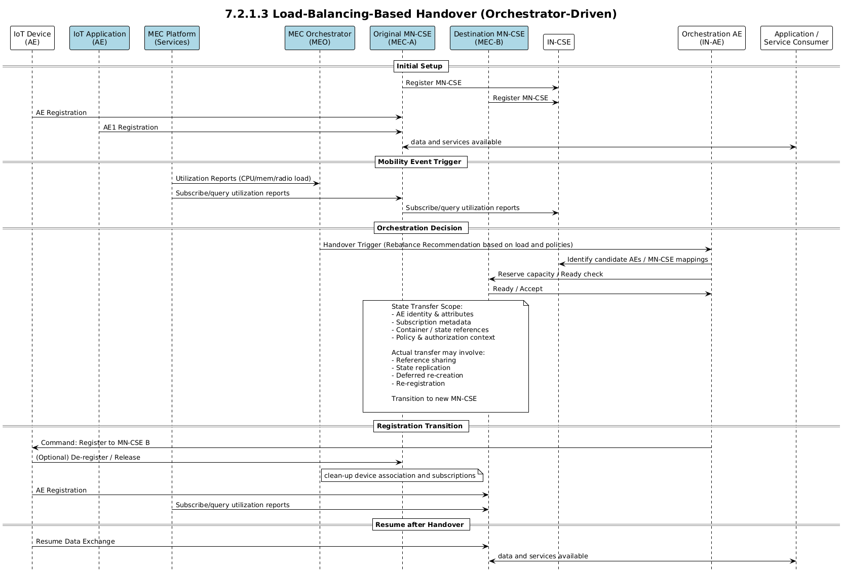

---/dev/null
+++b/media/handover_7_2_1_4.png
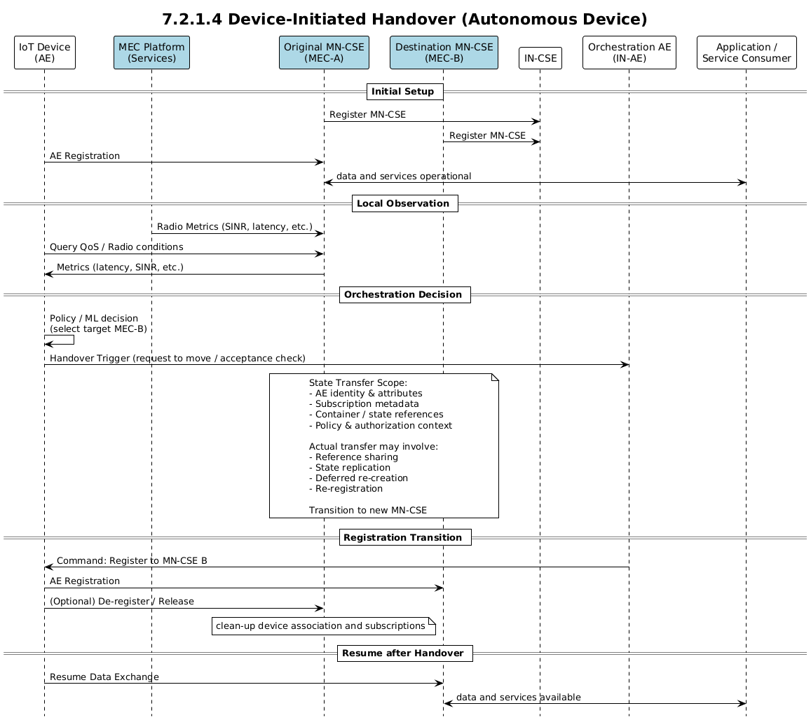

---/dev/null
+++b/media/handover_7_2_1_5.png
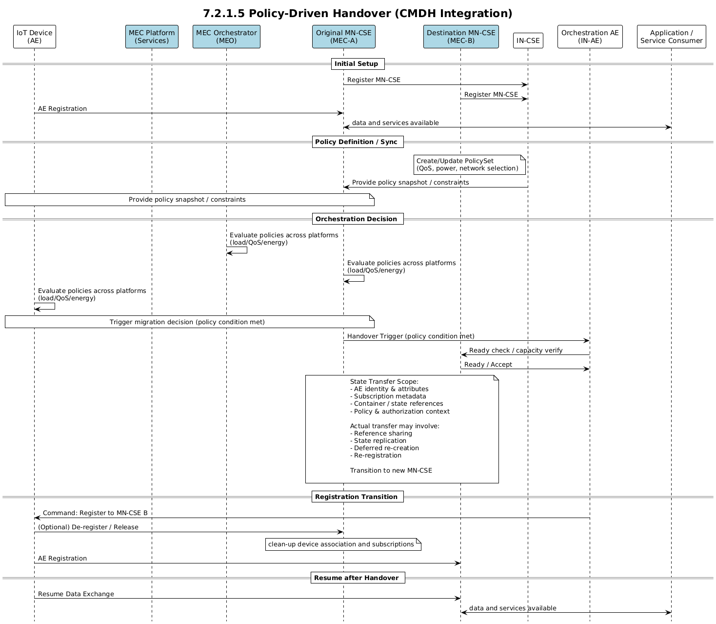

---/dev/null
+++b/media/handover_7_2_1_6.png
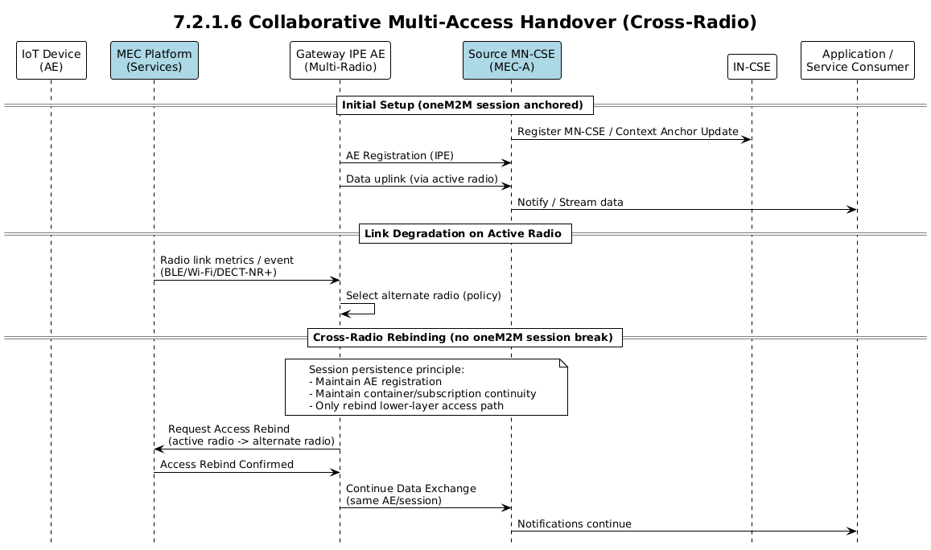

---/dev/null
+++b/media/handover_7_2_2_1.png
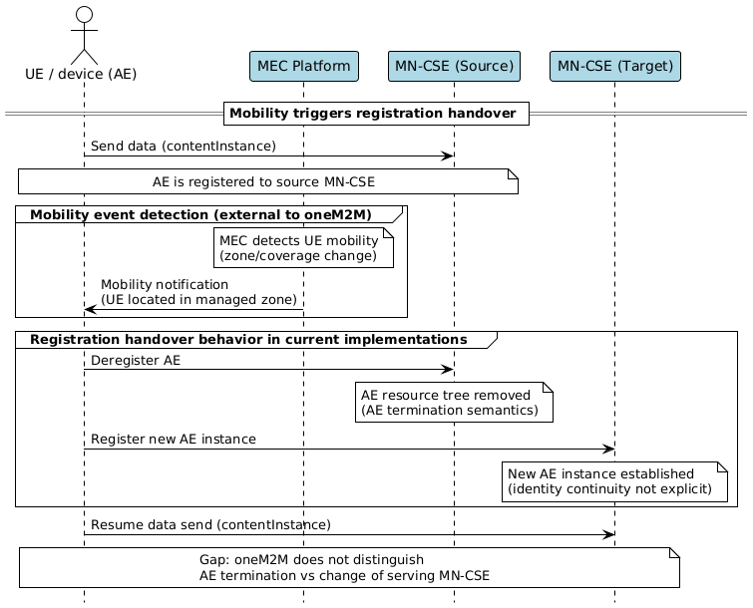

---/dev/null
+++b/media/handover_7_2_2_2.png
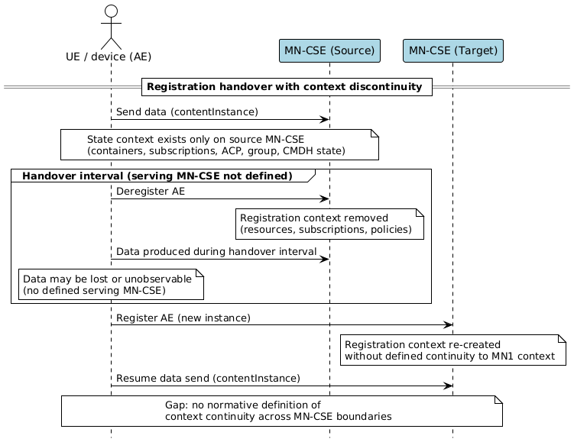

---/dev/null
+++b/media/handover_7_2_2_3.png
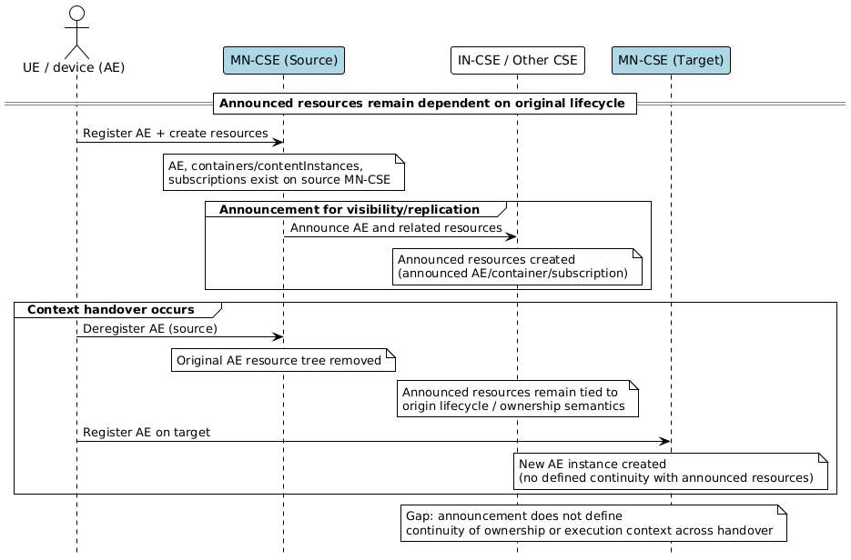

---/dev/null
+++b/media/handover_7_2_2_4.png
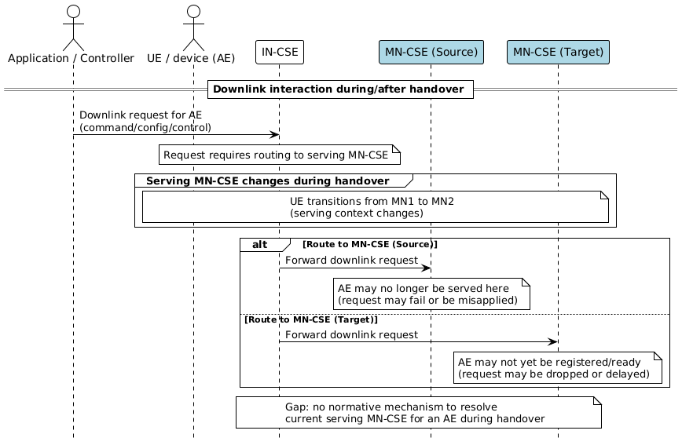

---/dev/null
+++b/media/handover_7_2_2_5.png
