
oneM2M
Technical Report
Document Number | oneM2M-TR-0077-V-0.2.0
Document Name: | oneM2M and MEC integartion scenario and mechanisms
Date: | <2025-09-29>
Abstract: | < An abstract of the document and information that may be used in subsequent electronic searches>
Template Version: January 2020 (Do not modify)
The present document is provided for future development work within oneM2M only. The Partners accept no liability for any use of this report.
The present document has not been subject to any approval process by the oneM2M Partners Type 1. Published oneM2M specifications and reports for implementation should be obtained via the oneM2M Partners’ Publications Offices.
About oneM2M
The purpose and goal of oneM2M is to develop technical specifications which address the need for a common M2M Service Layer that can be readily embedded within various hardware and software, and relied upon to connect the myriad of devices in the field with M2M application servers worldwide.
More information about oneM2M may be found at: http//www.oneM2M.org
Copyright Notification
- 2025, oneM2M Partners Type 1.
All rights reserved.
The copyright and the foregoing restriction extend to reproduction in all media.
Notice of Disclaimer & Limitation of Liability
The information provided in this document is directed solely to professionals who have the appropriate degree of experience to understand and interpret its contents in accordance with generally accepted engineering or other professional standards and applicable regulations. No recommendation as to products or vendors is made or should be implied.
NO REPRESENTATION OR WARRANTY IS MADE THAT THE INFORMATION IS TECHNICALLY ACCURATE OR SUFFICIENT OR CONFORMS TO ANY STATUTE, GOVERNMENTAL RULE OR REGULATION, AND FURTHER, NO REPRESENTATION OR WARRANTY IS MADE OF MERCHANTABILITY OR FITNESS FOR ANY PARTICULAR PURPOSE OR AGAINST INFRINGEMENT OF INTELLECTUAL PROPERTY RIGHTS. NO oneM2M PARTNER TYPE 1 SHALL BE LIABLE, BEYOND THE AMOUNT OF ANY SUM RECEIVED IN PAYMENT BY THAT PARTNER FOR THIS DOCUMENT, WITH RESPECT TO ANY CLAIM, AND IN NO EVENT SHALL oneM2M BE LIABLE FOR LOST PROFITS OR OTHER INCIDENTAL OR CONSEQUENTIAL DAMAGES. oneM2M EXPRESSLY ADVISES ANY AND ALL USE OF OR RELIANCE UPON THIS INFORMATION PROVIDED IN THIS DOCUMENT IS AT THE RISK OF THE USER.

Contents
1 Scope
2 References
2.1 Normative references
2.2 Informative references
3 Definition of terms, symbols and abbreviations
3.1 Terms
3.2 Symbols
3.3 Abbreviations
4 Conventions
5 Introduction to Interworking with ETSI MEC
5.1 Deploying oneM2M with ETSI MEC
5.1.1 Option A
5.1.2 Option B
5.1.3 Option C
5.1.4 Option D
5.2 Additional services to be deployed
5.2.1 Swarm Computing Services
[5.2.2 Federated Learning Services]
6 Potential impacts for Interworking with ETSI MEC
6.1 Architecture for oneM2M and MEC
6.1.1 ETSI MEC IPE
6.1.2 3rd Party IPE
6.1.3 Mca Proxy
6.1.4 Swarm Compute AE
6.1.5 Federated Learning AE
6.1.6 3rd Party IPE MN-AE
6.1.7 MEC CSF
6.1.8 Swarm Computing CSF
6.1.9 Federated Learning CSF
6.1.10 oneM2M CSE as MEC Service
6.2 Orchestration of oneM2M CSE’s and MEC platforms
6.3 Handover of IoT devices to oneM2M/MEC platforms
6.4 oneM2M/MEC support of swarm computing
6.5 oneM2M and MEC support for federated Learning
7 Potential solutions for Interworking with ETSI MEC
[7.1 feature/services using oneM2M with ETSI MEC]
7.1.1 Description
[7.1.2 Feature Gap Analysis]
[7.1.3 Key Issues and requirements]
[7.1.4 Solution #n]
7.1 Registration of oneM2M to ETSI MEC
7.1.1 Description
[7.1.2 Feature Gap Analysis]
[7.1.3 Key Issues and requirements]
[7.1.4 Solution 1: Registering IPE AE]
[7.1.5 Solution 2: Registering IN-CSE to MEC hosted IPE AE]
[7.1.6 Solution 3: Registering MN-CSE to MEC on separate platform]
[7.1.7 Solution 4: Registering MN-CSE as MEC application]
[7.1.8 Solution 5: Integrating oneM2M as a MEC service]
7.2 Transfer registration from oneM2M host on a first MEC platform to another second MEC Platform
7.2.1 Description
7.2.2 Feature Gap Analysis
7.2.3 Key Issues and requirements
7.2.4 Solution #n
7.3 Coordinate Federated Learning
7.3.1 Description
7.3.2 Feature Gap Analysis
7.3.3 Key Issues and requirements
7.3.4 Solution #n
7.4 Coordinate Swarm computing
7.4.1 Description
7.4.2 Feature Gap Analysis
7.4.3 Key Issues and requirements
7.4.4 Solution #n
[Proforma copyright release text block]
[Annexes]
[Annex <A>:Title of annex]
[Annex <B>:Title of annex]
[ First clause of the annex]
B.1.1 First subdivided clause of the annex
[Annex <y>:Bibliography]
History

1 Scope
The present document …
EXAMPLE: The present document provides the necessary adaptions to the endorsed document.
The Scope shall not contain requirements.

2 References
The following text block applies.
References are either specific (identified by date of publication and/or edition number or version number) or nonspecific. For specific references,only the cited version applies. For non-specific references, the latest version of the referenced document (including any amendments) applies.

2.1 Normative references
As a Technical Report (TR) is entirely informative it shall not list normative references.
The following referenced documents are necessary for the application of the present document.
Not applicable.

2.2 Informative references
Clause 2.2 shall only contain informative references which are cited in the document itself.
The following referenced documents are not necessary for the application of the present document but they assist the user with regard to a particular subject area.
- [i.1] oneM2M Drafting Rules https://member.onem2m.org/static_Pages/others/Rules_Pages/oneM2M-Drafting-Rules-V1%202%202.doc

3 Definition of terms, symbols and abbreviations
Delete from the above heading the word(s) which is/are not applicable.

3.1 Terms
Clause numbering depends on applicability.
- A definition shall not take the form of, or contain, a requirement.
- The form of a definition shall be such that it can replace the term in context. Additional information shall be given only in the form of examples or notes (see below).
- The terms and definitions shall be presented in alphabetical order.
For the purposes of the present document, the [following] terms and definitions [given in … and the following] apply:
Definition format
<defined term>: <definition>
If a definition is taken from an external source, use the format below where [N] identifies the external document which must be listed in Section 2 References.
<defined term>[N]: <definition>
example 1: text used to clarify abstract rules by applying them literally
NOTE: This may contain additional information.

3.2 Symbols
Clause numbering depends on applicability.
For the purposes of the present document, the [following] symbols [given in … and the following] apply:
Symbol format
&lt;symbol> &lt;Explanation>
&lt;2nd symbol> &lt;2nd Explanation>
&lt;3rd symbol> &lt;3rd Explanation>

3.3 Abbreviations
Abbreviations should be ordered alphabetically.
Clause numbering depends on applicability.
For the purposes of the present document, the [following] abbreviations [given in … and the following] apply:
Abbreviation format
&lt;ABBREVIATION1> &lt;Explanation>
&lt;ABBREVIATION2> &lt;Explanation>
&lt;ABBREVIATION3> &lt;Explanation>

4 Conventions
The key words “Shall”, “Shall not”, “May”, “Need not”, “Should”, “Should not” in this document are to be interpreted as described in the oneM2M Drafting Rules [i.1]

5 Introduction to Interworking with ETSI MEC
Interworking oneM2M with ETSI MEC aims to add capabilities that enable hosting a (potentially more than one) oneM2M CSE as well as IPE AE’s (as needed) on an edge platform. This will allow oneM2M to leverage recent capabilities that focus on edge platforms that can perform complex processing and reduce end-to-end latency and throughput. The document describes services that are exposed by ETSI MEC and additional new features that are defined to offer enhanced services from oneM2M and ETSI MEC.

5.1 Deploying oneM2M with ETSI MEC
The services in this clause are fundamentally based on an edge computing compliant deployment, where oneM2M and ETSI MEC platforms are central to the architecture. Such an integration can consider several deployment options, each presenting distinct technical and business implications. In June 2023, oneM2M and ETSI MEC collaboratively developed a white paper titled “Enabling Multi-access Edge Computing in Internet-of-Things: how to deploy ETSI MEC and oneM2M.” [i.15] This white paper proposes four distinct deployment options for how oneM2M and MEC can be integrated and operated.

5.1.1 Option A
oneM2M CSE is deployed in a cloud platform and MEC in an Edge platform. This deployment scenario positions the IoT platform itself primarily on the cloud side, with MEC functioning at the edge. It represents one of the most common deployment configurations for cloud-based IoT platforms integrating with edge computing. While it allows for some benefits of edge computing through localized network and processing, it doesn’t fully leverage the advantages of a 100% edge computing environment, as the cloud remains the ultimate endpoint for data storage and management.
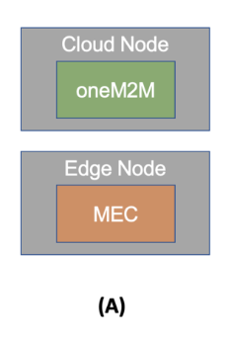
Deployment A

5.1.2 Option B
oneM2M CSE and MEC as Edge Nodes hosted on different physical Nodes. In this option, both oneM2M and MEC are deployed as edge nodes, but they reside on physically separate edge hardware. Compared to Option A, this setup allows for all data and information exchange between oneM2M and MEC to be performed locally at the edge, resulting in faster processing. Despite oneM2M IoT service providers and ETSI MEC entities potentially being distinct, this scenario is viable, particularly in the nascent stages of the edge computing market.
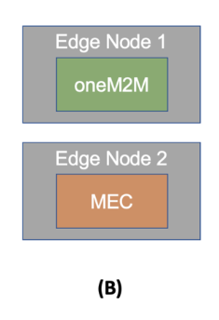
Deployment B

5.1.3 Option C
oneM2M and MEC are deployed on the same physical Edge Node. This scenario involves the oneM2M and MEC platforms being installed and operated on the very same physical edge node. This co-location can significantly enhance service performance by eliminating unnecessary data and information exchange between separate nodes. Implementing this option typically necessitates a Service Level Agreement (SLA) between the respective platform providers, and both platforms must support dynamic deployment capabilities across various edge nodes.
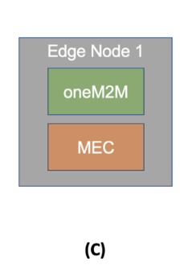
Deployment C

5.1.4 Option D
oneM2M and ETSI MEC are tightly coupled within the same edge node. This represents the deepest level of integration, where oneM2M and MEC platforms are physically coupled, often through direct API-level interworking. In this setup, the oneM2M platform can be recognized and function as an MEC application, fully leveraging all services and functions provided by the MEC environment to deliver a truly 100% edge computing solution. Conversely, the MEC platform can directly offer data source, processing, and multi-access networking capabilities by hosting oneM2M as an integrated application. Achieving this level of tight coupling necessitates the development of standard documents defining clear interoperability and interworking specifications between the oneM2M and ETSI MEC platforms.
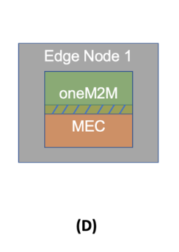
Deployment D

5.2 Additional services to be deployed

5.2.1 Swarm Computing Services
Architecture using oneM2M and ETSI MEC ### 5.2.2 Federated Learning Services Architecture using oneM2M and ETSI MEC

6 Potential impacts for Interworking with ETSI MEC

6.1 Architecture for oneM2M and MEC
Clause 5.1 describes the four deployment options for oneM2M and MEC integration. These options range from deploying oneM2M in a cloud platform with MEC at the edge (Option A) to tightly coupling oneM2M and MEC within the same edge node (Option D). Each option presents different technical and business implications, with varying degrees of integration and performance benefits.
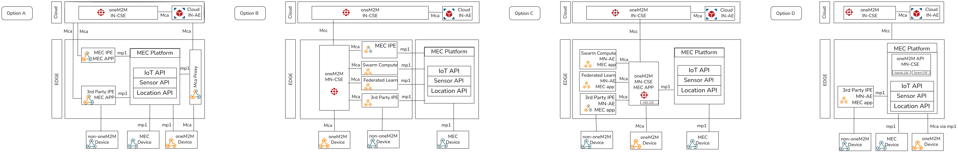
Four architectures
This clause looks at each of the deployments and identifies the unique components involved in integration of oneM2M and ETSI MEC. These 4 deployment options are reflected in the following diagram with components that are needed to implement each deployment. This clause will identify the components and then solutions that are needed to be implemented will be described in clause 7.

6.1.1 ETSI MEC IPE
Define a MEC Interworking Proxy Entity (IPE) that acts as a bridge between the MEC and oneM2M environments, facilitating seamless communication and data exchange. The MEC IPE may deployed as a MEC application that is hosted on the MEC platform or some other platform.
- The MEC IPE will follow existing oneM2M IPE (TS-0033 IPE) principles to convert data that comes from devices that use the MEC APIs to a oneM2M resource structure.
- The MEC IPE will operate as a MEC application and register to the MEC platform.
- The MEC IPE will support the discovery of MEC services and capabilities exposed by the MEC platform.
- The MEC IPE may discover and provision devices that are connected to the MEC platform.
This is shown in deployment option A and B.

6.1.2 3rd Party IPE
Define a 3rd Party Interworking Proxy Entity (IPE) that allows external applications or services to interact with the oneM2M and MEC environments. This IPE can be used to extend the capabilities of the MEC platform by integrating with external systems. - The 3rd Party IPE will follow existing oneM2M IPE (TS-0033 IPE) principles to convert data that comes from external applications to a oneM2M resource structure. - The 3rd Party IPE will operate as a MEC application and register to the MEC platform. - The 3rd Party IPE may also provide additional functionality, such as data aggregation or analytics, to leverage the capabilities of the MEC platform.
This is shown in deployment option A.

6.1.3 Mca Proxy
Define a Mca Proxy that enables communication between oneM2M devices and the registered CSE. This component is needed to facilitate communication between oneM2M devices where there is no direct connection to the IN-CSE. In the oneM2M architecture devices communicate with CSEs using the Mca reference point, however devices cannot directly communicate with other oneM2M applications or devices. A new component is needed to facilitate this communication. - The Mca Proxy is implemented as an MEC Application. - The Mca Proxy will facilitate communication between oneM2M devices and the registered CSE by acting as an intermediary. - The Mca Proxy may also provide additional functionality, such as security processing or provisioning.
This is shown in deployment option A.

6.1.4 Swarm Compute AE
Define a Swarm Compute Application Entity (AE) that enables swarm computing capabilities within the oneM2M and MEC environments. This AE will facilitate the coordination and management of multiple devices working together to perform complex tasks. - The Swarm Compute AE will be implemented as a MEC application and register to the MEC platform. - The Swarm Compute AE will support the orchestration and management of swarm computing tasks across multiple devices. - The Swarm Compute AE will leverage MEC services and capabilities to enhance the performance and efficiency of swarm computing operations.
This is shown in deployment option B.

6.1.5 Federated Learning AE
Define a Federated Learning Application Entity (AE) that enables federated learning capabilities within the oneM2M and MEC environments. This AE will facilitate the coordination and management of multiple devices working together to perform distributed machine learning tasks. - The Federated Learning AE will be implemented as a MEC application and register to the MEC platform. - The Federated Learning AE will support the orchestration and management of federated learning tasks across multiple devices. - The Federated Learning AE will leverage MEC services and capabilities to enhance the performance and efficiency of federated learning operations.
This is shown in deployment option B.

6.1.6 3rd Party IPE MN-AE
Define a 3rd Party IPE (MN-AE) that acts as an intermediary between non-oneM2M devices and the oneM2M architecture. This IPE will facilitate the interaction between non-oneM2M devices and oneM2M applications by converting data formats and managing communication protocols. The difference between the 3rd Party IPE (MN-AE) and the 3rd Party IPE (MEC APP) is that it is not managed by the MEC platform. (see 6.1.4) - The 3rd Party IPE (MN-AE) will follow existing oneM2M IPE (TS-0033 IPE) principles to convert data that comes from non-oneM2M devices to a oneM2M resource structure. - The 3rd Party IPE (MN-AE) will register to the MEC platform. - The 3rd Party IPE (MN-AE) will support the discovery of services and capabilities exposed by the MEC platform.
This is shown in deployment option B.

6.1.7 MEC CSF
Define a MEC Common Service Framework (CSF) that provides a set of common services and APIs for MEC applications. The MEC CSF will enable seamless integration and interoperability between MEC applications and oneM2M services. - The MEC CSF will be registered to the MEC platform. - The MEC CSF will leverage MEC services and capabilities to enhance the performance and efficiency of registered devices. - The MEC CSF will provide a unified API for oneM2M applications to access MEC services.
This is shown in deployment option C.

6.1.8 Swarm Computing CSF
Define a Swarm Computing Common Service Framework (CSF) that provides a set of common services and APIs for swarm computing applications. The Swarm Computing CSF will enable seamless integration and interoperability between swarm computing applications and oneM2M services. - The Swarm Computing CSF will provide a unified API for oneM2M applications to access swarm computing services.
This is shown in deployment option D.

6.1.9 Federated Learning CSF
Define a Federated Learning Common Service Framework (CSF) that provides a set of common services and APIs for federated learning applications. The Federated Learning CSF will enable seamless integration and interoperability between federated learning applications and oneM2M services. - The Federated Learning CSF will provide a unified API for oneM2M applications to access federated learning services.
This is shown in deployment option D.

6.1.10 oneM2M CSE as MEC Service
Define a oneM2M CSE that is deployed as a MEC service. This CSE will be tightly integrated with the MEC platform, allowing it to leverage MEC services and capabilities to enhance its performance and efficiency.
This is shown in deployment option D.

6.2 Orchestration of oneM2M CSE’s and MEC platforms
When using a oneM2M and MEC edge platform the deployments include multiple oneM2M/MEC instances. This clause describes needed features for the management, orchestration and federation of edge platforms that include a oneM2M MN-CSE and the ETSI MEC platform. The federation and orchestration framework will explore the existing APIs for discovery and resource management principles defined in both standards, while proposing extensions to them with federation and synchronization capabilities. Before orchestrating handover, swarm computing, or federated learning mechanisms, MEC/oneM2M instances must be able to discover, register, and organize themselves into collaborative groups:
- Instances Registration: MEC/oneM2M nodes (e.g., IN-CSE, MN-CSE, MEC Platform, MEC Host, etc.) should be able to register to a federation registry, that may include its identity, capabilities, and available services.
- Instances Discovery: MEC/oneM2M nodes should be able to advertise its capabilities through standard discovery mechanisms (e.g., oneM2M Discovery resource, MEC location, etc.). This might be achieved by publishing metadata about the MEC/oneM2M node’s processing power, storage capabilities, network connectivity, and supported APIs.
- Instances Federation: once discovered, MEC/oneM2M instances can be logically grouped into a federation group. Such a group might be a collection of MEC/oneM2M instances that are allowed to intercommunicate and cooperate in executing distributed tasks. Federation groups could be defined based on geographic proximity, application domain or QoS requirements.
- Roles Assignment: based on their capabilities, the MEC/oneM2M nodes could be selected for specific roles such as handover anchor, swarm computing worker or federated learning participant. For the instance, MEC/oneM2M nodes with high processing power and storage capacity could be selected for swarm computing and federated learning training tasks, while nodes with good connectivity could be used for handover, service continuity and low-latency communications.
Therefore, the orchestration framework should:
- Implement resource replication mechanisms to mirror or move device/application registration between MN-CSE instances or IN-CSE or across MEC hosts including the reference criteria for doing that.
- Ensure a handover-safe mechanism for migrating subscriptions (first establish a new subscription and then terminate the old one).
- Establish synchronization mechanisms between MN-CSE and IN-CSE to ensure that the recent device states are propagated upward and historical data are migrated asynchronous, when necessary.
- Identify and discover MEC/oneM2M instances from logical federation group.
- Match available resources (e.g., storage, compute, connectivity, etc.) with service requirements (e.g., handover, swarm computing or federated learning).
- Assign tasks to federation nodes.
- Keep registrations, subscriptions, and data synchronized across MN-CSEs/IN-CSEs and MEC nodes.
- Continuously monitor nodes performances and workload by reassigning tasks or triggering handover when needed.
The orchestration framework should create a federated, service-aware, and resource-optimized environment where ETSI MEC and oneM2M instances jointly deliver advanced distributed computing and IoT data management, by addressing handover continuity, swarm scalability, and federated learning privacy. It may also support dynamic service discovery and registration, load balancing across multiple instances, and failover and redundancy mechanisms.

6.3 Handover of IoT devices to oneM2M/MEC platforms
The Handover mechanism refers to the process of transferring control of a device or service from one MEC/oneM2M instance to another, ensuring seamless connectivity and service continuity. There three main scenarios where handover is essential: - Optimizing the connection of wireless IoT devices as they move geographically, ensuring they remain connected to the most appropriate edge node. - Maintenance of services or servers that need to be migrated between MEC/oneM2M instances due to load balancing, resource optimization, or fault tolerance. - Emergency scenarios where rapid handover is required to maintain service continuity during network disruptions or failures, such as a failure of an edge node or a sudden surge in demand.
This process, illustrated in Figure 6.3.1, is critical when devices move between different edge nodes or when services must be migrated to maintain low latency, reliability, and high availability.
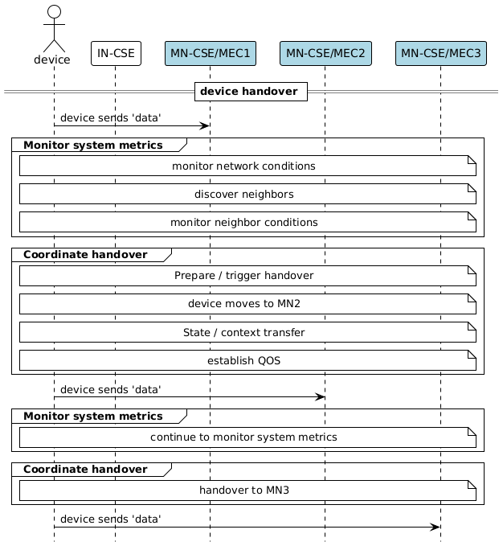
Fig 6.3.1
Fig 6.3.1 IoT device handover Depending on system design and device capability, handover control can follow one of two approaches:
- Device-controlled handover: The device itself detects conditions that trigger a handover (e.g., deteriorating radio quality, mobility, policy changes). It initiates discovery, re-registration, and session updates with the target MEC/oneM2M instance. This approach offers autonomy but assumes the device has sufficient resources to evaluate conditions, make decisions, and handle signaling.
- Network-controlled handover: The MEC/oneM2M infrastructure (e.g., MN-CSEs or gateways) monitors device connectivity and system load, then initiates or enforces a handover. The device simply follows the instructions (e.g., re-register to a new MN-CSE) without needing complex logic or extensive signaling capability. This approach could be suitable for constrained IoT devices with limited processing or decision-making capacity.
In practice, the chosen strategy should balance device capability, network intelligence, and the requirements of the application domain. For resource-constrained IoT devices, offloading decision-making to the MEC/oneM2M layer may reduce device complexity and power usage, while device-controlled handovers may provide faster reaction times and greater autonomy in heterogeneous deployments. To design an effective handover mechanism, the following high-level considerations should be addressed:
- Identity & Security: The device must maintain a consistent identity across MEC/oneM2M instances, with fast and secure re-authentication (e.g., token-based methods). Security credentials and keys should be managed automatically to ensure a smooth transition.
- Session & State Continuity: Handover must preserve session continuity and data consistency. This includes mechanisms for state replication (buffers, acknowledgments, sequence numbers), subscription reinstatement, downlink catch-up, and, where possible, context transfer of QoS or profiles between gateways.
- Performance & Latency: Interruptions must be minimized with well-defined handover budgets (e.g., ≤200 ms for critical telemetry). Local buffering, ordering policies, duplicate suppression, and time synchronization help maintain low latency and reliable delivery.
- Network Awareness & Adaptation: The mechanism should leverage network conditions such as bandwidth, signal strength, and congestion when selecting target gateways. Neighbour awareness, proactive discovery, and policy-based triggers (RSSI/SNR thresholds, cost/latency trade-offs) are key to ensuring optimal handover decisions. Admission control policies must also be considered, allowing gateways to accept or defer connections gracefully.
- Monitoring & Reliability: System reliability depends on the ability to measure and manage handovers. KPIs such as attach/authentication time, packet loss, and latency deltas should be tracked. Tracing, alarms for frequent or failed handovers, and robust retry/backoff logic ensure stability and resilience.
- Device Constraints & Efficiency: IoT devices, often resource- or power-constrained, require lightweight solutions. Gateway-local registrations can reduce complexity, while power-aware scanning and cached neighbour reports minimize RF cost. Feature negotiation and versioned message contracts further improve compatibility and efficiency across heterogeneous deployments.
These considerations will be further analyzed in oneM2M and ETSI MEC.

6.4 oneM2M/MEC support of swarm computing
Swarm Computing refers to the coordination of multiple MEC/oneM2M instances to perform distributed computing tasks, leveraging the capabilities of edge devices and networks. In this paradigm, individual MEC/oneM2M nodes act like members of a swarm, each contributing processing power, storage, connectivity, or sensing capabilities to achieve collective goal. The system operates in a decentralized and adaptive manner, where tasks can be dynamically partitioned, distributed, and recombined across nodes depending on resource availability, network conditions, and application requirements. This enables resilient, scalable, and low-latency processing, as tasks are executed closer to the data sources and devices while ensuring cooperative load balancing, fault tolerance, and energy efficiency. When mapped onto MEC/oneM2M interworking, distributed instances could be implemented as Application Entities (AEs) hosted on Middle Nodes (MNs) or Application Dedicated Nodes (ADNs). In this scenario, local coordination within a swarm could be supported by nearby Common Service Entities (CSEs). In ETSI MEC terms, there can be MEC Services or MEC Applications which provide contextual information aggregated from other swarm nodes. In this clause, the entities involved are described as follows:
- Swarm Agent (Local/Edge): is a software entity running on a device, MEC host, or oneM2M Application Entity that performs local computation and participates in cooperative swarm behavior. It executes subtasks of a global distributed task, shares local state, sensor data, or intermediate results with peers. The local Swarm Agent may run on constrained devices or ADNs, focusing on lightweight processing and sensing, while the Edge Swarm Agent may run on MEC hosts or MNs, handling more complex subtasks and acting as a bridge to cloud/federated nodes.
- Swarm Entity: is any participating user or platform (e.g., device, MEC host, AE, MN, or ADN) that contributes computing, storage, or sensing resources to the swarm. It executes assigned subtasks and exchanges state updates with other nodes via oneM2M group communication or MEC APIs.
- Swarm Collector: software (e.g., CSE or MEC host) that aggregates results from multiple swarm nodes and produces a unified output. It collects partial results from distributed swarm nodes, performs aggregation (e.g., fusion of sensor data), and provides the final output back to the orchestrator, applications, or end-users.
- Swarm Orchestrator: is the central coordination entity of the swarm that manages task distribution, resource allocation, synchronization, resilience, and policy enforcement. It splits global tasks into subtasks, assigns subtasks to swarm nodes based on capacity, connectivity, and energy, detects node failures and reassigns tasks, and ensures QoS, latency, energy, and fault-tolerance goals. It may operate centrally (e.g., cloud IN-CSE) or decentrally (e.g., at MEC/MN-CSE) depending on deployment.
Consistent with the deployment options described in Clause 5, swarm computing may be implemented through the following options:
- Option 1: In this configuration, Swarm Entities ask Swarm Agents to perform local tasks and interact with a Swarm Collector located nearby at the edge. The Swarm Orchestrator coordinates task assignment and resource allocation. Swarm Agents can execute subtasks locally and return intermediate results to the Swarm Collector, which consolidates outputs and sends them back to the Swarm Orchestrator. The Swarm Orchestrator and the Swarm Collector may be co-located or deployed separately on the edge. This option emphasizes low-latency collaboration between distributed Swarm Nodes and is well-suited for scenarios where tasks require real-time responses and localized aggregation as illustrated in Figure 6.4.1.
- 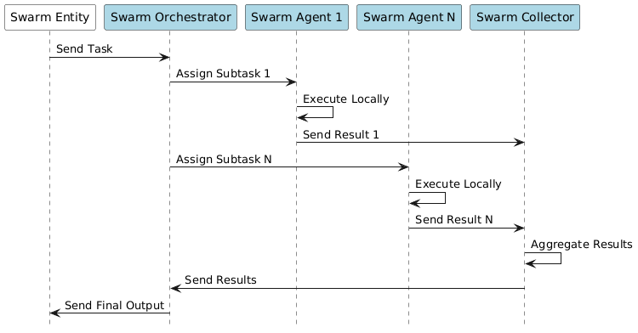
- Fig 6.4.1
Fig 6.4.1 Swarm Computing Implementation - Option 1
- Option 2: Swarm Entities could be resource-constrained devices running lightweight processing. These devices can only execute simple tasks and rely on the Swarm Agents for heavier processing and the Swarm Collector for results aggregation. The Swarm Orchestrator manages tasks’ distribution and offloading policies, ensuring that constrained Swarm Entities are not overloaded. The Swarm Collector aggregates results from multiple Swarm Agents (e.g., deployed on the edge, namely Swarm Agent 1 and Swarm Agent 2) in charge of processing of the different sub-tasks, and returns consolidated outputs. This result is then shared with the Swarm Orchestrator as well as with the Swarm Agent that sent the original request. Finally, the initial Swarm Agent (Local) performs post-processing operations according to the requirements of the initial request, as shown in the Figure 6.4.2. In this option, the Swarm Collector and the Swarm Orchestrator may be co-located on the edge platform..
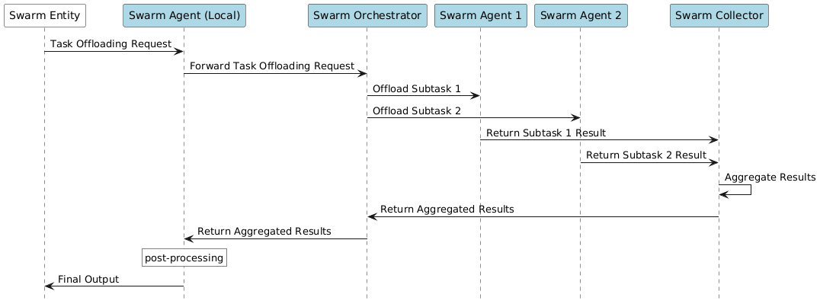
Fig 6.4.2
Fig 6.4.2 Swarm Computing Implementation - Option 2
- Option 3: This option extends orchestration beyond the edge by combining local processing with cloud-level intelligence. Swarm Entities interact with Swarm Agents at the edge (close to the devices) to perform latency-sensitive processing. In addition, the Swarm Collector, located in a more centralized or cloud domain, executes high-level analytics such as large-scale pattern recognition or long-term optimization using datasets that have been previously collected. The Swarm Orchestrator ensures synchronization between local results coming from the Swarm Agent at the edge and global insights from the cloud, as illustrated in Figure 6.4.3. The Swarm Collector (Global) receives the data produced by the Swarm Entity via the Swarm Orchestrator, and then performs application-specific pattern recognition which is shared with the Swarm Entity via the Swarm Orchestrator and the Swarm Agent. This hybrid model leverages the strengths of both edge and cloud: low latency at the edge and high computational power in the cloud, enabling scalable and adaptive swarm intelligence. This option is more application-specific because it divides intelligence between cloud and edge based on the workload. While Options 1 and 2 mainly vary by how close computation is to devices or how much is offloaded, Option 3 requires a split between real-time behavior at the edge and high-level reasoning in a cloud. Therefore, the placement of functions depends on the type of analytics, latency constraints, and data-handling rules of each application.
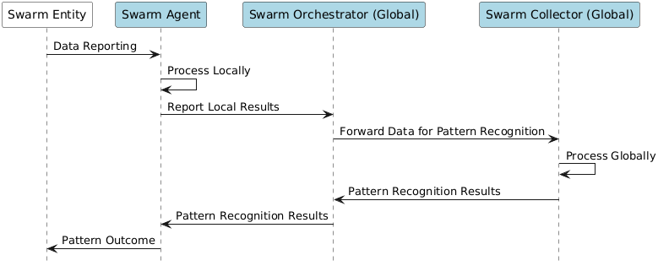
Fig 6.4.3
Fig 6.4.3 Swarm Computing Implementation - Option 3
To allow multiple MEC/oneM2M nodes to collaboratively perform distributed tasks, the orchestration mechanisms should take into account the following aspects:
- Task Decomposition: a global computation task is divided into smaller subtasks. The orchestrator distributes these subtasks to participating MEC/oneM2M nodes based on their declared processing and storage capacity, network connectivity, or CPU/GPU availability.
- Synchronization: appropriate synchronization mechanisms (e.g., publish/subscribe over oneM2M and MEC APIs) should ensure swarm nodes operate on consistent views of data. To maintain consistent swarm knowledge across federated nodes, a distributed state synchronization is required.
- Task offloading: the orchestration mechanism should support task offloading policies where swarm members dynamically delegate high-complexity processing to nearby MEC/oneM2M nodes.
- Resilience: in case of node failures, the orchestrator dynamically reallocates unfinished subtasks to other swarm nodes.
- Coordination and Aggregation: results from swarm nodes are aggregated at a designed MEC host, IN-CSE or MN-CSE which acts as a collector node. The oneM2M’s group communication primitives could be used to coordinate actions across swarm members, while MEC APIs could be used to optimize routing and QoS for tasks exchanges.
The swarm computing orchestrator is the coordinator, load balancer, and fault manager of swarm computing. It does not always execute tasks itself, instead it manages how, where, and when the tasks are executed, ensuring that the swarm MEC/oneM2M nodes behave like a single resilient and adaptive system.

6.5 oneM2M and MEC support for federated Learning
Federated Learning is a distributed machine learning approach in which model training is performed locally on multiple nodes and only model’s parameters or weights, not row data, are exchanged with aggregators. Instead of sending sensitive data to a central location, each node trains a local model using its own data and then shares only the model updates with a central location, which aggregates these updates to improve the global model. This enhances privacy, reduces bandwidth usage, and allows model adaptation close to data sources and IoT devices.
In the MEC/oneM2M interworking context, local training can be executed within Application Entities (AEs) on Middle Nodes (MN-CSE) or even on constrained edge devices, while aggregation roles can be hosted on Infrastructure Nodes CSEs (IN-CSE) in the cloud environment, or on ETSI MEC applications acting as intermediate servers at the edge. ETSI MEC services could provide capabilities such as Location API, Radio Network Information API, or IoT API to enrich local training with contextual features.
In this clause, the entities involved are described as follows:
- FL Client: a participating device or node (e.g., IoT sensor, oneM2M AE, oneM2M MN-CSE, MEC node or application entity) that trains a machine learning model locally using its own private data. It holds raw data (never shared outside the device), performs local model training based on the global model received from the server/aggregator, and sends only model updates/gradients (not raw data) back to the FL Server or Aggregator.
- FL Server: coordinates the training process across all clients by distributing the initial global model, collecting updates, and managing the learning rounds. It selects which clients participate in each training round, sends the current global model parameters to selected clients, receives updated parameters or gradients from clients after local training, and passes these updates to the FL Aggregator for combination. The FL Server could be hosted on a MN-CSE (at the edge) acting as a local server distributing models to nearby AEs, on an IN-CSE (in the cloud) serving as a central FL Server for large-scale coordination, on a MEC Application or MEC Hosts playing the role of a distributed FL Server close to the edge FL Clients, or on a MEC Platform hosting control logic for FL Clients selection and management/orchestration.
- FL Aggregator: is responsible for combining model updates from multiple clients into a new, improved global model. It performs model aggregation (e.g., weighted averaging of client models), handles data heterogeneity by balancing contributions from clients (e.g., clients with more data may weigh more), and ensures robustness against noisy updates, stragglers, or malicious clients (e.g., secure aggregation techniques). The FL Aggregator could be hosted as an IN-CSE in the form of a central orchestration entity coordinating across multiple CSEs, on a MN-CSE for local orchestration, or on a MEC Platform exposing APIs for monitoring resources and optimizing FL Client/Fl Aggregator placement.
- FL Orchestrator: manages the overall lifecycle and policies of the federated learning process, ensuring scalability and resilience across distributed clients and servers. It decides which clients participate in each round (e.g., based on resource availability, network conditions, or data diversity), optimizes how training workloads are distributed, especially in heterogeneous edge/cloud environments, handles privacy rules, security requirements, energy constraints, fault tolerance, and orchestrates interactions across multiple FL Servers/Aggregators. The FL Orchestrator maps to high-level coordination functions in MEC Platform or in oneM2M IN-CSE but can also exist locally at MN-CSE for edge deployment scenarios.
Deployment of federated learning may be implemented through the following options:
- Option 1: In this option, the FL Orchestrator might be hosted in a cloud-based environment, while the FL Aggregator and FL Server might run on the edge. Finally, FL Clients could be hosted on the edge or device, depending on the computational capabilities. The FL Orchestrator, as depicted in Figure 6.5.1, initiates the first training round and delivers the initial global model to the FL Server which is in charge of distributing the model to each FL Client. Each FL Client trains the model locally on private data and sends its model updates back to the FL Server. The FL Server forwards the collected client updates to the FL Aggregator (Global) which combines the updates to produce the global model. The global model is returned to the FL Server, which passes it back to the FL Client and the FL Orchestrator. The FL Orchestrator starts then the next training round. In this configuration, the FL Server coordinates participation in each round and forwards collected updates to a FL Aggregator (Global) located at the edge, while the FL Orchestrator supervises the process by initiating training rounds, distributing models, and ensuring synchronization across all participants. The Option 1 is suitable for applications that require rapid response as the aggregation is completed at the edge only (locally), and it addresses low latency requirements since the process remains close to the data sources.
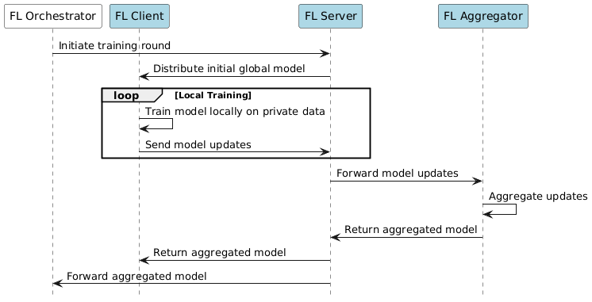
Fig 6.5.1
Fig 6.5.1 Federated Learning Orchestration - Option 1
- Option 2: In this option, both the FL Orchestrator and the FL Aggregator (Global) might be hosted in a cloud-based environment, while the FL Aggregators (Local) and FL Servers might run on the edge. Finally, FL Clients could be hosted on the edge or device, depending on the computational capabilities. The FL Orchestrator, as depicted in Figure 6.5.2, initiates the first training round and distributes the initial global model to the FL Server which is in charge of distributing the model to each FL Client. Each FL Client trains the model locally on its private dataset and sends model updates to the FL Aggregator (Local) which performs partial aggregation of the client updates to reduce communication overhead. The aggregated results are forwarded to the FL Server, which transmits the aggregated updates to the FL Aggregator (Global). The FL Aggregator (Global) performs the final global aggregation, producing the improved global model. This model is then returned to the FL Server and then to the FL Orchestrator. The FL Orchestrator initiates the next training round. In this option, the FL Servers act as the local coordination layer, while the FL Orchestrator manages the end-to-end process. The Option 2 is suitable for large-scale and geographically distributed deployment scenarios as the aggregation occurs in two stages (first at the edge, then globally).
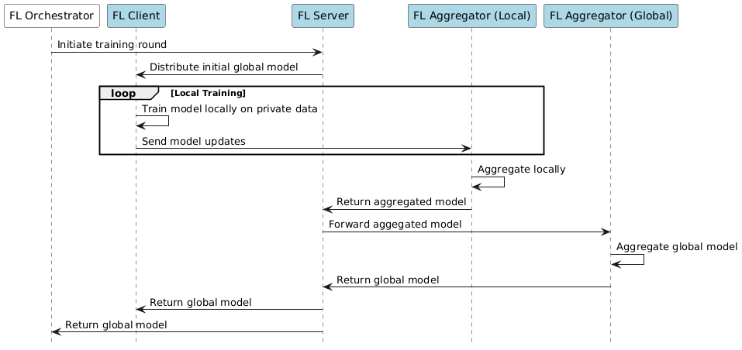
Fig 6.5.2
Fig 6.5.2 Federated Learning Orchestration - Option 2
The orchestration mechanism should be able to perform the following steps:
- Federation Group Selection: based on the federation registry, MEC/oneM2M nodes or instances with sufficient compute and local training capabilities are selected as participants to the federated learning process.
- Model Distribution: a global training model initialized at IN-CSE or MEC Orchestrator is distributed among selected participants.
- Local Training: each selected node trains the model locally using its own data. The training parameters (e.g., weights, gradients, etc.) are stored locally and not exposed outside the node.
- Aggregation and Synchronization: model’s updates are periodically transmitted to the aggregation nodes which might be either an IN-CSE or a MEC host. The aggregator combines updates using secure aggregation protocols and redistributes the improved global model. This allows to maintain consistency between IN-CSE/MEC host, MEC/oneM2M nodes and MEC orchestrator (aggregator).

7 Potential solutions for Interworking with ETSI MEC
This will describe solutions that are discussed considering options and alternative if available. ## 7.1 feature/services using oneM2M with ETSI MEC ### 7.1.1 Description ### 7.1.2 Feature Gap Analysis ### 7.1.3 Key Issues and requirements ### 7.1.4 Solution #n

7.1 Registration of oneM2M to ETSI MEC

7.1.1 Description
To deploy oneM2M along with ETSI MEC will require a registration process. The process will need to address registration from IPE AEs and CSEs (IN, MN, AN). The registration process will also require discovery of capabilities that are exposed by ETSI MEC and publishing services available from oneM2M. ### 7.1.2 Feature Gap Analysis ### 7.1.3 Key Issues and requirements ### 7.1.4 Solution 1: Registering IPE AE ### 7.1.5 Solution 2: Registering IN-CSE to MEC hosted IPE AE ### 7.1.6 Solution 3: Registering MN-CSE to MEC on separate platform ### 7.1.7 Solution 4: Registering MN-CSE as MEC application ### 7.1.8 Solution 5: Integrating oneM2M as a MEC service

7.2 Transfer registration from oneM2M host on a first MEC platform to another second MEC Platform

7.2.1 Description
show a couple images from use cases showing some sort of neighbour search and handover process

7.2.2 Feature Gap Analysis

7.2.3 Key Issues and requirements

7.2.4 Solution #n

7.3 Coordinate Federated Learning

7.3.1 Description
Overview of FL. Provision model, coordinator, selection of nodes, private data used for training

7.3.2 Feature Gap Analysis

7.3.3 Key Issues and requirements

7.3.4 Solution #n

7.4 Coordinate Swarm computing

7.4.1 Description
Overview of Swarm Computing; selection of coordinator, selection of nodes; ..

7.4.2 Feature Gap Analysis

7.4.3 Key Issues and requirements

7.4.4 Solution #n

Proforma copyright release text block
This text box shall immediately follow after the heading of an element (i.e. clause or annex) containing a proforma or template which is intended to be copied by the user. Such an element shall always start on a new page.
Notwithstanding the provisions of the copyright clause related to the text of the present document, oneM2M grants that users of the present document may freely reproduce the <proformatype> proforma in this {clause|annex} so that it can be used for its intended purposes and may further publish the completed <proformatype>.
<PAGE BREAK>

Annexes
Each annex shall start on a new page (insert a page break between annexes A and B, annexes B and C, etc.).

Annex <A>:
Title of annex
<Text>
<PAGE BREAK>

Annex <B>:
Title of annex
<Text>

First clause of the annex
<Text>

B.1.1 First subdivided clause of the annex
<Text>
<PAGE BREAK>

Annex <y>:
Bibliography The annex entitled “Bibliography” is optional.
It shall contain a list of standards, books, articles, or other sources on a particular subject which are not mentioned in the document itself.
It shall not include references mentioned in the document.
- <Publication>: “<Title>”.
OR
<Publication>: “<Title>”.
<PAGE BREAK>

History
This clause shall be the last one in the document and list the main phases (all additional information will be removed at the publication stage).
Publication history
V1.1.1 | <yyyy-mm-dd> | <Milestone>
Draft history table to be removed on publication
Draft history
V0.1.0 | 2025-06-27 | SDS-2025-0108R01 - ESTIMED-Skeleton for STF685
V0.2.0 | 2025-09-29 | SDS-2025-0152-ESTIMED_tr-0077_federatedlearning  SDS-2025-0153-ESTIMED_tr-0077_swarmcomputing  SDS-2025-0154-ESTIMED_tr-0077_handover  SDS-2025-0155-ESTIMED_tr-0077_orchestration  SDS-2025-0156-ESTIMED_tr-0077_deployments

