

oneM2M
Technical Specification
Document Number | TS-0008-v5.2.0
Document Name: | CoAP Protocol Binding
Date: | 2026-06-03
Abstract: | The specification will cover the protocol specific part of communication protocol used by oneM2M compliant systems as 'CoAP binding'.
'Template Version: January 2026 (do not modify)

The present document is provided for future development work within oneM2M only. The Partners accept no liability for any use of this specification.
The present document has not been subject to any approval process by the oneM2M Partners Type 1. Published oneM2M specifications and reports for implementation should be obtained via the oneM2M Partners' Publications Offices.

About oneM2M
The goal of oneM2M is to develop technical specifications which address the need for a common M2M Service Layer that can be readily embedded within various hardware and software, and relied upon to connect the myriad of devices in the field with M2M application servers worldwide.
More information about oneM2M may be found at: http//www.oneM2M.org
Copyright Notification
© 2026, oneM2M Partners Type 1.
All rights reserved.
The copyright extends to reproduction in all media.

Notice of Disclaimer & Limitation of Liability
The information provided in this document is directed solely to professionals who have the appropriate degree of experience to understand and interpret its contents in accordance with generally accepted engineering or other professional standards and applicable regulations. No recommendation as to products or vendors is made or should be implied.
NO REPRESENTATION OR WARRANTY IS MADE THAT THE INFORMATION IS TECHNICALLY ACCURATE OR SUFFICIENT OR CONFORMS TO ANY STATUTE, GOVERNMENTAL RULE OR REGULATION, AND FURTHER, NO REPRESENTATION OR WARRANTY IS MADE OF MERCHANTABILITY OR FITNESS FOR ANY PARTICULAR PURPOSE OR AGAINST INFRINGEMENT OF INTELLECTUAL PROPERTY RIGHTS. NO oneM2M PARTNER TYPE 1 SHALL BE LIABLE, BEYOND THE AMOUNT OF ANY SUM RECEIVED IN PAYMENT BY THAT PARTNER FOR THIS DOCUMENT, WITH RESPECT TO ANY CLAIM, AND IN NO EVENT SHALL oneM2M BE LIABLE FOR LOST PROFITS OR OTHER INCIDENTAL OR CONSEQUENTIAL DAMAGES. oneM2M EXPRESSLY ADVISES ANY AND ALL USE OF OR RELIANCE UPON THIS INFORMATION PROVIDED IN THIS DOCUMENT IS AT THE RISK OF THE USER.

Contents
No table of contents entries found.

1 Scope
The present document will cover the protocol specific part of communication protocol used by oneM2M compliant systems as 'RESTful CoAP binding'.
The scope of the present document is (not limited to as shown below):
- Binding oneM2M primitives to CoAP messages.
- Binding oneM2M Response Status Codes to CoAP Response Codes.
- Defining behaviour of a CoAP Client and Server depending on oneM2M parameters.

2 References

2.1 Normative references
References are either specific (identified by date of publication and/or edition number or version number) or non-specific. For specific references, only the cited version applies. For non-specific references, the latest version of the referenced document (including any amendments) applies.
The following referenced documents are necessary for the application of the present document.
[1] IETF RFC 7252: "The Constrained Application Protocol (CoAP)".
[2] oneM2M TS-0004: "Service Layer Core Protocol Specification".
[3] IETF RFC 7959: "Block-Wise Transfers in the Constrained Application Protocol (CoAP)".
[4] oneM2M TS-0003: "Security solutions".
[5] IETF RFC 6347: "Datagram Transport Layer Security Version 1.2".
[6] IETF RFC 8132: "PATCH and FETCH Methods for the Constrained Application Protocol (CoAP)".

2.2 Informative references
References are either specific (identified by date of publication and/or edition number or version number) or non-specific. For specific references, only the cited version applies. For non-specific references, the latest version of the reference document (including any amendments) applies.
The following referenced documents are not necessary for the application of the present document but they assist the user with regard to a particular subject area.
[i.1] oneM2M Drafting Rules.
NOTE: Available at http://www.onem2m.org/images/files/oneM2M-Drafting-Rules.pdf.

3 Abbreviations and acronyms
For the purposes of the present document, the following abbreviations and acronyms apply:
ACK CoAP Acknowledgement message
AE Application Entity
CON CoAP Confirmable message
CSE Common Service Entity
DTLS Datagram Transport Layer Security
HTTP Hyper Text Transfer Protocol
IANA Internet Assigned Numbers Authority
IP Internet Protocol
NON CoAP Non-confirmable message
RST CoAP ReSeT message
TCP Transport Control Protocol
TLS Transport Layer Security
TLV Tag - Length - Value (data structure)
UDP User Datagram Protocol
URI Uniform Resource Identifier
XML eXtensible Markup Language

4 Conventions
The keywords "Shall", "Shall not", "May", "Need not", "Should", "Should not" in the present document are to be interpreted as described in the oneM2M Drafting Rules [i.1].

5 Overview

5.0 Introduction
The clause describes which features need to be supported in CoAP layer and introduces a message format and several features of CoAP used in this protocol binding specification.

5.1 Required Features
This clause explicitly specifies the required features of the CoAP layer for oneM2M to properly bind oneM2M primitives into CoAP messages:
- The 4-byte binary CoAP message header is defined in section 3 of IETF RFC 7252 [1].
- Confirmable (CON), Non-confirmable (NON), Acknowledgement (ACK) and Reset (RST) messages shall be supported. The Reset message is used to send an error message in response to a malformed Confirmable message in CoAP layer.
- GET, PUT, POST and DELETE methods shall be supported, as shall the FETCH method defined in IETF RFC 8132 [6]. oneM2M primitives map to these methods.
- The CoAP Response Codes specified in clause 6.2.4 shall be supported for oneM2M Response Status Code parameter mapping.
- The Uri-Host, Uri-Port, Uri-Path, and Uri-Query shall be supported.
- The Content-Type Option shall be used to indicate the media types of the payload.
- Block-wise transfers feature may be supported to carry large payloads.
- The Caching feature may be supported.

5.2 Introduction to CoAP

5.2.0 Introduction
This clause describes a message format, and caching and block-wise transfers features which may be used to map oneM2M primitives to CoAP messages.

5.2.1 Message Format
This clause specifies details about the CoAP [1] message format:
- CoAP message occupies the data section of one UDP datagram.
- CoAP message format supports a 4-byte fixed-size header.
- The fixed-size header is followed by a Token value of length 0 to 8 bytes.
- The Token value is followed by a sequence of zero or more CoAP Options in TLV format.
- CoAP Options are followed by the payload part.
For more details on the CoAP message format and the supported header fields, refer to IETF RFC 7252 [1].

5.2.2 Caching

5.2.2.0 Introduction
CoAP [1] supports caching of responses to fulfil future equivalent requests to the same resource. Caching is supported using freshness and validity information carried with CoAP [1] responses.

5.2.2.1 Freshness
- CoAP server shall use Max-Age CoAP Option to specify the explicit expiration time for the CoAP Response's resource representation. This indicates that the response is not fresh after its age is greater than the specified number of seconds.
- Max-Age Option defaults to a value of 60 (seconds). In case, Max-Age Option is not present in the cacheable response, the response shall not be considered fresh after its age is greater than 60 seconds.
- The CoAP server shall set the Max-Age Option value to 0 (zero) to prevent or disable caching.
- The CoAP client, having a fresh stored response, can make new request matching the request for that stored response. In this case, the new response shall invalidate the old response.

5.2.2.2 Validity
- A CoAP endpoint with stored responses but not able to satisfy subsequent requests (for example, the response is not fresh), shall use the Etag Option to perform a conditional request to the CoAP server where the resource is hosted.
- If the cached response with the CoAP client is still valid, the server shall include the Max-Age Option in the response along with a code of 2.03 - Valid. This shall update the freshness of the cached response at the CoAP client.
- If the cached response with the CoAP client is not valid, the server shall respond with an updated representation of the resource with response code 2.05 - Content. The CoAP client shall use the updated response to satisfy request and may also replace/update the stored or cached response.

5.2.3 Block-wise Transfers
CoAP Block [3] Options may be used when CoAP endpoints need to transfer large payloads e.g. firmware, software updates. Instead of relying on IP fragmentation, the CoAP Block Option should be used for transferring multiple blocks of information in multiple request-response pairs.

6 CoAP Message Mapping

6.1 Introduction
When AE or CSE binds oneM2M primitives to CoAP messages, or binds CoAP messages to oneM2M primitives, it is required that:
- AE shall host a CoAP client and should host a CoAP server; or
- CSE shall host both a CoAP client and a CoAP server.
In general a single oneM2M request primitive is mapped to a single CoAP request message, and a single oneM2M response primitive is mapped to a single CoAP response message. However, a single oneM2M request/response primitive is mapped to multiple CoAP request/response messages respectively when the CoAP block-wise transfer feature is used.
Mapping between CoAP message and oneM2M primitive shall be applied in the following cases:
- when the Originator sends a request primitive;
- when the Receiver receives a CoAP message(s);
- when the Receiver sends a response primitive;
- when the Originator receives a CoAP message(s).
The following sub-clauses specify how to map each oneM2M primitive parameter defined in oneM2M TS-0004 [2] to a corresponding CoAP message field to compose a CoAP request/response message.

6.2 Primitive Mapping to CoAP Message

6.2.0 Introduction
This clause describes where to map oneM2M parameters in a primitive to header, Option and payload fields in a CoAP message. The mappings are summarised in Table 6.2.0-1 and more detail is given in subsequent clauses.
In Table 6.2.0-1
- "CoAP option" means a oneM2M-specific CoAP option as defined in clause 6.2.2.4.
- "Payload" in the second column means that the parameter is passed in a serialized oneM2M primitive. See clause 6.2.3.
- "Uri-Query" means that the parameter is sent as part of the CoAP Uri-Query option. See clause 6.2.2.3.
Table 6.2.0-1: oneM2M Primitive Parameter Mappings
Primitive Parameter | Release 5 | Earlier releases
Operation | Header (blocking requests)  Uri-Query (other requests) | Header (blocking requests)  Uri-Query (other requests)
To | Standard CoAP options | Standard CoAP options
From | Payload or CoAP option | CoAP option
Request Identifier | Payload or CoAP option | CoAP option
Content | Payload | Payload
Originating Timestamp | Payload or CoAP option | CoAP option
Request Expiration Timestamp | Payload or CoAP option | CoAP option
Result Expiration Timestamp | Payload or CoAP option | CoAP option
Operation Execution Time | Payload or CoAP option | CoAP option
Role IDs | Payload | Uri-Query
Response Type - notificationURI | Payload | CoAP option
Response Type - responseTypeValue | Payload | Uri-Query
Result Persistence | Payload | Uri-Query
Result Content | Payload | Uri-Query
Event Category | Payload or CoAP option | CoAP option
Response Status Code | New CoAP option | CoAP option
Delivery Aggregation | Payload | Uri-Query
Group Request Identifier | Payload | CoAP option
Filter Criteria | Payload | Uri-Query
Desired Identifier Result Type | Payload | Uri-Query
Resource Type | Payload or CoAP option | CoAP option
Content Offset | Payload or CoAP option | CoAP option
Content Status | Payload or CoAP option | CoAP option
Assigned Token Identifiers | Payload | CoAP option
Tokens | Payload | Uri-Query
Token IDs | Payload | Uri-Query
Local Token IDs | Payload | Uri-Query
Token Request Indicator | Payload | Uri-Query
Token Request Information | Payload | Payload
Release Version Indicator | Payload or CoAP option | CoAP option
Vendor Information | Payload | CoAP option
Group Request Target Members | Payload | CoAP option
Group Somecast Target Number | Payload | Uri-Query
Authorization Signature Indicator | Payload | Uri-Query
Authorization Signatures | Payload | CoAP option
Authorization Signature Request Information | Payload | CoAP option
Authorization Relationship Indicator | Payload | Uri-Query
Semantic Query Indicator | Payload | Uri-Query
Ontology Mapping Resources | Payload | CoAP option
Primitive Profile Identifier | Payload | CoAP option
M2M Service User | Payload | CoAP option

6.2.1 Header
This clause specifies how to configure CoAP header information:
- The Version field shall be configured as 1.
- The Type field shall be configured according to clause 6.3. The Reset message is used to indicate an error in response to a malformed message in the CoAP layer.
- In case of a request, the Code field indicates the CoAP Method. If the oneM2M operation is sent as a Blocking request the oneM2M Operation parameter shall be mapped to a CoAP Method according to the table 6.2.1-1. In non-blocking and flex blocking cases, the request shall use the CoAP POST method, and the Operation parameter shall be mapped as described in clause 6.2.2.3.
- In case of a response, the Code field indicates the CoAP Response Code. The oneM2M Response Status Code parameter shall be mapped to a CoAP Response Code as specified in clause 6.2.4.
- The Originator and Receiver shall set the 16-bit MessageId in accordance with the CoAP specification [1] and shall retry transmission of all unacknowledged Confirmable messages, as required by that specification.
Table 6.2.1-1: oneM2M Operation Parameter Mapping
oneM2M Operation Parameter | CoAP Method | CoAP Method Code
CREATE | POST | 0.02
RETRIEVE | FETCH or GET | 0.05 (FETCH) or 0.01 (GET)
UPDATE | PUT | 0.03
DELETE | DELETE | 0.04
NOTIFY | POST | 0.02

The Originator shall use the FETCH method as defined in RFC 8132 [6] when sending a RETRIEVE request, except in when the Receiver is running Release 4 or earlier in which case it shall use the GET method. See clause 6.6 for more details on the use of FETCH.
At the Receiver, a CoAP request message with a POST method that does not carry an Operation parameter shall be mapped to a oneM2M CREATE or NOTIFY operation in accordance with the existence of the Resource Type parameter. If a Resource Type parameter exists then the value of the Operation parameter is CREATE and if the Resource Type parameter does not exist, the value of the Operation parameter is NOTIFY.

6.2.2 Configuration of Token and Options

6.2.2.0 Introduction
This clause describes configuration of Token and Options based on oneM2M parameters.

6.2.2.1 Token
The CoAP token is used by the CoAP layer to match a response to a request, in a manner that is similar to the oneM2M Request Identifier. Due to size limitations, a Request Identifier cannot be used directly as the CoAP Token.
The use of tokens by Originator and Receiver shall comply with requirements of the CoAP specification [1].

6.2.2.2 Content Format Negotiation Options
The CoAP Accept Option may be used to indicate which Content-Format is acceptable to an Originator. If a Hosting CSE supports the Content-Format specified in Accept Option of the request, the Hosting CSE shall respond with that Content-Format. If the Hosting CSE does not support the Content-Format specified in Accept Option of the request, 4.06 "Not Acceptable" shall be sent as a response, unless another error code takes precedence for this response.
Possible values for Content-Format and Accept options are listed below:
- application/xml (41);
- application/json (50);
- application/cbor (60);
- media types specified in clause 6.7 "oneM2M specific MIME media types" of oneM2M TS-0004 [2].
Numeric values for oneM2M defined media types are listed in table 6.2.2.2-1.
Table 6.2.2.2-1: CoAP oneM2M Specific Content-Formats
oneM2M Specific Media Type | ID
application/vnd.onem2m-res+xml | 10014
application/vnd.onem2m-res+json | 10015
application/vnd.onem2m-ntfy+xml | 10016
application/vnd.onem2m-ntfy+json | 10003
application/vnd.onem2m-preq+xml | 10006
application/vnd.onem2m-preq+json | 10007
application/vnd.onem2m-prsp+xml | 10008
application/vnd.onem2m-prsp+json | 10009
application/vnd.onem2m-res+cbor | 10010
application/vnd.onem2m-ntfy+cbor | 10011
application/vnd.onem2m-preq+cbor | 10012
application/vnd.onem2m-prsp+cbor | 10013

NOTE: ID values for oneM2M specific media type are subject to change after IANA registration.

6.2.2.3 URI Options
This clause describes how to configure CoAP Uri-Host, Uri-Port, Uri-Path, and Uri-Query Options.
Host and port part of the address specified in pointOfAccess attribute of <remoteCSE> resource shall be mapped to Uri-Host and Uri-Port respectively.
If To parameter contains absolute format, then the first URI-Path Option shall contain a letter "_" and map To parameter removing starting "//" into next URI-Path Option(s).
If To parameter contains SP-relative format, then the first URI-Path Option shall contain a letter "~" and map To parameter removing starting "/" into next URI-Path Option(s).
If To parameter contains CSE-relative format, then To parameter shall be mapped to URI-Path Option(s).
Table 6.2.2.3-1 shows valid mappings between the To request primitive parameter and the Uri-Path of the CoAP.
CSEBase represents the resource name of a <CSEBase > resource, CSEBase/ae12/cont27/contInst696 represents a structured CSE-relative resource ID, and cin00856 an unstructured CSE-relative resource ID.
Table 6.2.2.3-1: Mapping examples between To parameter and Uri-Path of the CoAP
Method |  | Request Scope
 |  | CSE-Relative | SP-Relative | Absolute
Structured | To | CSEBase/ae12/cont27/contInst696 | /CSE178/CSEBase/ae12/cont27/contInst696 | //mym2msp.org/CSE178/CSEBase/ae12/cont27/contInst696
Structured | Uri-Path | CSEBase |  | _ (underscore)
Structured | Uri-Path | CSEBase | ~ (tilde) | mym2msp.org
Structured | Uri-Path | CSEBase | CSE178 | CSE178
Structured | Uri-Path | CSEBase | CSEBase | CSEBase
Structured | Uri-Path | ae12 | ae12 | ae12
Structured | Uri-Path | cont27 | cont27 | cont27
Structured | Uri-Path | contInst696 | contInst696 | contInst696
Unstructured | To | cin00856 | /CSE178/cin00856 | //mym2msp.org/CSE178/cin00856
Unstructured | Uri-Path | cin00856 |  | _ (underscore)
Unstructured | Uri-Path | cin00856 | ~ (tilde) | mym2msp.org
Unstructured | Uri-Path | cin00856 | CSE178 | CSE178
Unstructured | Uri-Path | cin00856 | cin00856 | cin00856
NOTE: How to read this table: To primitive - from left to right, Uri-Path - from top to bottom.

NOTE: In oneM2M Release 4 or earlier some primitive parameters are mapped to the CoAP Uri-Query option. Implementations should accept parameters passed in this manner from a Release 4 (or earlier) implementation and should place them, if needed, in the Uri-Query when sending a primitive to such an implementation. These parameters are shown in table 6.2.0-1. In the Uri-Query they are represented using the short names specified in clause 8.2.2 of oneM2M TS-0004 [2].

6.2.2.4 oneM2M-specific CoAP Options

6.2.2.4.0 Introduction
This clause describes additional CoAP Options used for binding several oneM2M primitive parameters. Tables 6.2.2.4.0-1 and 6.2.2.4.0-2 contain definitions of the oneM2M-defined CoAP Options and the sub-clauses that follow this one specify the oneM2M parameter mappings to these CoAP Options.
Table 6.2.2.4.0-1: Definition of oneM2M Options
No | C | U | N | R | Name | Format | Length | Default
279 | X | X |  |  | oneM2M-FR | string | 0-255 | (None)
283 | X | X |  |  | oneM2M-RQI | string | 0-255 | (None)
259 | X | X |  |  | oneM2M-OT | string | 15 | (None)
291 | X | X |  |  | oneM2M-RQET | string | 15 | (None)
295 | X | X |  |  | oneM2M-RSET | string | 15 | (None)
299 | X | X |  |  | oneM2M-OET | string | 15 | (None)
303 | X | X |  |  | oneM2M-EC | uint | 1 | (None)
307 | X | X |  |  | oneM2M-RSC | uint | 2 | (None)
267 | X | X |  |  | oneM2M-TY | uint | 2 | (None)
319 | X | X |  |  | oneM2M-CTO | uint | 2 | (None)
323 | X | X |  |  | oneM2M-CTS | uint | 2 | (None)
271 | X | X |  |  | oneM2M-RVI | string | 1-2 | (None)
NOTE 1: C, U, N, R means Critical, Unsafe, NoCacheKey and Repeatable respectively [1]. Table 6.2.2.4.0-1 follows the template used in clause 5.10 Option Definitions of CoAP specification [1].
NOTE 2: CoAP Option numbers specified in table 6.2.2.4.0-1 are subject to change after review by IANA registration.

The Response Status Code in a response shall be carried using the CoAP option shown in table 6.2.2.4.0-1.
The remaining CoAP options listed in table 6.2.2.4.0-1 may be used to carry the corresponding Primitive Parameters, if needed, however these Primitive Parameters may instead be carried in the CoAP payload as described in clause 6.2.3.
- The parameter shall be carried in the payload and not as a CoAP option if its value is longer than the maximum length permitted for the CoAP option (see the length column in table 6.2.2.4.0-1)
NOTE 3: The CoAP option approach gives a more efficient encoding if the whole primitive is small enough to fit in a single CoAP message, however it could be less efficient if the primitive is larger and has to be split into multiple blocks (see clause 6.5). This is because CoAP options have to be repeated in each block.
NOTE 4: In Release 4 and earlier releases, some additional CoAP options are defined. These are shown in table 6.2.2.4.0-2. A oneM2M implementation should accept parameters passed using these options from a Release 4 (or earlier) implementation and should use the options when sending a oneM2M primitive to such an implementation.
Table 6.2.2.4.0-2: Additional Options used in Release 4 and earlier
No | C | U | N | R | Name | Format | Length | Default
263 | X | X |  |  | oneM2M-RTURI | string | 0-255 | (None)
311 | X | X |  |  | oneM2M-GID | string | 0-255 | (None)
327 | X | X |  |  | oneM2M-ATI | string | 0-255 | (None)
331 | X | X |  |  | oneM2M-VSI | string | 0-255 | (None)
335 | X | X |  |  | oneM2M-GTM | string | 0-512 | (None)
339 | X | X |  |  | oneM2M-AUS | string | 0-255 | (None)
275 | X | X |  |  | oneM2M-ASRI | string | 0-255 | (None)
343 | X | X |  |  | oneM2M-OMR | string | 0-255 | (None)
347 | X | X |  |  | oneM2M-PRPI | string | 0-255 | (None)
351 | X | X |  |  | oneM2M-MSU | string | 0-255 | (None)
NOTE 1: C, U, N, R means Critical, Unsafe, NoCacheKey and Repeatable respectively [1]. Table 6.2.2.4.0-2 follows the template used in clause 5.10 Option Definitions of CoAP specification [1].
NOTE 2: CoAP Option numbers specified in table 6.2.2.4.0-1 are subject to change after review by IANA registration.

The options in table 6.2.2.4.0-2 shall not be used when sending a oneM2M primitive to an implementation that is Release 5 or later.

6.2.2.4.1 From
The From parameter shall be mapped to the oneM2M-FR Option.

6.2.2.4.2 Request Identifier
The Request Identifier parameter shall be mapped to the oneM2M-RQI Option.

6.2.2.4.3 Void

6.2.2.4.4 Originating Timestamp
The Originating Timestamp parameter shall be mapped to the oneM2M-OT Option.

6.2.2.4.5 Request Expiration Timestamp
The Request Expiration Timestamp parameter shall be mapped to the oneM2M-RQET Option.

6.2.2.4.6 Result Expiration Timestamp
The Result Expiration Timestamp parameter shall be mapped to the oneM2M-RSET Option.

6.2.2.4.7 Operation Execution Time
The Operation Execution Time parameter shall be mapped to the oneM2M-OET Option.

6.2.2.4.8 notificationURI of Response Type
The notificationURI element of Response Type parameter shall be mapped to the oneM2M-RTURI Option.

6.2.2.4.9 Event Category
The Event Category parameter shall be mapped to the oneM2M-EC Option.

6.2.2.4.10 Response Status Code
The Response Status Code parameter shall be mapped to the oneM2M-RSC Option.

6.2.2.4.11 Group Request Identifier
The Group Request Identifier parameter shall be mapped to the oneM2M-GID Option.

6.2.2.4.12 Resource Type
The Resource Type parameter shall be mapped to the oneM2M-TY Option.

6.2.2.4.13 Content Offset
The Content Offset parameter shall be mapped to the oneM2M-CTO Option.

6.2.2.4.14 Content Status
The Content Status parameter shall be mapped to the oneM2M-CTS Option.

6.2.2.4.15 Assigned Token Identifiers
The Assigned Token Identifiers parameter shall be mapped to the oneM2M-ATI Option. The format of the oneM2M-ATI option shall be represented as a sequence of lti-value:tkid-value pairs separated by a colon ':' and multiple pairs separated by a '+' character.
EXAMPLE: The option looks as follows:

oneM2M-ATI: lti-value1:tkid-value1 + lti-value2:tkid-value2 + ...

if the XML representation of the Assigned Token Identifiers parameter is given as (using short element names):
<ati>
<ltia>
<lti>lti-value1</lti>
<tkid>tkid-value1</tkid>
</ltia>
<ltia>
<lti>lti-value2</lti>
<tkid>tkid-value2</tkid>
</ltia>
...
</ati>

The data type m2m:dynAuthlocalTokenIdAssignments of the Assigned Token Identifiers parameter is defined in clause 6.3.5.43 of oneM2M TS-0004 [2].

6.2.2.4.16 Release Version Indicator
The Release Version Indicator parameter shall be mapped to the oneM2M-RVI Option.

6.2.2.4.17 Vendor Information
The Vendor Information parameter shall be mapped to the oneM2M-VSI Option.

6.2.2.4.18 Group Request Target Members
The Group Request Target Members parameter shall be mapped to the oneM2M-GTM Option.

6.2.2.4.19 Authorization Signatures
The Authorization Signatures parameter shall be mapped to the oneM2M-AUS Option.

6.2.2.4.20 Authorization Signature Request Information
The Authorization Signature Request Information parameter shall be mapped to the oneM2M-ASRI Option.

6.2.2.4.21 Ontology Mapping Resources
The Ontology Mapping Resources parameter shall be mapped to the oneM2M-OMR Option. The format of the oneM2M-OMR option shall be represented as a sequence of oneM2M resource identifiers separated by a '+'.
EXAMPLE: The option looks as follows:

oneM2M-OMR: /IN-CSE-0001/omr1+/IN-CSE-0001/omr2+...

6.2.2.4.22 Primitive Profile Identifier
The Primitive Profile Identifier parameter shall be mapped to the oneM2M-PRPI Option.

6.2.2.4.23 M2M Service User
The M2M Service User parameter shall be mapped to the oneM2M-MSU Option.

6.2.3 Payload
The CoAP payload shall contain a oneM2M primitive that is serialised using the rules given in clause 8 of oneM2M TS-0004 [2]. These rules shall be applied to the m2m:requestPrimitive defined in clause 6.4.1 of oneM2M TS-0004 [2] or the m2m:responsePrimitive defined in clause 6.4.2 of oneM2M TS-0004 [2].
- Clause 6.2.2 of the present document requires some Primitive Parameters (e.g. the To and Response Status Code parameters) to be mapped to CoAP Options and it permits some other parameters (listed in Table 6.2.2.4.0-1) either to be passed either as a CoAP option or to be serialised into the request or response primitive. If a parameter is passed as a CoAP option it shall not be included in the serialised primitive.
The CoAP block-wise transfer mechanism shall be used to deliver the payload if it is too large to fit into one CoAP message. Refer to clause 6.5 for more information.
If the Content parameter contains URI and resource representation in a response to a create request, the URI shall be mapped to the CoAP Location-Path Option instead of being included in the CoAP payload.
The CoAP Content-Format option shall be included and shall be set to a value that complies with the data representation.
NOTE: In oneM2M Release 4 and earlier the CoAP payload is required to contain the value of the Token Request Information parameter (if present in a response primitive) and otherwise it is required to contain the value of the Content parameter (if present). Implementations should accept such CoAP payloads from an implementation that is Release 4 or earlier and should construct such payloads when sending oneM2M primitives to such implementations.

6.2.4 Response Codes Mapping
Table 6.2.4-1 defines the mapping between oneM2M Response Status Code parameter specified in [2] and CoAP Response Code that is referenced in clause 6.2.1.
Table 6.2.4-1: Mapping between oneM2M Response Status Code and CoAP Response Code
oneM2M Response Status Code | Description | CoAP Response Code | Description
1000 | ACCEPTED | None | Not used
1001 | ACCEPTED for nonBlockingRequestSynch | 2.01 | Created (indicates that a <request> resource has been created
1002 | ACCEPTED for nonBlockingRequestAsynch | 2.01 or 2.04 | 2.01 (Created) is used if a <request > resource was created, otherwise 2.04 (Changed) is used
2000 (for RETRIEVE operation) | OK | 2.05 | Content
2000 (for NOTIFY operation) | OK | 2.04 | Changed. CoAP payload shall be empty.
2001 | CREATED | 2.01 | Created
2002 | DELETED | 2.02 | Deleted
2004 | UPDATED | 2.04 | Changed
4000 | BAD_REQUEST | 4.00 | Bad Request
4001 | RELEASE_VERSION_NOT_SUPPORTED | 5.01 | Not Implemented
4004 | NOT_FOUND | 4.04 | Not Found
4005 | OPERATION_NOT_ALLOWED | 4.05 | Method Not Allowed
4008 | REQUEST_TIMEOUT | 5.04 | Gateway Timeout
4015 | UNSUPPORTED_MEDIA_TYPE | 4.15 | Unsupported Content-Format
4101 | SUBSCRIPTION_CREATOR_HAS_NO_PRIVILEGE | 4.03 | Forbidden
4102 | CONTENTS_UNACCEPTABLE | 4.00 | Bad Request
4103 | ORIGINATOR_HAS_NO_PRIVILEGE | 4.03 | Forbidden
4104 | GROUP_REQUEST_IDENTIFIER_EXISTS | 4.00 | Bad Request
4105 | CONFLICT | 4.03 | Forbidden
4106 | ORIGINATOR_NOT_AUTHENTICATED | 4.03 | Forbidden
4107 | SECURITY_ASSOCIATION_REQUIRED | 4.03 | Forbidden
4108 | INVALID_CHILD_RESOURCE_TYPE | 4.03 | Forbidden
4109 | NO_MEMBERS | 4.03 | Forbidden
4110 | GROUP_MEMBER_TYPE_INCONSISTENT | 4.00 | Bad Request
4111 | ESPRIM_UNSUPPORTED_OPTION | 4.03 | Forbidden
4112 | ESPRIM_UNKNOWN_KEY_ID | 4.03 | Forbidden
4113 | ESPRIM_UNKNOWN_ORIG_RAND_ID | 4.03 | Forbidden
4114 | ESPRIM_UNKNOWN_RECV_RAND_ID | 4.03 | Forbidden
4115 | ESPRIM_BAD_MAC | 4.03 | Forbidden
4116 | ESPRIM_IMPERSONATION_ERROR | 4.03 | Forbidden
4117 | ORIGINATOR_HAS_ALREADY_REGISTERED | 4.03 | Forbidden
4118 | ONTOLOGY_NOT_AVAILABLE | 4.04 | Not Found
4119 | LINKED_SEMANTICS_NOT_AVAILABLE | 4.04 | Not Found
4120 | INVALID_SEMANTICS | 4.02 | Bad Option
4121 | MASHUP_MEMBER_NOT_FOUND | 4.04 | Not Found
4122 | INVALID_TRIGGER_PURPOSE | 4.02 | Bad Option
4123 | ILLEGAL_TRANSACTION_STATE_TRANSITION_ATTEMPTED | 4.00 | Bad Request
4124 | BLOCKING_SUBSCRIPTION_ALREADY_EXISTS | 4.00 | Bad Request
4125 | SPECIALIZATION_SCHEMA_NOT_FOUND | 5.01 | Not Implemented
4126 | APP_RULE_VALIDATION_FAILED | 4.03 | Forbidden
4127 | OPERATION_DENIED_BY_REMOTE_ENTITY | 4.03 | Forbidden
4128 | SERVICE_SUBSCRIPTION_NOT_ESTABLISHED | 4.03 | Forbidden
4130 | ONTOLOGY_MAPPING_ALGORITHM_NOT_AVAILABLE | 4.04 | Not Found
4131 | ONTOLOGY_MAPPING_POLICY_NOT_MATCHED | 4.00 | Bad Request
4132 | ONTOLOGY_MAPPING_NOT_AVAILABLE | 4.04 | Not Found
4133 | BAD_FACT_INPUTS_FOR_REASONING | 4.00 | Bad Request
4134 | BAD_RULE_INPUTS_FOR_REASONING | 4.00 | Bad Request
4135 | DISCOVERY_LIMIT_EXCEEDED | 4.03 | Forbidden
4136 | PRIMITIVE_PROFILE_NOT_ACCESSIBLE | 4.03 | Forbidden
4137 | PRIMITIVE_PROFILE_BAD_REQUEST | 4.00 | Bad Request
4138 | UNAUTHORIZED_USER | 4.03 | Forbidden
4139 | SERVICE_SUBSCRIPTION_NOT_ACTIVE | 4.03 | Forbidden
4140 | SOFTWARE_CAMPAIGN_CONFLICT | 4.03 | Forbidden
4142 | INVALID_PROCESS_CONFIGURATION | 4.00 | Bad Request
4143 | INVALID_SPARQL_QUERY | 4.00 | Bad Request
5000 | INTERNAL_SERVER_ERROR | 5.00 | Internal Server Error
5001 | NOT_IMPLEMENTED | 5.01 | Not Implemented
5103 | TARGET_NOT_REACHABLE | 4.04 | Not Found
5105 | RECEIVER_HAS_NO_PRIVILEGE | 4.03 | Forbidden
5106 | ALREADY_EXISTS | 4.00 | Bad Request
5107 | REMOTE_ENTITY_NOT_REACHABLE | 4.04 | Not Found
5203 | TARGET_NOT_ SUBSCRIBABLE | 4.03 | Forbidden
5204 | SUBSCRIPTION_VERIFICATION_INITIATION_FAILED | 5.00 | Internal Server Error
5205 | SUBSCRIPTION_HOST_HAS_NO_PRIVILEGE | 4.03 | Forbidden
5206 | NON_BLOCKING_SYNCH_REQUEST_NOT_SUPPORTED | 5.01 | Not Implemented
5207 | NOT_ACCEPTABLE | 4.06 | Not Acceptable
5208 | DISCOVERY_DENIED_BY_IPE | 4.03 | Forbidden
5209 | GROUP_MEMBERS_NOT_RESPONDED | 5.00 | Internal Server Error
5210 | ESPRIM_DECRYPTION_ERROR | 5.00 | Internal Server Error
5211 | ESPRIM_ENCRYPTION_ERROR | 5.00 | Internal Server Error
5212 | SPARQL_UPDATE_ERROR | 5.00 | Internal Server Error
5214 | TARGET_HAS_NO_SESSION_CAPABILITY | 4.03 | Forbidden
5215 | SESSION_IS_ONLINE | 4.03 | Forbidden
5216 | JOIN_MULTICAST_GROUP_FAILED | 5.00 | Internal Server Error
5217 | LEAVE_MULTICAST_GROUP_FAILED | 5.00 | Internal Server Error
5218 | TRIGGERING_DISABLED_FOR_RECIPIENT | 5.03 | Service Unavailable
5219 | UNABLE_TO_REPLACE_ REQUEST | 5.03 | Service Unavailable
5220 | UNABLE_TO_RECALL_REQUEST | 5.03 | Service Unavailable
5221 | CROSS_RESOURCE_OPERATION_FAILURE | 5.00 | Internal Server Error
5222 | TRANSACTION_PROCESSING_IS_INCOMPLETE | 4.03 | Forbidden
5230 | ONTOLOGY_MAPPING_ALGORITHM_FAILED | 5.00 | Internal Server Error
5231 | ONTOLOGY_CONVERSION_FAILED | 5.00 | Internal Server Error
5232 | REASONING_PROCESSING_FAILED | 5.00 | Internal Server Error
6003 | EXTERNAL_OBJECT_NOT_REACHABLE | 4.04 | Not Found
6005 | EXTERNAL_OBJECT_NOT_FOUND | 4.04 | Not Found
6010 | MAX_NUMBER_OF_MEMBER_EXCEEDED | 4.00 | Bad Request
6020 | MGMT_SESSION_CANNOT_BE_ESTABLISHED | 5.00 | Internal Server Error
6021 | MGMT_SESSION_ESTABLISHMENT_TIMEOUT | 5.00 | Internal Server Error
6022 | INVALID_CMDTYPE | 4.00 | Bad Request
6023 | INVALID_ARGUMENTS | 4.00 | Bad Request
6024 | INSUFFICIENT_ARGUMENTS | 4.00 | Bad Request
6025 | MGMT_CONVERSION_ERROR | 5.00 | Internal Server Error
6026 | MGMT_CANCELLATION_FAILED | 5.00 | Internal Server Error
6028 | ALREADY_COMPLETE | 4.00 | Bad Request
6029 | MGMT_COMMAND_NOT_CANCELLABLE | 4.00 | Bad Request
6030 | EXTERNAL_OBJECT_NOT_REACHABLE_BEFORE_RQET_TIMEOUT | 5.04 | Gateway Timeout
6031 | EXTERNAL_OBJECT_NOT_REACHABLE_BEFORE_OET_TIMEOUT | 5.04 | Gateway Timeout
6033 | NETWORK_QOS_CONFIG_ERROR | 5.03 | Internal Server Error
6034 | REQUESTED_ACTIVITY_PATTERN_NOT_PERMITTED | 4.03 | Forbidden

The Receiver shall use this table to determine the CoAP response code that is to be used in the response, based on the value of the oneM2M Response Status Code parameter.

6.3 Accessing Resources in CSEs

6.3.0 Introduction
This clause describes the behaviour of the CoAP layer depending on the Response Type parameter. Note that the CoAP messaging model defined in [1] applies to all message exchanges.
oneM2M Requests should be sent as CoAP Confirmable (CON) messages, although an Originator can send a request as a Non-confirmable (NON) message if there is a good reason for doing this. An Originator that relies on getting a response to its request should use a Confirmable rather than a Non-confirmable message for its request.
oneM2M Responses should be sent as CoAP CON messages, although there is one case where a NON message should be used. This is indicated in clause 6.3.1.
If the Originator or Receiver sends a CON message it shall retransmit that message if it does not receive a CoAP acknowledgement message, as required by [1]. The recipient (Receiver or Originator) shall take care to de-duplicate CON messages as described in [1]
The recipient of a CoAP message shall process the oneM2M request or response it contains, even if it was sent as Non-confirmable.

6.3.1 Blocking case
- If the Response Type parameter is configured as "blockingRequest" (blocking case), the Originator (CoAP client) shall send the oneM2M request to the Receiver (CoAP server). The oneM2M Operation parameter shall be mapped to a CoAP Method according to Table 6.2.1-1.
- After processing the oneM2M request, the Receiver shall send the oneM2M response in a CoAP response with a CoAP response code as given by Table 6.2.4-1.
  - If the oneM2M request was sent as a CoAP Confirmable message, the Receiver may either piggyback this response to the request on the CoAP ACK message, or send the response as a separate CoAP Confirmable message after it has sent the CoAP ACK.
  - If the oneM2M request was sent as a Non-confirmable message, the oneM2M response shall be returned as a separate CoAP message. This response should be sent as a Non-confirmable CoAP message but it may be sent as Confirmable (this means that a receiver can, if it so chooses, send all Responses as Confirmable regardless of how the Request was sent).
- The Originator's CoAP binding may generate a response primitive containing a oneM2M Response Status Code of "REQUEST_TIMEOUT" if it considers that it has taken too long for the CoAP response to come back from the Receiver. It shall ignore any response to the original request that it might receive after it has done this.

6.3.2 Non-Blocking Asynchronous case
- If the Response Type parameter is configured as "nonBlockingRequestAsynch" (non-blocking asynchronous case), the Originator (CoAP client) should send the oneM2M request to the Receiver (CoAP server) as a CoAP Confirmable message. This request shall be sent using the CoAP POST method, and shall include the Operation parameter, mapped as described in clause 6.2.2.3.
- The Receiver, after validating the request and before processing it fully, shall return a oneM2M response to the originator. It may either piggyback (2a) this response on the CoAP ACK message (if the request was sent as a Confirmable message) or send the response as a separate CoAP response message after it has sent the CoAP ACK (2b). In this latter case it shall send the response as a Confirmable message.
  - If the Receiver supports the <request> resource type, it shall respond with a 2.01 (Created) CoAP response code and a oneM2M Response Status Code of "ACCEPTED for nonBlockingRequestAsynch". The response shall include the URI of the new <request> resource in a sequence of one or more Location-Path and/or Location-Query Options.
  - If the Receiver does not support the <request> resource type, it shall respond with a 2.04 (Changed) CoAP response code and a oneM2M Response Status Code of "ACCEPTED for nonBlockingRequestAsynch".
- The Receiver, upon successful processing of the request, shall send a new CoAP Confirmable request message using the CoAP POST method. This message contains a oneM2M NOTIFY primitive whose content contains the response to the original request.
- The Originator may either piggyback a response to this request (4a) or send it as a separate CoAP response after the acknowledgment message (4b). This response shall contain the appropriate CoAP response code as defined in table 6.2.4-1 and have an empty payload.
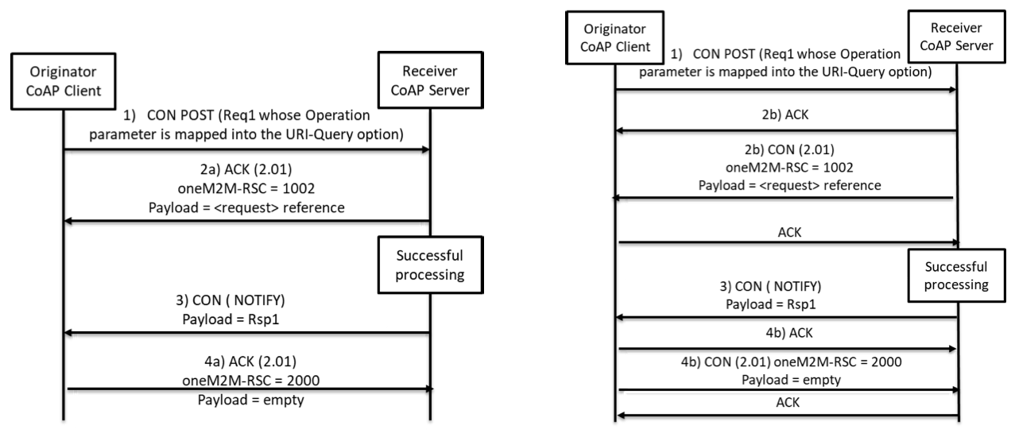
Figure 6.3.2-1: Non-Blocking Asynchronous Case

6.3.3 Non-Blocking Synchronous case
- If the Response Type parameter is configured as "nonBlockingRequestSynch" (non-blocking synchronous case), the Originator (CoAP client) should send the oneM2M request to the Receiver (CoAP server) as a CoAP Confirmable message. This request shall be sent using the CoAP POST method, and shall include the Operation parameter, mapped as described in clause 6.2.2.3.
- The Receiver, after validating the request and before processing it fully, shall return a oneM2M response to the originator. It may either piggyback this response (2a) on the CoAP ACK message (if the request was sent as a CON message) or send the response as a separate CoAP message after it has sent the CoAP ACK (2b). In this latter case it shall send the response as a Confirmable message.
  - If the Receiver supports the <request> resource type, it shall respond with a 2.01 (Created) CoAP response code and a oneM2M Response Status Code of "ACCEPTED for nonBlockingRequestSynch". The response shall include the URI of the new <request> resource in a sequence of one or more Location-Path and/or Location-Query Options.
  - If the Receiver does not support the <request> resource type, it shall respond with a 5.01 (Not implemented) CoAP response code and a oneM2M Response Status Code of "NON_BLOCKING_SYNCH_REQUEST_NOT_SUPPORTED".
- The Originator can use the <request> resource reference to make a blocking synchronous request to retrieve the <request> resource that corresponds to the original request.
- The Receiver, upon receipt of this retrieve request, shall handle it as in clause 6.3.1 since it is a blocking request.
NOTE: If the Receiver is a Transit CSE, the Receiver acts as CoAP client and CoAP server.
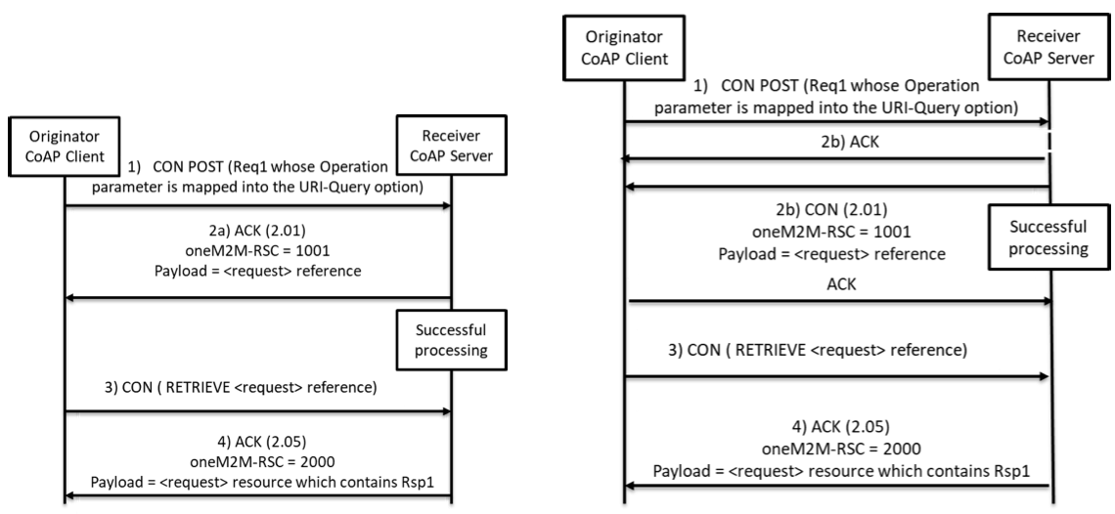
Figure 6.3.3-1: Non-Blocking Synchronous Case

6.3.4 Flex Blocking case
- If the Response Type parameter is configured as "flex blocking", the Originator (CoAP client) should send the oneM2M request to the Receiver (CoAP server) as a CoAP Confirmable message. This request shall be sent using the CoAP POST method, and shall include the Operation parameter, mapped as described in clause 6.2.2.3.
- The Receiver shall determine whether to handle the request using "nonBlockingRequestSynch" or "nonBlockingRequestAsynch" mode:
  - If the Receiver chooses "nonBlockingRequestAsynch" processing proceeds as described in clause 6.3.2, starting from step 2).
  - If the Receiver chooses "nonBlockingRequestSynch" processing proceeds as described in clause 6.3.3, starting from step 2).

6.4 Mapping rules of caching
This clause specifies how to enable or disable CoAP caching mechanism and how to use cached information.
If the CoAP end point supports caching mechanism by freshness, the CoAP server shall:
- set the Max-Age Option value to "0" (zero) to disable caching, in order to support complete oneM2M mapping; or
- set the Max-Age option value to another value (such as the default value), in order to use CoAP caching mechanism for constrained environment. > NOTE 1: In the second case, the new request from oneM2M layer can get the stored fresh response from CoAP client, not from CoAP server.
If the CoAP end point supports caching mechanism by validity:
- the CoAP server shall not present Etag in responses to disable caching, in order to support complete oneM2M mapping; or
- the CoAP server shall present Etag in responses, in order to use CoAP caching mechanism for constrained environment. > NOTE 2: In the second case, the new request from oneM2M layer can get the stored fresh response from CoAP server, not from oneM2M layer.

6.5 Usage of Block-wise Transfers
Using Block Options, large oneM2M resource representations can be fragmented and reassembled by CoAP independently of the lower layers as well as the above application. The CoAP Block1 Option shall be used to define the size of the blocks used for oneM2M request primitives and the CoAP Block2 Option shall be used to define the size of the blocks used for oneM2M response responses. Refer to IETF RFC 7959 [3] for further details.

6.6 Use of the CoAP FETCH method
When both Originator and Receiver are using oneM2M Release 5 or later all Blocking RETRIEVE requests shall be sent using the CoAP FETCH method defined in RFC 8132 [6]. The FETCH method differs from the GET method in that it contains a CoAP payload.
The CoAP payload shall be set to contain the oneM2M Request primitive, serialized as described in clause 6.2.2.
RFC 8132 requires that the CoAP Content-Format option be present in the request to indicate the nature of the payload. The Content-Format shall be set to one of the oneM2M-specific MIME media type values defined in clause 6.2.2.2. The value to use depends on the encoding used for the request as follows:
- application/vnd.onem2m-preq+xml if the request is encoded using XML
- application/vnd.onem2m-preq+json if the request is encoded using JSON
- application/vnd.onem2m-preq+cbor if the request is encoded using CBOR

7 Security Consideration
This clause applies to CoAP unicast communication only. Security for multicast communication is addressed in clause B.1.
CoAP itself does not provide protocol primitives for authentication or authorization.
Just as HTTP is secured using Transport Layer Security (TLS) over TCP, CoAP can be secured using Datagram TLS (DTLS) [5].
All CoAP messages shall be sent as DTLS "application data". For matching an ACK or RST to a CON message or a RST to a NON message: The DTLS session shall be the same and the epoch shall be the same.
For matching a response to a request, the DTLS session shall be the same and the epoch shall be the same. The response to a DTLS secured request shall always be DTLS secured using the same security session and epoch.
OneM2M primitive parameters contained in CoAP messages may be protected by DTLS in a hop-by-hop manner. For the details, see oneM2M security solution specification [4].

Annex A (informative):
Example Procedures

A.1 Blocking case of AE Registration
Figure A.1-1 illustrates CoAP mapping of AE Registration procedure described in clauses 7.2.2.1, 7.4.6.2.2 and E.1 of oneM2M TS-0004 [2] and shows an example of blocking case which is described in clause 6.3.1.
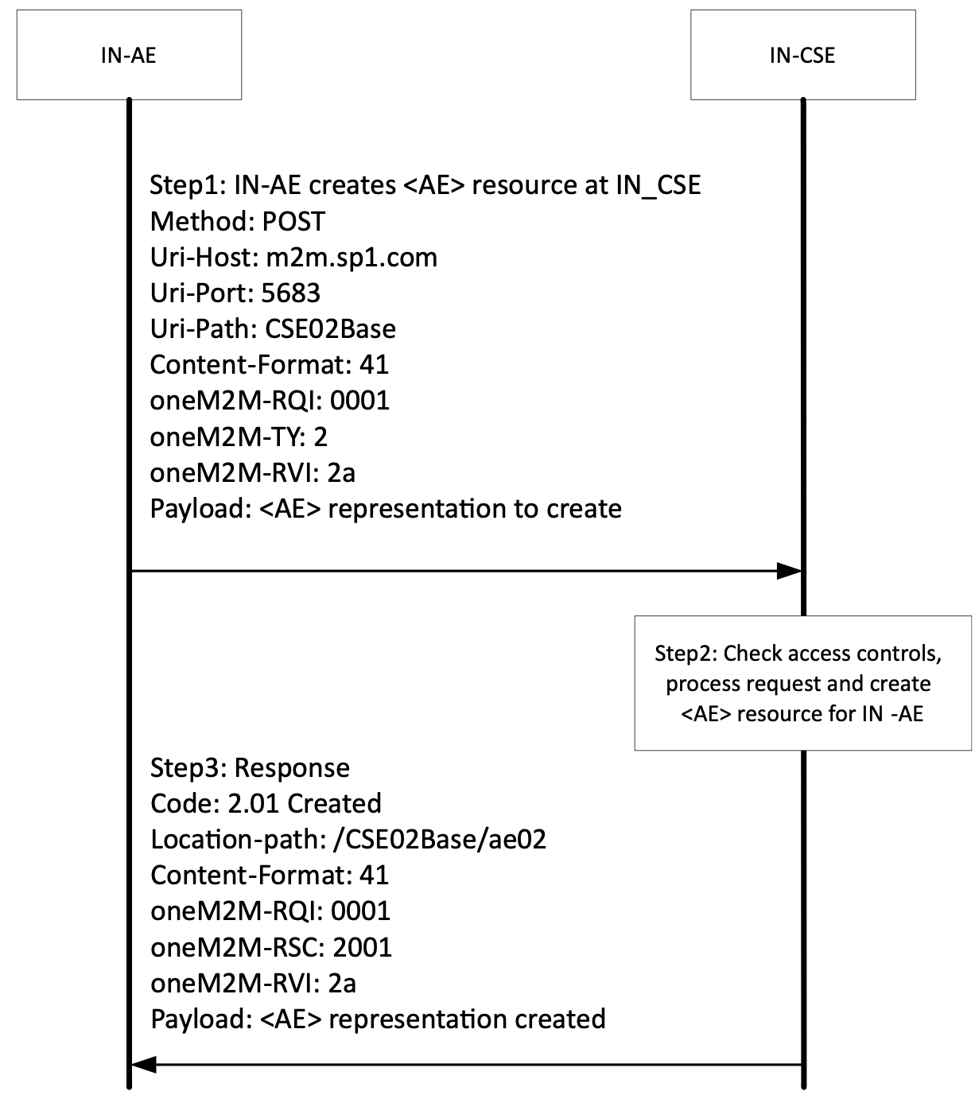
Figure A.1-1: Binding Example - Blocking case of AE Registration

A.2 Non-blocking synchronous case of AE Registration
Figure A.2-1 illustrates CoAP mapping of AE Registration procedure described in clauses 7.2.2.1, 7.4.6.2.2 and E.2 of oneM2M TS-0004 [2] and shows an example of non-blocking synchronous case which is described in clause 6.3.3.
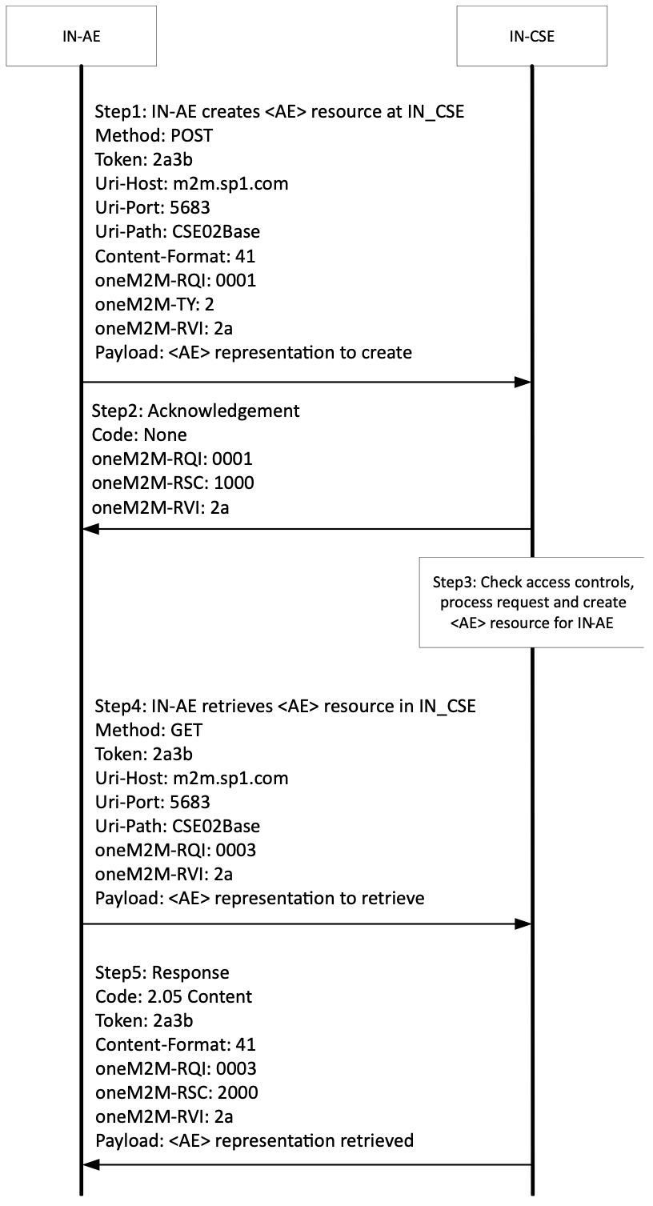
Figure A.2-1: Binding Example - Non-blocking synchronous case of AE Registration

Annex B (normative):
Multicast group fan out procedure

B.0 Introduction
This clause describes the behaviour of CoAP layer for multicast group fan out procedure. Figure B.0-1 illustrates the steps involved in the interaction.
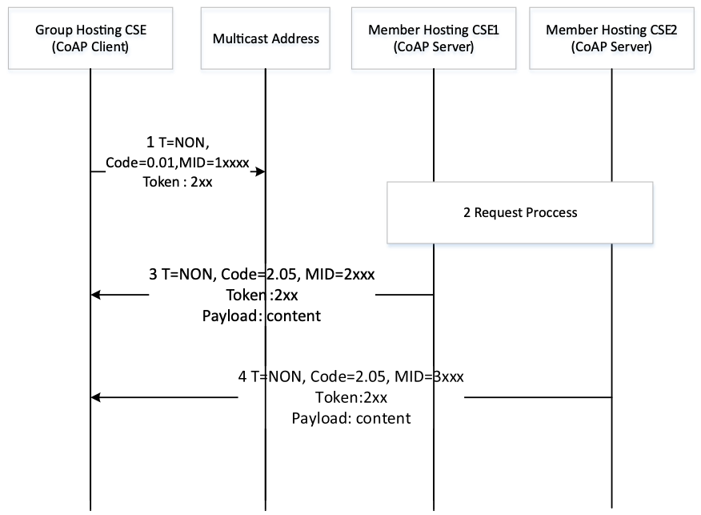
Figure B.0-1: Multicast group fan out procedure
- The Group Hosting CSE (CoAP client) shall use the Non-confirmable Method for the resource to the Member Hosting CSEs (CoAP server). The Group Hosting CSE shall provide a unique Token value in the request.
- The Member Hosting CSE, upon successful processing of the request, shall send an appropriate response in a separate Non-confirmable message with the same Token value.

B.1 Security
DTLS is not applicable to multicast group fan out messages. Security for multicast group fan out is addressed in clause 6.1.2.2.3 of oneM2M TS-0003 [4].

B.2 Caching
A GET request to a multicast group fan out shall not contain an ETag option.

History
Publication history

Draft history
V5.0.0 | 20 May 2024 | Initial version using V4.5.0 as a baseline and incorporating CR:  SDS-2024-0028R04-CoAP_Primitive_Parameter_mapping_changes  Including a fix to the following issue:  #205 Error in TS-0008 clause 6.3.3
V5.1.0 | 23 Feb 2025 | Incorporated CR  SDS-2024-0161-TS-0008_(R5)_Add_missing_INVALID_PROCESS_CONFIGURATION_status_code_map
V5.2.0 | 3 June 2026 | Converted to Markdown  Incorporated fixes to issue #259

