

oneM2M
Technical Specification
Document Number | TS-0035-v5.0.1
Document Name: | OSGi Interworking
Date: | 2026-03-19
Abstract: | The document defines principles and guidelines on interworking OSGi based devices and gateways to oneM2M system.
'Template Version: January 2020 (do not modify)

The present document is provided for future development work within oneM2M only. The Partners accept no liability for any use of this specification.
The present document has not been subject to any approval process by the oneM2M Partners Type 1. Published oneM2M specifications and reports for implementation should be obtained via the oneM2M Partners' Publications Offices.

About oneM2M
The purpose and goal of oneM2M is to develop technical specifications which address the need for a common M2M Service Layer that can be readily embedded within various hardware and software, and relied upon to connect the myriad of devices in the field with M2M application servers worldwide.
More information about oneM2M may be found at: http//www.oneM2M.org
Copyright Notification
© 2026, oneM2M Partners Type 1.
All rights reserved.
The copyright extends to reproduction in all media.

Notice of Disclaimer & Limitation of Liability
The information provided in this document is directed solely to professionals who have the appropriate degree of experience to understand and interpret its contents in accordance with generally accepted engineering or other professional standards and applicable regulations. No recommendation as to products or vendors is made or should be implied.
NO REPRESENTATION OR WARRANTY IS MADE THAT THE INFORMATION IS TECHNICALLY ACCURATE OR SUFFICIENT OR CONFORMS TO ANY STATUTE, GOVERNMENTAL RULE OR REGULATION, AND FURTHER, NO REPRESENTATION OR WARRANTY IS MADE OF MERCHANTABILITY OR FITNESS FOR ANY PARTICULAR PURPOSE OR AGAINST INFRINGEMENT OF INTELLECTUAL PROPERTY RIGHTS. NO oneM2M PARTNER TYPE 1 SHALL BE LIABLE, BEYOND THE AMOUNT OF ANY SUM RECEIVED IN PAYMENT BY THAT PARTNER FOR THIS DOCUMENT, WITH RESPECT TO ANY CLAIM, AND IN NO EVENT SHALL oneM2M BE LIABLE FOR LOST PROFITS OR OTHER INCIDENTAL OR CONSEQUENTIAL DAMAGES. oneM2M EXPRESSLY ADVISES ANY AND ALL USE OF OR RELIANCE UPON THIS INFORMATION PROVIDED IN THIS DOCUMENT IS AT THE RISK OF THE USER.

Contents

1 Scope
The present document defines principles and guidelines on how to interwork devices and gateways that comply to the OSGi framework to the oneM2M system. The interworking includes service exposure between an OSGi device or gateway and the oneM2M system. With the interworking, OSGi defined services can be made available by oneM2M defined resources. As a result, by making requests to oneM2M resources, applications can access the services provided by OSGi devices or gateways.

2 References

2.1 Normative references
References are either specific (identified by date of publication and/or edition number or version number) or nonspecific. For specific references, only the cited version applies. For non-specific references, the latest version of the referenced document (including any amendments) applies.
The following referenced documents are necessary for the application of the present document.
[1] oneM2M TS-0023: "Home Appliances Information Model and Mapping".
[2] oneM2M TS-0033: "Proximal IoT Interworking".
NOTE: Available at http://www.onem2m.org/technical/published-drafts.

2.2 Informative references
References are either specific (identified by date of publication and/or edition number or version number) or nonspecific. For specific references, only the cited version applies. For non-specific references, the latest version of the referenced document (including any amendments) applies.
The following referenced documents are not necessary for the application of the present document but they assist the user with regard to a particular subject area.
[i.1] oneM2M Drafting Rules.
NOTE: Available at http://www.onem2m.org/images/files/oneM2M-Drafting-Rules.pdf.
[i.2] OSGi Residential.
NOTE: Available at https://osgi.org/download/r6/osgi.residential-6.0.0.pdf.

3 Abbreviations
For the purposes of the present document, the following abbreviations apply:
DAL Device Abstraction Layer
AE Application Entity
CSE Common Services Entity
SDT Smart Device Template
DMT Device Management Tree
IPE Interworking Proxy Entity
HAIM Home Appliance Information Model
UID Unique Identifier
UIDS Unique Identifiers
TS Technical Specification

4 Conventions
The key words "Shall", "Shall not", "May", "Need not", "Should", "Should not" in this document are to be interpreted as described in the oneM2M Drafting Rules [i.1].

5 OSGi Interworking General Architecture

5.1 OSGi Interworking Architecture
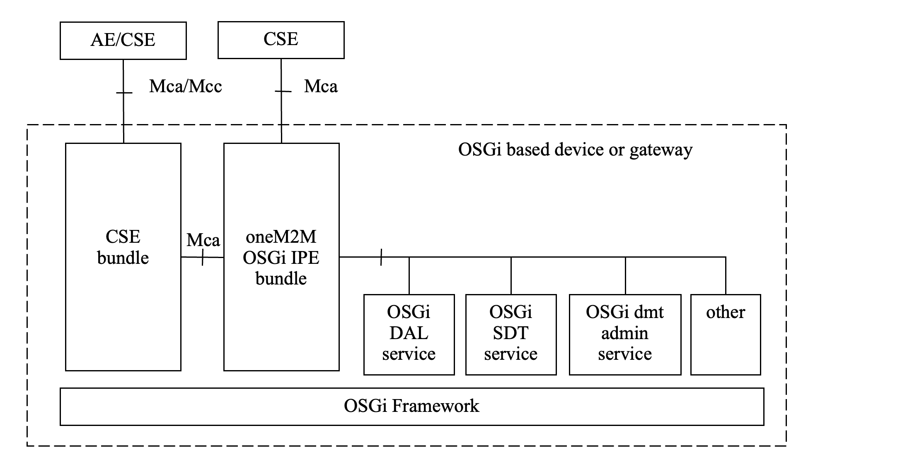
Figure 5.1-1: OSGi Interworking Architecture
Figure 5.1-1: OSGi Interworking Architecture
OSGi Interworking is to interwork services provided by an OSGi based device or gateway to oneM2M entities which may be an AE or CSE. The OSGi services may include an OSGi defined DAL (Device Abstraction Layer) service, SDT (Smart Device Template) service, DMT (device management tree) admin service, other standardized services or proprietary services. The oneM2M-OSGi IPE bundle is in charge of the interworking of OSGi services to oneM2M resources and vice versa.
The IPE bundle maps the invocation of the OSGi services and changes of state of oneM2M resources. If the OSGi based device or gateway hosts a CSE bundle, the IPE interacts with the CSE bundle internally. The OSGi based device or gateway interacts with the other oneM2M entities through Mca or Mcc reference point. If the OSGi based device or gateway does not host a CSE bundle, the IPE interacts with the CSE through a network interface.
The principle of how the interworking should be done shall follow the definition in oneM2M TS-0033 [2] proximal IoT interworking. For devices described by HAIM (Home Appliance Information Model) in oneM2M TS-0023 [1], <flexContainer> resources shall be used to represent the OSGi services. oneM2M also allows the transparent interworking of OSGi services through <container> resources, <AE> resources and <node> resources as defined in oneM2M TS-0033 [2].

6 Mapping of OSGi DAL

6.1 Introduction
The OSGi DAL (Device Abstraction Layer) [i.2] is an OSGi defined service to unify interfaces for accessing devices. By using the OSGi DAL, application developers do not need to deal with protocol details to interact with different types of devices such as sensors, actuators, etc.
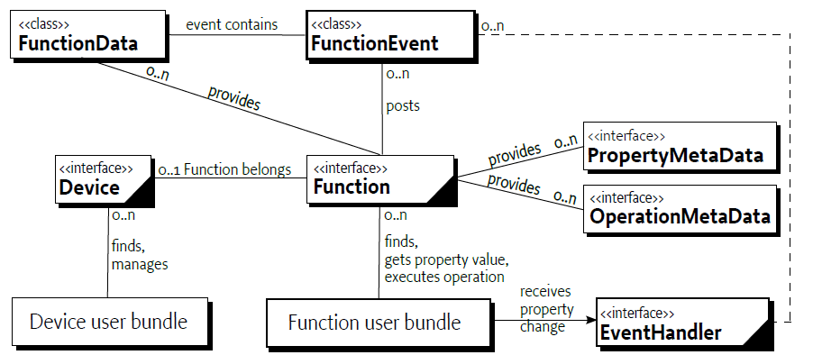
Figure 6.1-1: OSGi DAL [i.2]
Figure 6.1-1: OSGi DAL [i.2]
OSGi DAL is comprised of several services:
- Device: represents the registered device in the OSGi framework. The device service contains properties describing the device's metadata and context information. The device service has one or more function services.
- Function: represents the function provided by the device. The function could be data reporting or actuating. The function provides a set of FunctionData, properties and operations. A property is the data information that can be accessed by the application. An operation is the interface that can be invoked by an application to trigger a certain procedure. The function also posts FunctionEvent.
- FunctionEvent: represents the asynchronous event of the function. Once the event is triggered, the event is handled by the registered event handler.
- FunctionData: represents the data structure that contains the property and metadata of the function.
- PropertyMetadata: represents the metadata of the function property.
- OperationMetadata: represents the metadata of the function operation.

6.2 Device service
The device service defined by OSGi DAL maps to a oneM2M NoDN and is represented as a specialized <flexContainer> resource and a <node> resource.
The OSGi device service itself shall be mapped to a specialized <flexContainer> resource of a specific device model that the OSGi device service instance represents. The properties of an OSGi device service shall be mapped to the attributes of the <flexContainer> resource, the <node> resource, and its child [deviceInfo] resource.
Once an OSGi device service is registered at the OSGi framework, the IPE shall be responsible for acquiring all OSGi device service properties and other related services (such as OSGi function services) and creating the corresponding resources on the oneM2M CSE.
Upon the registration of an OSGi device service, the IPE should create a <node> resource and a [deviceInfo] specialization as the child resource of the <node> resource. The IPE should also create one_<flexContainer>_ resource with specialized mandatory [customAttribute] as a 'nodeLink' attribute, which links to a <node> resource that is hosted on the same hosting CSE of the <flexContainer> . The mapping between OSGi device and oneM2M resources shall be as follows.
Table 6.2-1: Mapping of OSGi device service to oneM2M resources
OSGi | oneM2M | Description
OSGi device service | <node> resource, [deviceInfo] resource, <flexContainer> resource | The <node> , [deviceInfo] and <flexContainer> resources are created upon the available of OSGi device service.
SERVICE_UID property | See description | Maps to the resourceID of the <flexContainer> allocated by the Hosting CSE, however the value does not need to be same. The mapping between SERVICE_UID and resourceID is maintained by IPE internally.
SERVICE_REFERENCE_UIDS property | See description | Reference device maps to the sub-device defined in oneM2M. Therefore, the reference device in OSGi is mapped to the hierarchical relationship of <flexContainer> resources.
SERVICE_DRIVER property | areaNwkType attribute of [areaNwkInfo] resource | Service driver maps to the area network type.
SERVICE_NAME property | resourceName attribute of <flexContainer> resource | The SERVICE_NAME is used to request resource name of <flexContainer> resource.
SERVICE_STATUS property | See description | Is maintained by lifecycle management of <flexContainer> resources. The <flexContainer> resource should only be created if the SERVICE_STATUS of the OSGi device is STATUS_ONLINE.
SERVICE_STATUS_DETAIL property | See description | The status is not visible to oneM2M. The IPE will monitor the status change and reflect the status change in the lifecycle management of the <flexContainer> resource.
SERVICE_HARDWARE_VENDOR property | manufacturer attribute of [deviceInfo] resource | -
SERVICE_HARDWARE_VERSION property | hwVersion attribute [deviceInfo] resource | -
SERVICE_FIRMWARE_VENDOR property | labels attribute of [deviceInfo] resource | -
SERVICE_FIRMWARE_VERSION property | fwVersion attribute of [deviceInfo] resource | -
SERVICE_TYPES property | deviceType attribute of [deviceInfo] resource | -
SERVICE_MODEL property | model attribute of [deviceInfo] resource | -
SERVICE_SERIAL_NUMBER property | deviceLabel attribute of [deviceInfo] resource | -

6.3 Function service

6.3.1 Introduction
An OSGi function service maps to a specialized <flexContainer> resource that correspond to a moduleClass specified in oneM2M TS-0023 [1]. An OSGi function service may be mapped to different <flexContainer> s that correspond to different moduleClasses depending on the OSGi device service that the OSGi function service belongs to.
Table 6.3.1-1: Mapping of OSGi function to oneM2M resources
OSGi | oneM2M | Description
OSGi function service | moduleClass <flexContainer> resource | The function service is mapped to moduleClass <flexContainer> .
SERVICE_UID property | See description | Maps to resourceID of <flexContainer> resource. The resourceID is allocated by Hosting CSE. The mapping relationship is maintained by IPE internally.
SERVICE_TYPE property | See description | Maps to containerDefinition of <flexContainer> resource and is maintained by IPE.
SERVICE_VERSION property | labels attribute of the <flexContainer> resource | Versioning information of the OSGi service is mapped to labels attribute of the <flexContainer> resource.
SERVICE_DEVICE_UID property | See description | Maintained by the parent-child relationship of device model <flexContainer> and moduleClass <flexContainer>
SERVICE_REFERENCE_UIDS property | labels attribute of the <flexContainer> resource | Mappes to the labels attribute of the <flexContainer> resource.
SERVICE_DESCRIPTION property | labels attribute of <flexContainer> resource | The description of the service maps to the labels attribute of <flexContainer> resource.
SERVICE_OPERATION_NAMES property | <flexContainer> resource for action
SERVICE_PROPERTY_NAMES property | <flexContainer> resource for property

6.3.2 BooleanControl Function
BooleanControl function is used for switch-type of device functions like a light, door, window or power socket. It maps to the binarySwitch <flexContainer> that is a moduleClass.
Table 6.3.2-1: Mapping of BooleanControl function to binarySwitch moduleClass
OSGi | oneM2M | Description
inverse | toggle | Toggle the switch.
setTrue | Update the powerState to true
setFalse | Update the powerState to false
data | powerState | The current state of the switch

6.3.3 BooleanSensor Function
BooleanSensor function is used to report the data of a device function such as a light, door, window or power socket. It maps to several different <flexContainer> resources that are moduleClass. It is based on the device type which determines the specialization of <flexContainer> to be mapped to.
Table 6.3.3-1: Mapping of BooleanSensor function to binarySwitch moduleClass
OSGi | oneM2M | Description
data | powerState
Table 6.3.3-2: Mapping of BooleanSensor function to doorLock moduleClass
OSGi | oneM2M | Description
data | doorLock
Table 6.3.3-3: Mapping of BooleanSensor function to boiler moduleClass
OSGi | oneM2M | Description
data | status
Table 6.3.3-4: Mapping of BooleanSensor function to waterSensor moduleClass
OSGi | oneM2M | Description
data | alarm

6.3.4 MultiLevelControl Function
The MultiLevelControl Function maps to different moduleClass depending on the device type.
Table 6.3.4-1: Mapping of MultiLevelControl function to brightness moduleClass
OSGi | oneM2M | Description
data | brightness
Table 6.3.4-2: Mapping of MultiLevelControl function to foaming moduleClass
OSGi | oneM2M | Description
data | foamingStrength

6.3.5 MultiLevelSensor Function
The MultiLevelSensor Function maps to different moduleClass depending on the device type.
Table 6.3.5-1: Mapping of MultiLevelControl function to height moduleClass
OSGi | oneM2M | Description
data | height
Table 6.3.5-2: Mapping of MultiLevelControl function to weight moduleClass
OSGi | oneM2M | Description
data | weight
Table 6.3.5-3: Mapping of MultiLevelControl function to liquidRemaining moduleClass
OSGi | oneM2M | Description
data | liquidRemaining
Table 6.3.5-4: Mapping of MultiLevelControl function to brightness moduleClass
OSGi | oneM2M | Description
data | brightness
Table 6.3.5-5: Mapping of MultiLevelControl function to foaming moduleClass
OSGi | oneM2M | Description
data | foamingStrength

6.3.6 Meter Function
The Meter Function maps to different moduleClass depending on the device type.
Table 6.3.6-1: Mapping of Meter function to energyConsuption moduleClass
OSGi | oneM2M | Description
current | roundingEnergyConsumption
total | absoluteEnergyConsumption

6.3.7 Alarm Function
The Alarm Function maps to different moduleClass depending on the device type.
Table 6.3.7-1: Mapping of Alarm function to motionSensor moduleClass
OSGi | oneM2M | Description
alarm | alarm
Table 6.3.7-2: Mapping of Alarm function to smokeSensor moduleClass
OSGi | oneM2M | Description
alarm | alarm
Table 6.3.7-3: Mapping of Alarm function to temperatureAlarm moduleClass
OSGi | oneM2M | Description
alarm | alarm
Table 6.3.7-4: Mapping of Alarm function to waterSensor moduleClass
OSGi | oneM2M | Description
alarm | alarm

6.3.8 Keypad Function
The Keypad Function maps to keypad moduleClass of oneM2M.
Table 6.3.8-1: Mapping of Keypad function to keypad moduleClass
OSGi | oneM2M | Description
key | keyNumber

6.3.9 WakeUp Function
This Function currently has no corresponding moduleClass in oneM2M.

6.4 Device service procedure
The IPE is responsible for monitoring the OSGi Device service and synchronizing the properties of the Device service to attributes of the oneM2M resources.
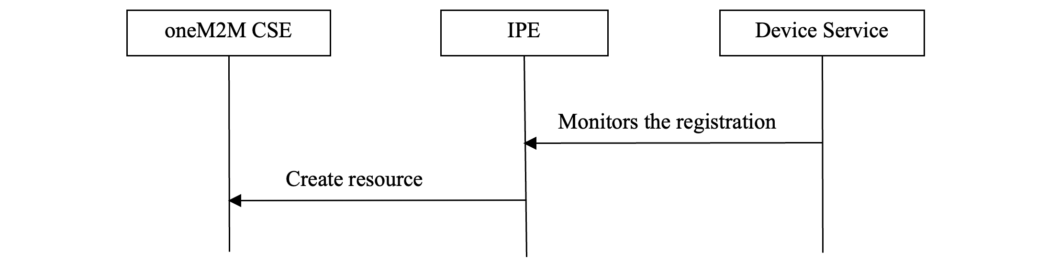
Figure 6.4-1: Procedure of registering Device service
Figure 6.4-1: Procedure of registering Device service
The mapping of resources shall follow the definition in oneM2M TS-0033 [2] proximal IoT interworking. Depending on the available properties of the Device service, <node> resource, <AE> resource, <container> resource or <flexContainer> resource may be used to represent the Device service.

6.5 Function service procedure
The IPE is responsible for monitoring the Function property and synchronizing the change of the property to oneM2M resources. The IPE is also responsible for monitoring the update of the oneM2M resource that corresponds to the Function operation. Upon receiving the request targeting the resource, the IPE shall invoke the corresponding Function operation.
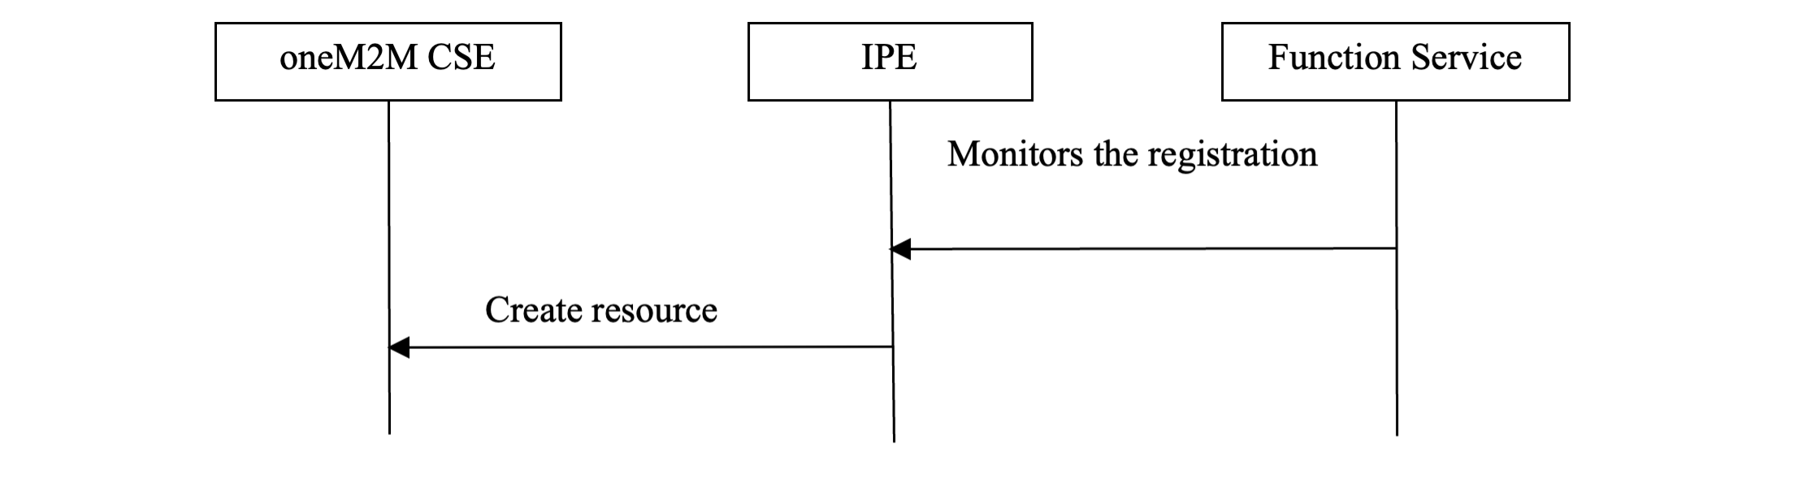
Figure 6.5-1: Procedure of registering function service
Figure 6.5-1: Procedure of registering function service
Monitors the registration: The IPE monitors the registration of the Function service to the OSGi framework.
Create resource: The IPE creates the corresponding resource to the oneM2M CSE.
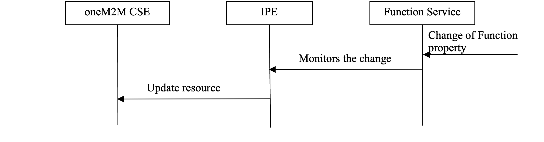
Figure 6.5-2: Procedure of changing function property
Figure 6.5-2: Procedure of changing function property
Change of Function property: The Function property may be changed due to various reasons such as hardware triggered break, sensor change, local application change etc.
Monitors the change: The IPE monitors the change by subscribing to the eventable properties, acquiring the property periodically or by some other internal call back functions.
Update the resource: The IPE updates the corresponding resource of the Function.
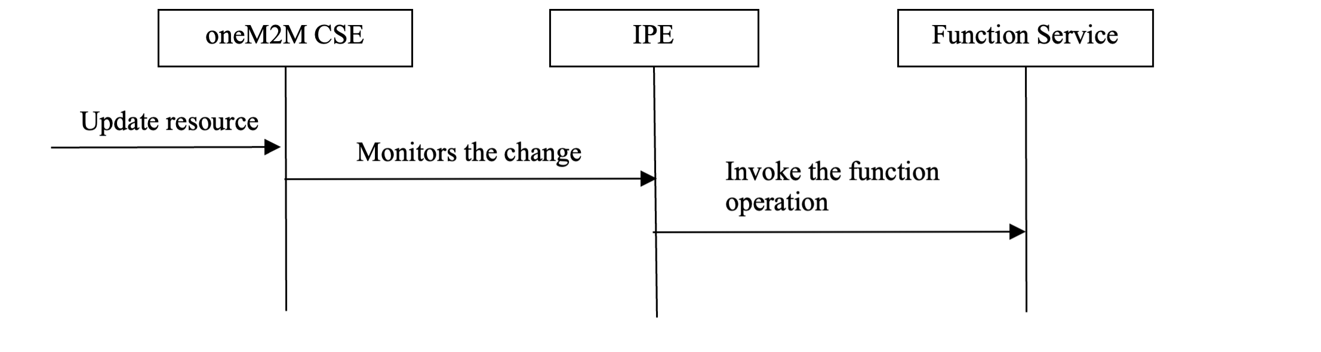
Figure 6.5-3: Procedure of invoking function operation
Figure 6.5-3: Procedure of invoking function operation
Update resource: The oneM2M CSE receives update requests from applications to update the resource that corresponds with the Function service.
Monitors the change: The IPE monitors the change by subscribing to the resource and receiving notifications or polling etc.
Invoke the function operation: The IPE invokes the function operation provided by the Function service.

History
Publication history
V3.0.0 | April 2019 | Release 3 - Publication
V4.0.0 | February 2023 | Release 4 - Publication

Draft history (to be removed on publication)
V5.0.0 | 2025-04-01 | First draft for Rel-5 based on V4.0.0
V5.0.1 | 2026-03-19 | Conversion to markdown format

