

oneM2M
Technical Specification
Document Number | TS-0040-v5.0.3
Document Name: | Modbus Interworking
Date: | 2026-03-20
Abstract: | The present document specifies the oneM2M and Modbus interworking technologies that enable Modbus devices and oneM2M entities produce/consume services. This includes the interworking architecture model that describes where the Modbus Interworking Proxy Entity (IPE) is hosted and how the IPE is composed with. This document describes Modbus services to oneM2M resource mapping structure and rules, followed by describing detailed interworking procedures.
'Template Version: January 2020 (do not modify)

The present document is provided for future development work within oneM2M only. The Partners accept no liability for any use of this specification.
The present document has not been subject to any approval process by the oneM2M Partners Type 1. Published oneM2M specifications and reports for implementation should be obtained via the oneM2M Partners' Publications Offices.

About oneM2M
The purpose and goal of oneM2M is to develop technical specifications which address the need for a common M2M Service Layer that can be readily embedded within various hardware and software, and relied upon to connect the myriad of devices in the field with M2M application servers worldwide.
More information about oneM2M may be found at: http//www.oneM2M.org
Copyright Notification
© 2026, oneM2M Partners Type 1.
All rights reserved.
The copyright extends to reproduction in all media.

Notice of Disclaimer & Limitation of Liability
The information provided in this document is directed solely to professionals who have the appropriate degree of experience to understand and interpret its contents in accordance with generally accepted engineering or other professional standards and applicable regulations. No recommendation as to products or vendors is made or should be implied.
NO REPRESENTATION OR WARRANTY IS MADE THAT THE INFORMATION IS TECHNICALLY ACCURATE OR SUFFICIENT OR CONFORMS TO ANY STATUTE, GOVERNMENTAL RULE OR REGULATION, AND FURTHER, NO REPRESENTATION OR WARRANTY IS MADE OF MERCHANTABILITY OR FITNESS FOR ANY PARTICULAR PURPOSE OR AGAINST INFRINGEMENT OF INTELLECTUAL PROPERTY RIGHTS. NO oneM2M PARTNER TYPE 1 SHALL BE LIABLE, BEYOND THE AMOUNT OF ANY SUM RECEIVED IN PAYMENT BY THAT PARTNER FOR THIS DOCUMENT, WITH RESPECT TO ANY CLAIM, AND IN NO EVENT SHALL oneM2M BE LIABLE FOR LOST PROFITS OR OTHER INCIDENTAL OR CONSEQUENTIAL DAMAGES. oneM2M EXPRESSLY ADVISES ANY AND ALL USE OF OR RELIANCE UPON THIS INFORMATION PROVIDED IN THIS DOCUMENT IS AT THE RISK OF THE USER.

Contents

1 Scope
The present document specifies the oneM2M and Modbus interworking technologies that enable Modbus devices and oneM2M entities produce/consume services.
Clause 5 defines the interworking architecture model that describes where the Modbus IPE is hosted and how the IPE is composed with.
Clause 6 defines the architecture aspects that mainly describes Modbus services to oneM2M resource mapping structure and rules. Furthermore, this explains the IPE registration and interworking procedures.

2 References

2.1 Normative references
References are either specific (identified by date of publication and/or edition number or version number) or nonspecific. For specific references, only the cited version applies. For non-specific references, the latest version of the reference document (including any amendments) applies.
The following referenced documents are necessary for the application of the present document.
[1] oneM2M TS-0001: "Functional Architecture".
[2] oneM2M TS-0004: "Service Layer Core Protocol".
[3] oneM2M TS-0023: "SDT based Information Model and Mapping for Vertical Industries".

2.2 Informative references
References are either specific (identified by date of publication and/or edition number or version number) or nonspecific. For specific references, only the cited version applies. For non-specific references, the latest version of the reference document (including any amendments) applies.
The following referenced documents are not necessary for the application of the present document but they assist the user with regard to a particular subject area.
[i.1] oneM2M Drafting Rules.
NOTE: Available at http://www.onem2m.org/images/files/oneM2M-Drafting-Rules.pdf.
[i.2] Modbus website.
NOTE: Available at http://www.modbus.org/.
[i.3] Modbus-Application-Protocol-V1-1b3, Modbus Organization.
[i.4] Modbus-Messaging-Implementation-Guide-V1-0b, Modbus Organization.
[i.5] Modbus-over-serial-line-V1-02, Modbus Organization.
[i.6] IETF RFC 4180: "Common Format and MIME Type for Comma-Separated Values (CSV) Files".
NOTE: Available at https://www.ietf.org/rfc/rfc4180.txt#page-1.

3 Definition of terms, symbols and abbreviations

3.1 Terms
For the purposes of the present document, the following terms apply:
Modbus Master: software running on a computer or a server as a host to access Modbus Slaves by issuing unicast requests
Modbus Slave/Device: peripheral device that provides a Modbus interface and responds by supplying the requested data to the master, or by taking the action requested in the query

3.2 Symbols
Void.

3.3 Abbreviations
For the purposes of the present document, the following abbreviations apply:
AE Application Entity
CSE Common Services Entity
CSV Comma-Separated Values
IPE Interworking Proxy Entity
SDT Smart Device Template
MN/IN Middle Node/Infrastructure Node
noDN Non-oneM2M Device Node
RTU Remote Terminal Unit
UDP User Datagram Protocol
PLC Programmable Logic Controller
I/O Input/Output
ASCII American Standard Code for Information Interchange
TCP Transmission Control Protocol
IP Internet Protocol
MB Modbus
MBP Modbus Plus
HDLC High-level Data Link Control
ADU Application Data Unit
PDU Protocol Data Unit
RS Recommended Standard
MBAP Modbus Application Protocol
PC Personal Computer

4 Conventions
The key words "Shall", "Shall not", "May", "Need not", "Should", "Should not" in the present document are to be interpreted as described in the oneM2M Drafting Rules [i.1].

5 Architecture Model

5.1 Reference model
The architecture model followed in the present document is based on the architecture model in oneM2M TS0001 [1] that describes how interworking between oneM2M CSEs and non-oneM2M systems using specialized Interworking Proxy application Entities (IPEs). The present document describes the Modbus IPE that supports the following reference model.
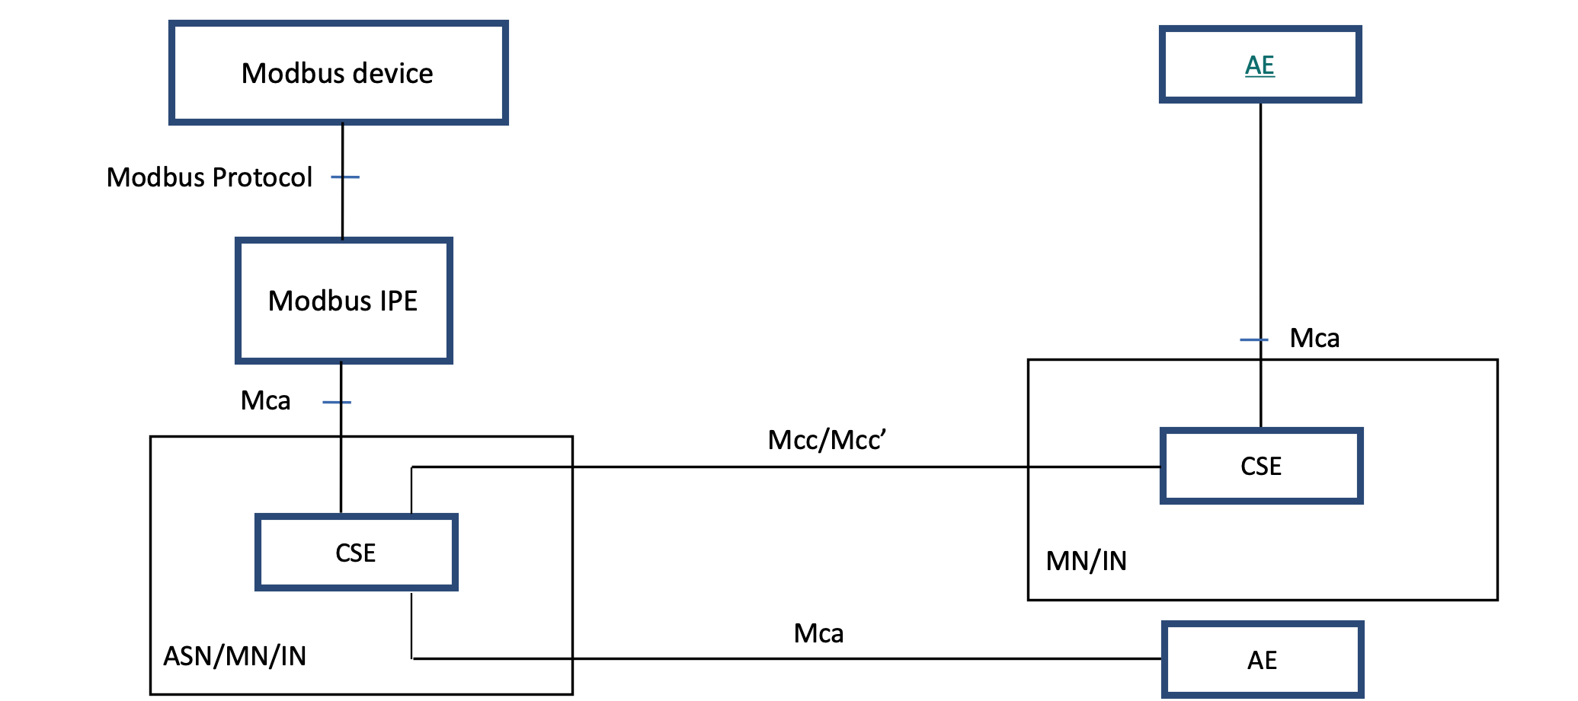
Figure 5.1-1: Modbus interworking reference model
Figure 5.1-1: Modbus interworking reference model

5.2 Composition of the IPE
As shown in Figure 5.2-1, the Modbus IPE consists of AE and Modbus Master [i.2]. To provide the interworking functions to other oneM2M entities, the IPE shall register to a CSE and communicate with Modbus devices using Modbus protocol. The IPE registration is mandatory in oneM2M systems. Modbus discovery and session establishment are needed for the IPE to communicate with other Modbus applications. A single Modbus IPE may expose Modbus functions provided by one or more Modbus devices to the oneM2M System.
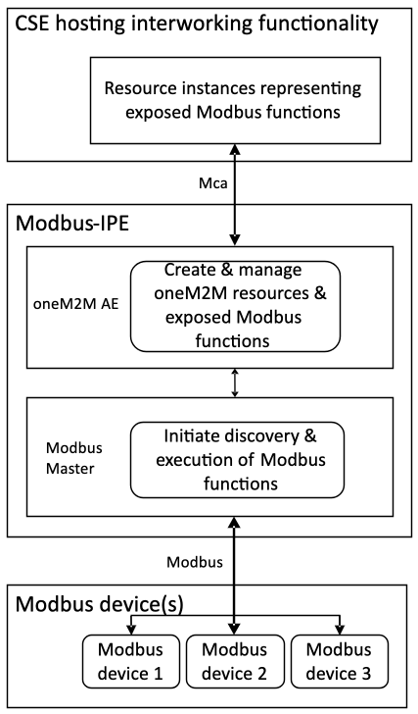
Figure 5.2-1: Composition of Modbus-IPE
Figure 5.2-1: Composition of Modbus-IPE

6 Architecture Aspects

6.1 Introduction
The present document specifies the functions for Modbus interworking in the following aspects:
- oneM2M resource mapping structure;
- Modbus IPE registration;
- Modbus service mapping;
- Modbus interworking procedures.

6.2 oneM2M resource mapping structure

6.2.1 Introduction
In this clause, the overall resource mapping structure for exposing services between Modbus devices and oneM2M entities is introduced. Firstly, Modbus devices are modelled according to the oneM2M SDT described in oneM2M TS0023 [3]. The oneM2M SDT offers a generic and flexible modeling structure for describing functionalities of nononeM2M devices including Modbus devices. After the SDT schemas of the Modbus devices are created, they are mapped to oneM2M resources.

6.2.2 Mapping Modbus devices into SDT schemas
Each Modbus device shall be modelled as a Device component. The Modules of the Device shall be created according to the functionality of the Modbus device as defined in oneM2M TS0023 [3].
For representing data objects of a Modbus device, the mapping between a Modbus device's registers [i.2], [i.3] and SDT DataPoints is defined. Every Modbus register has the following properties: slave id, register type, address, length. The information of these registers is typically provided by a manufacturer in a device's datasheet. Register type and length are used to define the following SDT DataPoint attributes: DataType, writable, readable, and optional. The rules to perform the mapping are shown in Table 6.2.2-1. A holding register and input register of length 2 can be mapped into either xs:integer or xs:float DataType depending on data context. As an example mapping, a coil register can be mapped to a DataPoint with DataType (xs:boolean), Readable (True), and Writable (True). The optional attribute depends on a Modbus device and application logic and is supposed to be defined by the system integrator.
Table 6.2.2-1: Mapping between Modbus register types and SDT Data points
Modbus Register |  | Mapping | SDT Data points
Modbus register type | Length |  | DataType | Readable | Writable
Coil (1 bit, Read-Write) | 1 (1 bit) | => | xs:boolean | True | True
Discrete Input (1 bit, Read-Only) | 1 (1 bit) | => | xs:boolean | True | False
Holding Register  (16-bit, Read-Write) | 2  (4 bytes) | => | xs:integer / xs:float | True | True
Input Register  (16-bit, Read-Only) | 2  (4 bytes) | => | xs:integer / xs:float | True | False
Holding Register  (16-bit, Read-Write) | 1  (2 bytes) | => | xs:integer | True | True
Input Register  (16-bit, Read-Only) | 1  (2 bytes) | => | xs:integer | True | False
Holding Register  (16-bit, Read-Write) | 4  (8 bytes) | => | xs:double | True | True
Input Register  (16-bit, Read-Only) | 4  (8 bytes) | => | xs:double | True | False

6.2.3 Mapping SDT schemas into oneM2M resources
The mapping of all SDT components follows the mapping procedure defined in clause 6.2 of oneM2M TS0023 [3]. For example, the ModuleClass models shall be mapped to the specializations of <flexContainer> resource and their DataPoints to customAttributes of the corresponding <flexContainer> specializations. However, the SDT schemas do not consider interworking options with non-oneM2M Device Nodes (noDN) such as Modbus devices. For that reason, a nodnProperties attribute shall be added as a customAttribute of a <flexContainer> resource specialization which is mapped from an associated ModuleClass model.
The nodnProperties attribute stores one-to-one mappings in CSV string format [i.6] between each customAttribute of <flexContainer> resource specialization and a Modbus register with which it is associated. Each line in the nodnProperties shall contain the name of a customAttribute and associated Modbus register properties (slave id, register type, address, length). The order they are aligned is the following: customAttribute name, slave id, register type, address, length. The nodnProperties shall have one record per line and each property separated by a comma. The header line for this CSV string is mandatory and shall contain the names corresponding to the fields in the string as defined in the section 2.3 of the CSV format specification [i.6]. Table 6.2.3-1 shows the detailed information on the fields of the nodnProperties attribute.
An example oneM2M resource schema including nodnProperties is provided in Annex B, Figure B.2.2-2.
Table 6.2.3-1: Fields of nodnProperties attribute
Field name | Type | Description
customAttribute name | String | Name of customAttribute
slave id | Integer | Slave id of Modbus device
register type | Enumeration | One of 4 register types (see Table 6.2.3-2)
address | Integer | Address of the first register associated with a variable
length | Integer | Number of registers an associated variable occupies
Table 6.2.3-2: Interpretation of register type
Value | Interpretation
1 | Coil
2 | Discrete input
3 | Holding register
4 | Input register

6.3 Modbus IPE registration
Figure 6.3-1 shows the device registration call flow:
- The IPE shall request to create an <AE> resource on the Hosting CSE to register the Modbus master collocated on the IPE.
- The Hosting CSE shall evaluate the request, performs the appropriate checks, and creates the <AE> resource. The Hosting CSE shall respond with the successful result of <AE> resource creation, otherwise it responds with an error.
- Modbus devices are registered at Modbus IPE, in particular Modbus interworking information (slave id, registers type, address, length) are defined in accordance with provided device datasheet.
- Modbus IPE shall send corresponding requests to a CSE to create resources which were from SDT schemas as described in clause 6.2.3. For all <flexContainer> resources, the containerDefinition attribute is mandatory. The contentSize attribute is calculated by the Hosting CSE. The customAttributes of the <flexContainer> resources should be specified if they are mandatory for that <flexContainer>. Each resource creation is originated by the Modbus-IPE in a separate request for each resource.
- After verifying the privileges and the given attributes, the Hosting CSE shall create each resource.
- The Hosting CSE shall respond with the successful result for each created resource, otherwise it shall respond with an error.
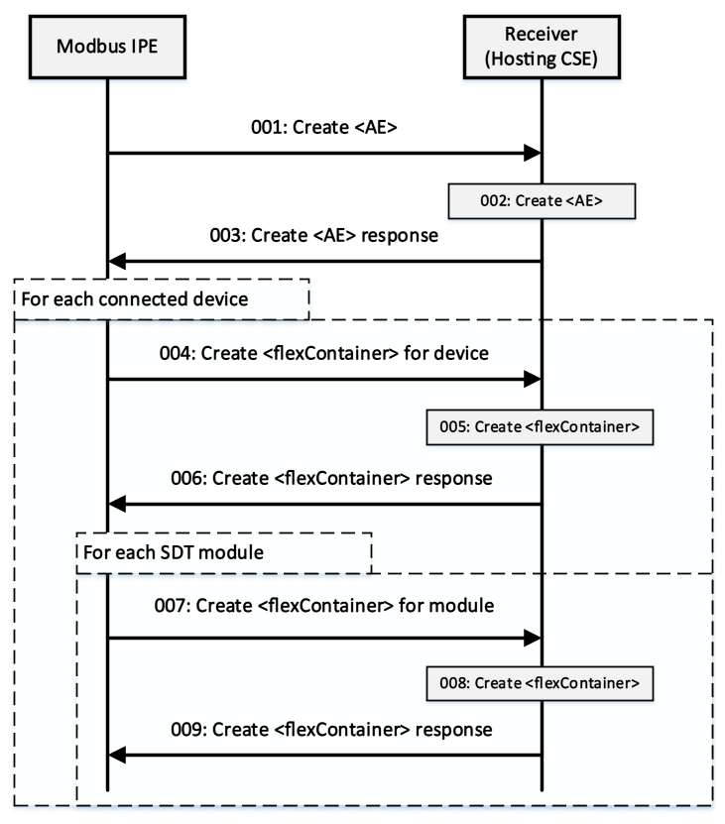
Figure 6.3-1: Device registration call flow
Figure 6.3-1: Device registration call flow

6.4 Modbus service mapping
The Modbus devices can accept either read or write requests from the Master. The operation to be executed is identified from the function code of a Modbus message. Therefore, the IPE needs to be able to map the oneM2M messages to Modbus messages with the appropriate function code. The function code is identified from register type of the register to be read for the read requests and from a tuple of register type and number of registers to be written (length) for the write requests.
For the read requests, the IPE shall map the register type of the register to be read to the function code according to Table 6.4-1. For the write requests, the IPE shall map the tuple of register type and the number of registers to be written (length) to the function code according to Table 6.4-2. Both the register type and the length along with other Modbus data needed to construct the Modbus message can be retrieved from the nodnProperties customAttribute of a <flexContainer> specialization derived from a ModuleClass.
Table 6.4-1: Register type to function code mapping for Modbus read request
Register type | Function code
Coil | 01
Discrete input | 02
Holding register | 03
Input register | 04
Table 6.4-2: Register type and length to function code mapping for Modbus write request
Register type | Length > 1 | Function code
Coil | false | 05
Coil | true | 0F
Holding register | false | 06
Holding register | true | 10

6.5 Modbus interworking procedures

6.5.1 Retrieve data from a Modbus device
Suppose a scenario when current readings of a Modbus device need to be displayed at an AE application and Modbus-IPE continuously monitors a Modbus device and uploads that data to a CSE hosted on a server in the network. Initially, the AE shall be subscribed to the <flexContainer> resource, which is a specialization of some SDT module for a Modbus device, using a <subscription> resource (notificationEventType A, see clause 9.6.8 in oneM2M TS0001 [1]). The following steps described in Figure 6.5.1-1 shall be performed for this scenario:
- The Modbus IPE shall send a retrieve <flexContainer> request to the hosting CSE. This <flexContainer> resource is a specialization of some Modbus module and contains nodnProperties attribute.
- The Hosting CSE shall respond to the retrieve request with <flexContainer> data that includes nodnProperties .
- The Modbus IPE shall use information stored in nodnProperties to compose Modbus read request. The function code can be identified from a register type as in Table 6.4-1. Slave id, address and length should be written in corresponding message fields. After the Modbus message is composed, the Modbus IPE sends this message to Modbus device.
- The Modbus device responds with requested data.
- The Modbus IPE shall send an update <flexContainer> request (see clause 7.4.37.2.3 in oneM2M TS0004 [2]). The request body specifies the customAttributes to be updated and their new values read from Modbus device.
- After verifying the privileges and the given attributes, the hosting CSE shall update <flexContainer> resource.
- The hosting CSE shall respond with updated <flexContainer> data after successful update to the Modbus IPE, otherwise it responds with an error.
- The hosting CSE shall send a notification for <flexContainer> resource update to the AE (see clause 7.5.1.2.2 in oneM2M TS0004 [2]).
- The AE sends a confirmation message about notification receiving to the hosting CSE (see clause 7.5.1.2.2 in oneM2M TS0004 [2]).
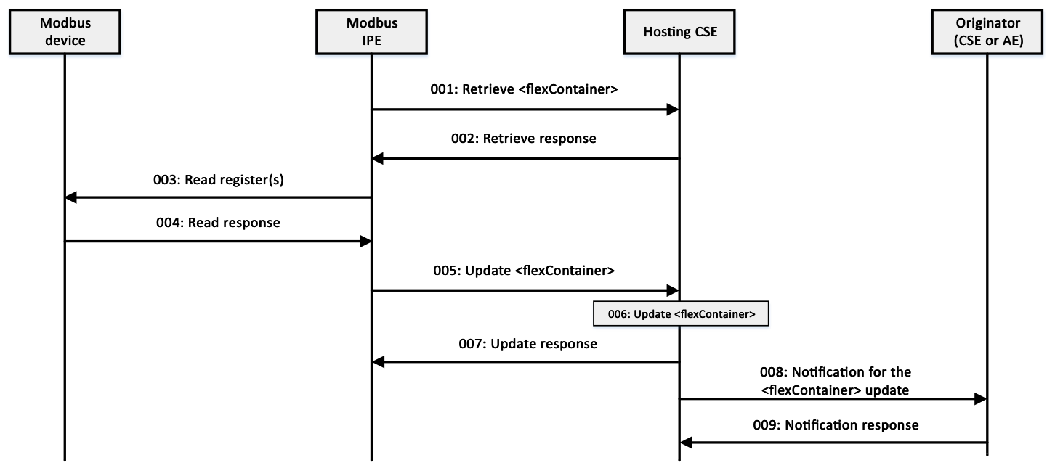
Figure 6.5.1-1: Modbus Slave Device monitoring call flow
Figure 6.5.1-1: Modbus Slave Device monitoring call flow

6.5.2 Write data to a Modbus device
Suppose a scenario when it is required to update some value in a Modbus device through an AE application registered to a CSE. Initially, the Modbus IPE shall be subscribed to the <flexContainer> resource, which is a specialization of some SDT module for a Modbus device, using a blocking type of <subscription> resource (notificationEventType G, see clause 9.6.8 in oneM2M TS0001 [1]). The following steps described in Figure 6.5.2-1 shall be performed for this scenario:
- In order to write data to a Modbus device from the AE, the AE sends a request to update specified customAttributes of the <flexContainer> resource which map to the Modbus Device (see clause 7.4.37.2.3 in oneM2M TS0004 [2]).
- After verifying the privileges and the given attributes, the hosting CSE shall send a notification for the received write request to the Modbus IPE (notification shall include nodnProperties ) and temporarily blocks the <flexContainer> resource for any UPDATE operations (see clause 7.5.1.2.2 in oneM2M TS0004 [2]).
- The Modbus IPE shall use information stored in nodnProperties to compose Modbus write request. The function code to be used can be identified from a register type and length as in Table 6.4-2. Slave id, address, and length should be written in corresponding message fields. After the Modbus message is composed the Modbus IPE shall send this message to Modbus device.
- The Modbus device responds with written data to the Modbus IPE.
- The Modbus IPE shall respond to the hosting CSE with successful device update message, otherwise respond with an error (see clause 7.5.1.2.2 in oneM2M TS0004 [2]).
- If the device was updated successfully, the hosting CSE shall update the <flexContainer> resource internally, otherwise discard the changes. The resource is unlocked for UPDATE operations.
- The hosting CSE shall respond to the AE with the result of the UPDATE request.
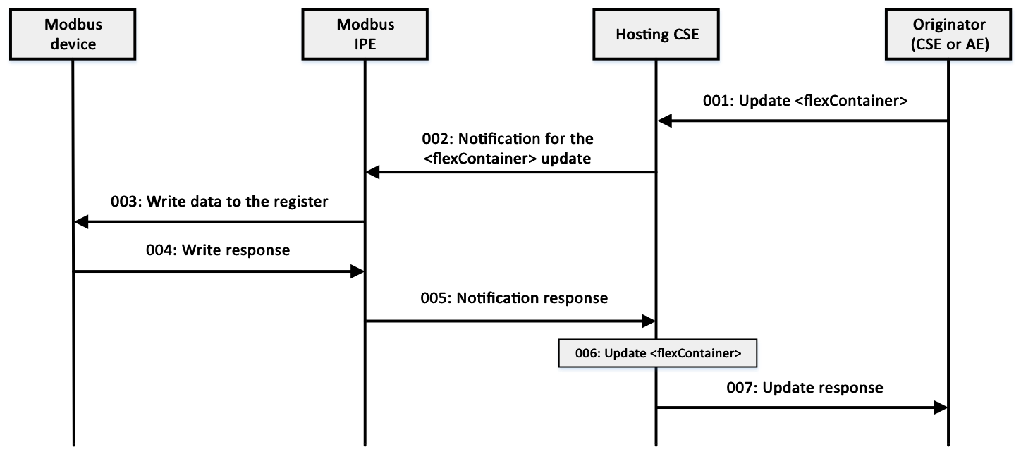
Figure 6.5.2-1: Writing to a Modbus Slave Device call flow
Figure 6.5.2-1: Writing to a Modbus Slave Device call flow

Annex A (informative):
Introduction to Modbus

A.1 Background
Modbus was first introduced by Modicon® (now part of Schneider Electric®) for process control systems. It is used to establish master-slave/client-server communication between intelligent devices and sensors and instruments. It is a de facto standard, truly open and the most widely used network protocol in the industrial manufacturing environment.
Modbus is easy to deploy and maintain and is used across a wide range of industries. It is also an ideal protocol for Remote Terminal Unit (RTU) applications where wireless communication is required. Modbus is not only an industrial protocol. Building, infrastructure, transportation and energy applications also make use of its benefits.
Originally, Modbus was implemented as an application level protocol intended to transfer data over serial port, it has expanded to include implementations over serial, TCP/IP, and UDP. Today, it is a common protocol used by countless devices for simple, reliable, and efficient communication across a variety of networks. Modbus was designed as a request-response protocol with a flexible data and function model that are part of the reason it is still in use today. In addition, support for the simple and elegant structure of Modbus continues to grow [i.4].

A.2 Architecture and protocol stack
The Modbus protocol follows a master and slave architecture where a master transmits a request to a slave and waits for the response (as shown in Figure A.2-1). This architecture gives the master full control over the flow of information, which has benefits on older multidrop serial networks. Even on modern TCP/IP networks, it gives the master a high degree of control over slave behavior, which is helpful in some designs.
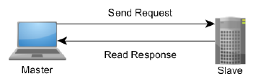
Figure A.2-1: The Master-Slave, Request-Response Relationship of Modbus device
Figure A.2-1: The Master-Slave, Request-Response Relationship of Modbus device
The Modbus protocol allows an easy communication within all types of networks (as shown in Figure A.2-2). Every type of devices (such as PLC, Driver, Motion control, I/O Device, etc.) can use Modbus protocol to initiate a remote operation.
The same communication can be done as well on serial line as on an Ethernet TCP/IP network. Gateways allow a communication between several types of buses or network using the Modbus protocol [i.5].
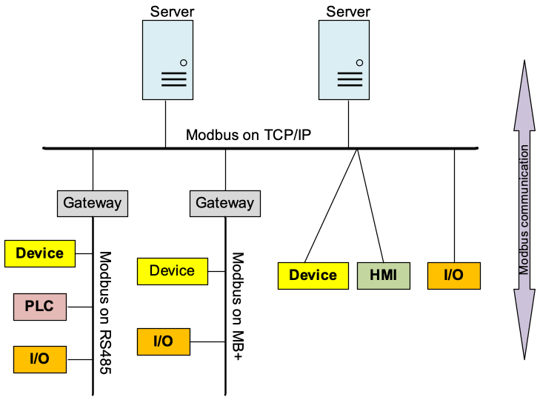
Figure A.2-2: Modbus Network Architecture
Figure A.2-2: Modbus Network Architecture
There are many variants of Modbus protocols:
- Modbus RTU - This is used in serial communication & makes use of a compact, binary representation of the data for protocol communication. Modbus RTU is the most common implementation available for Modbus. A Modbus RTU message is transmitted continuously without inter-character hesitations.
- Modbus ASCII - This is used in serial communication and makes use of ASCII characters for protocol communication.
- Modbus TCP/IP or Modbus TCP - This is a Modbus variant used for communications over TCP/IP networks. It does not require a checksum calculation as lower layers already provide checksum protection.
- Modbus over TCP/IP or Modbus over TCP or Modbus RTU/IP - This is a Modbus variant that differs from Modbus TCP in that a checksum is included in the payload as with Modbus RTU.
- Modbus over UDP - Some have experimented with using Modbus over UDP on IP networks, which removes the overheads required for TCP.
- Modbus Plus (Modbus+, MB+ or MBP) - Modbus Plus is proprietary to Schneider Electric® and unlike the other variants, it supports peer-to-peer communications between multiple masters. It requires a dedicated co-processor to handle fast HDLC-like token rotation. It uses twisted pair at 1 Mbit/s and includes transformer isolation at each node, which makes it transition/edge triggered instead of voltage/level triggered.
At present, Modbus TCP is more efficient networking through the use of dedicated connections and identifiers for each request and response. Modbus RTU and Modbus ASCII are older serial ADU formats with the primary difference between the two being that RTU uses a compact binary representation while ASCII sends all requests as streams of ASCII characters.
The Modbus protocol defines a simple Protocol Data Unit (PDU) independent of the underlying communication layers. The mapping of Modbus protocol on specific buses or network can introduce some additional fields on the Application Data Unit (ADU). The Modbus frame is as shown in Figure A.2-3.
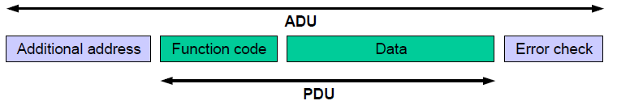
Figure A.2-3: Modbus Frame
Figure A.2-3: Modbus Frame
A Modbus frame or Modbus Application Data Unit (ADU) consists of the following:
- Additional address field: A field containing additional addresses used by the underlying communication protocol. It is 1 byte slave address over serial links (such as RS 232, RS 485). For Modbus TCP, it is called Modbus Application Protocol (MBAP) Header that include transaction identifier, protocol identifier, length and unit identifier.
- Modbus PDU: It is independent of underlying communication layer and consists of two parts: 1) 1-byte Function code to indicate identity of the requested service, 2) Variable length data field containing payload of the requested service. There are three types of Modbus PDUs: Modbus Request, Modbus Response and Modbus Exception.
- An optional error check field. Modbus TCP is not needed.

A.3 Key feature
There are many devices and gateways that support Modbus, as it is a very simple protocol and convenient to transmit and understand. Specially, Modbus TCP/IP simply takes the Modbus instruction set and wraps TCP/IP around it. Development costs are exceptionally low. Minimum hardware is required, and development is easy under any operating system. The following are key features of Modbus:
- Communication mode
Modbus uses master-slave/client-server communication mode, Master issues a unicast request and slave responds to that. In serial and MB+ networks, only the node assigned as the Master may initiate a command. On Ethernet, any device can send out a Modbus command, although usually only one master device does so. Modbus also supports broadcast mode where master's request is sent to all the slaves but no slave responds to broadcast request.
- Data model
Modbus manages the access of data simply and flexibly. Modbus data are divided into four ranges, they are that these types of data can be provided/alterable by I/O system or an application program. In most cases, slaves store each type of data that it supports in separate memory, and limits the number of data elements that a master can access.
- Function code There are three categories of Modbus Function codes, including Public Function codes, User-Defined Function codes and Reserved Function codes. Public Function codes can satisfy common operations, such as accessing data in device by reading and writing data model, and simply diagnosing device. Function code is flexibility that user can select and implement a function code by self-defining User-Defined Function codes according to service requirements.
- Availability of many devices Interoperability among different vendors' devices and compatibility with a large installed base of Modbus-compatible devices makes Modbus an excellent choice.

A.4 Data model
The Modbus standard defines bit-addressable and 16-bit word addressable input and output data items. Modbus bases its data model on a series of tables that have distinguishing characteristics. The four primary tables for data model are as following.
Table A.4-1: Modbus data model table
Primary tables | Object type | Type of access | Comments
Discretes Input | Single bit | Read-Only | This type of data can be provided by an I/O system, e.g. read the status of switch
Coils | Single bit | Read-Write | This type of data can be alterable by an application program, e.g. switch on a transducer
Input Registers | 16-bit word | Read-Only | This type of data can be provided by an I/O system, e.g. read temperature on a sensor
Holding Registers | 16-bit word | Read-Write | This type of data can be alterable by an application, e.g. set value to a controller
There are two ways of organizing the data in device. Each device can have its own organization of the data according to its application. Figure A.4-1 below shows an example for data organization in a device having digital and analog, inputs and outputs. Data block (device application memory) is accessible with different Modbus functions, such as read coils, write holding registers. All the data elements handled via Modbus can be located in device application memory by reference numbers form 1to n. The pre-mapping between the Modbus data model and the device application is totally vendor device specific.
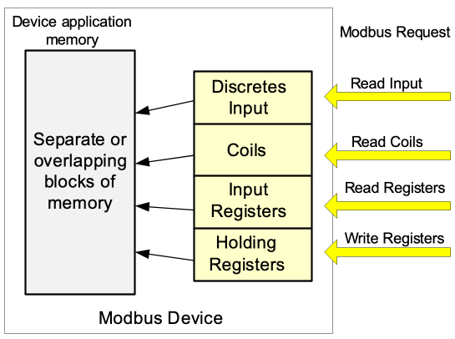
Figure A.4-1: Implementation example of Modbus data model
Figure A.4-1: Implementation example of Modbus data model

Annex B (informative):
Resource mapping examples

B.1 Introduction
The IPE constructs oneM2M resource tree on hosting CSE from the SDT schemas derived from the set of functionalities of Modbus devices.
The present clause gives an example of how to use the oneM2M resource tree to represent a Modbus device (i.e. Thermometer).
The next clause explains the creation process for an arbitrary thermometer device that communicates over Modbus. As the Modbus devices are firstly represented by SDT models, the SDT definition of the thermometer device described in clause 5.5.45 of oneM2M TS0023 [3] will be considered.

B.2 Example for thermometer device

B.2.1 Example for Device model 'deviceThermometer'
Mapping of the SDT Device model to oneM2M resources is performed according to the general mapping procedure described in clause 6.2.2 of oneM2M TS0023 [3]. Figure B.2.1-1 shows an example of the [deviceThermometer], which is modelled as a <flexContainer> resource specialization derived from the corresponding SDT Device component.
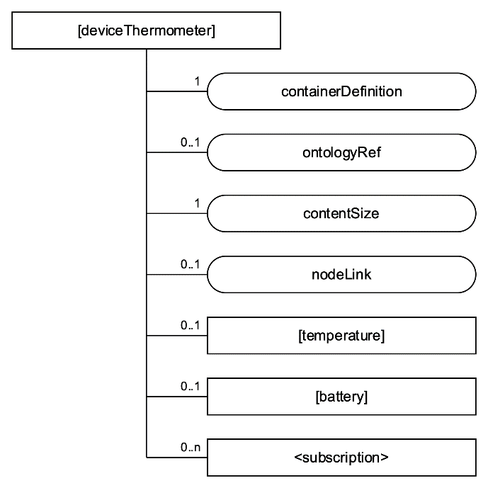
Figure B.2.1-1: Structure of [deviceThermometer] resource
Figure B.2.1-1: Structure of [deviceThermometer] resource

B.2.2 Example for ModuleClass 'temperature'
The SDT model of the 'temperature' ModuleClass is described in the clause 5.3.76 of oneM2M TS0023 [3]. Assume the DataPoints of the 'temperature' ModuleClass are created according to the mapping rule described in clause 6.2.2.
Mapping of the SDT ModuleClass model to oneM2M resources is performed according to the general mapping procedure described in clause 6.2.3 of oneM2M TS0023 [3]. The 'temperature' ModuleClass is mapped into [temperature], a <flexContainer> resource specialization, and its data points are mapped into customAttributes of that <flexContainer> resource specialization; and nodnProperties customAttribute is added the [temperature] as described in clause 6.2.3. Figure B.2.2-1 shows the structure of [temperature].
The example contents of nodnProperties are shown on Figure B.2.2-2.
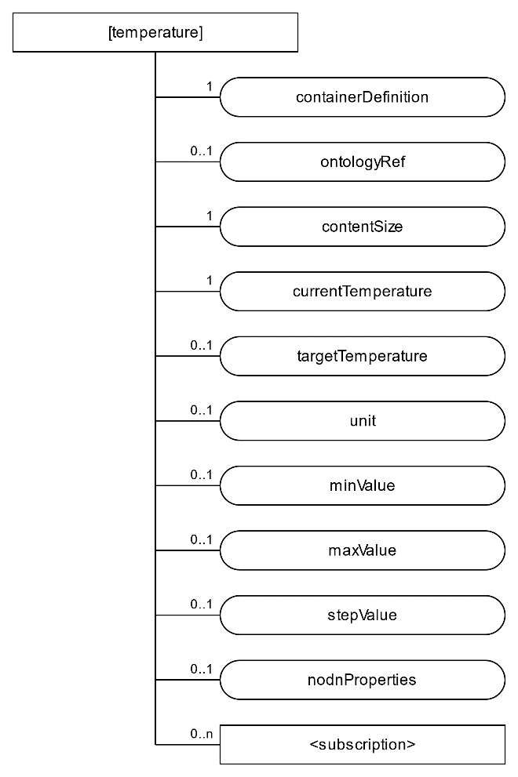
Figure B.2.2-1: Structure of [temperature] resource
Figure B.2.2-1: Structure of [temperature] resource
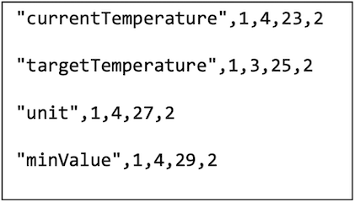
Figure B.2.2-2: Example contents of noDNproperties
Figure B.2.2-2: Example contents of noDNproperties

History
Publication history
V4.0.0 | November 2022 | Release 4 - Publication

Draft history
V5.0.0 | 2025-04-01 | First draft for Rel-5 based on V4.0.0
V5.0.1 | 2025-05-27 | Alignment of copyright statement for stable specification  (see SDS-2025-0097)
V5.0.2 | 2025-06-30 | New baseline after markdown conversion
V5.0.3 | 2026-03-20 | Replacing title pages with frontmatter settings

