

| **Work** **Item** | |
| --- | --- |
| Work Item title: | Edge Deployment using ETSI MEC |
| Document Number | WI-0120 |
| Date: | 2024-04-24 |
| Supporting Members or Partner type 2 | Exacta GSS, Sejong University, SBS, FSCOM SARL |
| Abstract: |This work items aims to develop interworking |between oneM2M Service Layer and ETSI MEC. | |

**oneM2M Copyright statement**  
No part may be reproduced except as authorized by written permission.  
The copyright and the foregoing restriction extend to reproduction in all media.  
All rights reserved.

# 1 Title (Acronym)

Edge Deployment using ETSI MEC

# 2 Justification

Edge computing, an evolution of cloud computing, moves application and data hosting closer to users, improving latency and bandwidth efficiency, which are crucial for meeting the demanding Key Performance Indicators (KPIs) of 5G networks and other use cases. Beyond technical benefits, edge computing is transforming telecommunications into versatile service platforms for industries and specific customer segments.

IoT technology connects various devices to the internet, allowing them to communicate without human intervention. Originally used for user-oriented services in smart homes, IoT is now pervasive across various fields such as smart cities, factories, agriculture, and daily life. It has become an infrastructure technology for core technologies like artificial intelligence, cloud computing, blockchain, and edge computing, driving the fourth industrial revolution. IoT enables more accurate data collection for real-time operations in smart factories and high-speed communication for services like autonomous vehicles.

In the June 2023 ETSI White Paper No. #59, <https://www.etsi.org/images/files/ETSIWhitePapers/ETSI-WP59-Enabling-Multi-access-Edge-Computing-in-iot.pdf>, several options for deploying ETSI MEC and oneM2M are presented.

# 3 Intended Output

**Tick all the appropriate cases**

| Check | Case |
| --- | --- |
| X | Change request(s) to existing Technical Specification(s) |
|  | Change request(s) to existing Technical Reports(s) |
| X | New Normative Technical Specifications(s) |
|  | New Permanent Technical Reports(s) |
| X | New Temporary Technical Reports(s) |

# 4 Impact

## 4.1 oneM2M Work Items

None

# 5 Scope

The scope of this work item is to enable interworking between oneM2M Service Layer and ETSI MEC. In particular, the main objective are as follows:

* Introduce ETSI MEC and its role in a oneM2M deployment.
* Identify what aspects of ETSI MEC API can be used from a oneM2M CSE.
* Identify how to deploy oneM2M to take advantage of MEC features and benefits. The figure below demonstrates some deployment options that will be considered.

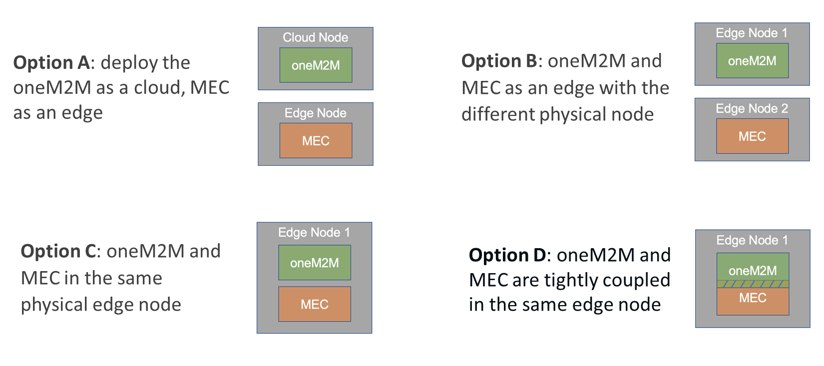

missing caption

# 6 Schedule and impacted specifications

Provide the schedule of tasks to be performed;

| Document Type | Document Number* | Title | Schedule (TP No.) Start | Schedule (TP No.) Change Control | Schedule (TP No.) Freeze | Schedule (TP No.) Approval | Lead WG | Impacted WGs | Comments |
| --- | --- | --- | --- | --- | --- | --- | --- | --- | --- |
| TR | TR-00xx | oneM2M and MEC integration scenario and mechanisms | TP#66 | 75 | 76 | 77 | WG2 |  |  |
| TS | TS-00xx | oneM2M and MEC interworking and deployments | TP#66 | 75 | 76 | 77 | WG2 |  |  |
| TR | TR-00xx | Developer Guide: oneM2M and MEC deployment | TP#68 | 73 | 74 | 75 | WG4 |  |  |

* The first versions will be assigned by the secretariat (WPM Secretary)

| Impacted TS/TR | CR number (when known) | Subject of the CR | Approved at plenary# | Impacted WGs | Comments |
| --- | --- | --- | --- | --- | --- |
| TR | TR-0001 | Uses Cases | TP#77 | WG2 |  |
| TS | TS-0001 | Functional Architecture | TP#77 | WG2 |  |
| TS | TS-0004 | Service Layer Core Protocol | TP#77 | WG2 |  |
| TS | TS-0018 | Test and conformance | TP#77 | WG4 |  |

# 7 Work Item Rapporteur(s)

JaeSeung Song, Sejong University, jssong@sejong.ac.kr

Bob Flynn, Exacta GSS, bob.flynn@exactagss.com

# 8 History

| Document history | | |
| --- | --- | --- |
| V0.0.1 | 2024-04-23 | Initial proposal at TP#64 |
| 2024-04-27 | Uploaded as a permanent document following agreement of TP-2024-0035R02 |
|  |  |  |
|  |  |  |