
Work Item
Work Item title: | Edge Deployment using ETSI MEC
Document Number: | WI-0120
Date: | 2024-04-24
Supporting Members or Partner type 2: | Exacta GSS, Sejong University, SBS, FSCOM SARL
Abstract: |This work items aims to develop interworking |between oneM2M Service Layer and ETSI MEC.
oneM2M Copyright statement
No part may be reproduced except as authorized by written permission.
The copyright and the foregoing restriction extend to reproduction in all media.
All rights reserved.

1 Title (Acronym)
Edge Deployment using ETSI MEC

2 Justification
Edge computing, an evolution of cloud computing, moves application and data hosting closer to users, improving latency and bandwidth efficiency, which are crucial for meeting the demanding Key Performance Indicators (KPIs) of 5G networks and other use cases. Beyond technical benefits, edge computing is transforming telecommunications into versatile service platforms for industries and specific customer segments.
IoT technology connects various devices to the internet, allowing them to communicate without human intervention. Originally used for user-oriented services in smart homes, IoT is now pervasive across various fields such as smart cities, factories, agriculture, and daily life. It has become an infrastructure technology for core technologies like artificial intelligence, cloud computing, blockchain, and edge computing, driving the fourth industrial revolution. IoT enables more accurate data collection for real-time operations in smart factories and high-speed communication for services like autonomous vehicles.
In the June 2023 ETSI White Paper No. #59, https://www.etsi.org/images/files/ETSIWhitePapers/ETSI-WP59-Enabling-Multi-access-Edge-Computing-in-iot.pdf, several options for deploying ETSI MEC and oneM2M are presented.

3 Intended Output
Tick all the appropriate cases
Check | Case
X | Change request(s) to existing Technical Specification(s)
 | Change request(s) to existing Technical Reports(s)
X | New Normative Technical Specifications(s)
 | New Permanent Technical Reports(s)
X | New Temporary Technical Reports(s)

4 Impact

4.1 oneM2M Work Items
None

5 Scope
The scope of this work item is to enable interworking between oneM2M Service Layer and ETSI MEC. In particular, the main objective are as follows:
- Introduce ETSI MEC and its role in a oneM2M deployment.
- Identify what aspects of ETSI MEC API can be used from a oneM2M CSE.
- Identify how to deploy oneM2M to take advantage of MEC features and benefits. The figure below demonstrates some deployment options that will be considered.
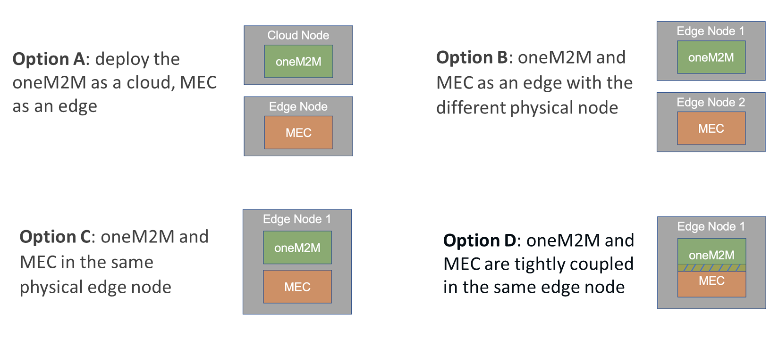
Deployment Options for oneM2M and ETSI MEC
- Define how to use oneM2M with ETSI MEC to implement features that enable Swarm computing as a core enabler for decentralized intelligence, where multiple oneM2M AE’s/MN-CSE’s collaborate autonomously to perform distributed tasks, adapting dynamically to topology and resource change.
- Define how to use oneM2M with ETSI MEC to implement features that support federate learning orchestration, e.g. training privacy preserving models, deployment of machine learning models target for cloud, edge, and IoT devices

6 Schedule and impacted specifications
Provide the schedule of tasks to be performed;
Document  Type | Document  Number* | Title | Schedule (TP No.)  Start | Schedule (TP No.)  Change Control | Schedule (TP No.)  Freeze | Schedule (TP No.)  Approval | Lead WG | Impacted WGs | Comments
TR | TR-0077 | oneM2M and MEC integration scenario and mechanisms | TP#66 | 75 | 76 | 77 | WG2
TS | TS-0042 | oneM2M and MEC interworking and deployments | TP#66 | 75 | 76 | 77 | WG2
TR | TR-0078 | Developer Guide: oneM2M and MEC deployment | TP#68 | 75 | 76 | 77 | WG4
TR | TR-0080 | Use cases for oneM2M and MEC deployment scenarios and services | TP#70 | 71 | 71 | 71 | WG2
- The first versions will be assigned by the secretariat (WPM Secretary)
Impacted  TS/TR | CR number (when known) | Subject of the CR | Approved at plenary# | Impacted WGs | Comments
TR | TR-0001 | Uses Cases | TP#77 | WG2
TS | TS-0001 | Functional Architecture | TP#77 | WG2
TS | TS-0004 | Service Layer Core Protocol | TP#77 | WG2
TS | TS-0018 | Test and conformance | TP#77 | WG4
TS | TS-0002 | Requirements | TP#73 | WG2

7 Work Item Rapporteur(s)
JaeSeung Song, Sejong University, jssong@sejong.ac.kr
Bob Flynn, Exacta GSS, bob.flynn@exactagss.com

8 History
Document history
V0.0.1 | 2024-04-23 | Initial proposal at TP#64
V0.0.1 | 2024-04-27 | Uploaded as a permanent document following agreement of TP-2024-0035R02
V0.0.2 | 2025-06-27 | Added temporary TR-0080 to capture initial STF 685 use cases
V0.0.3 | 2025-09-12 | Update document numbers and align schedule

